ICIAL INTERNATIONAL PUBLICATION OF THE ASSOCIATED LOCKSMITHS OF AM.

**• Focus** *Preview Alarm Lock 3000* • *Cylinder Guard Rings* • *New At Unican***

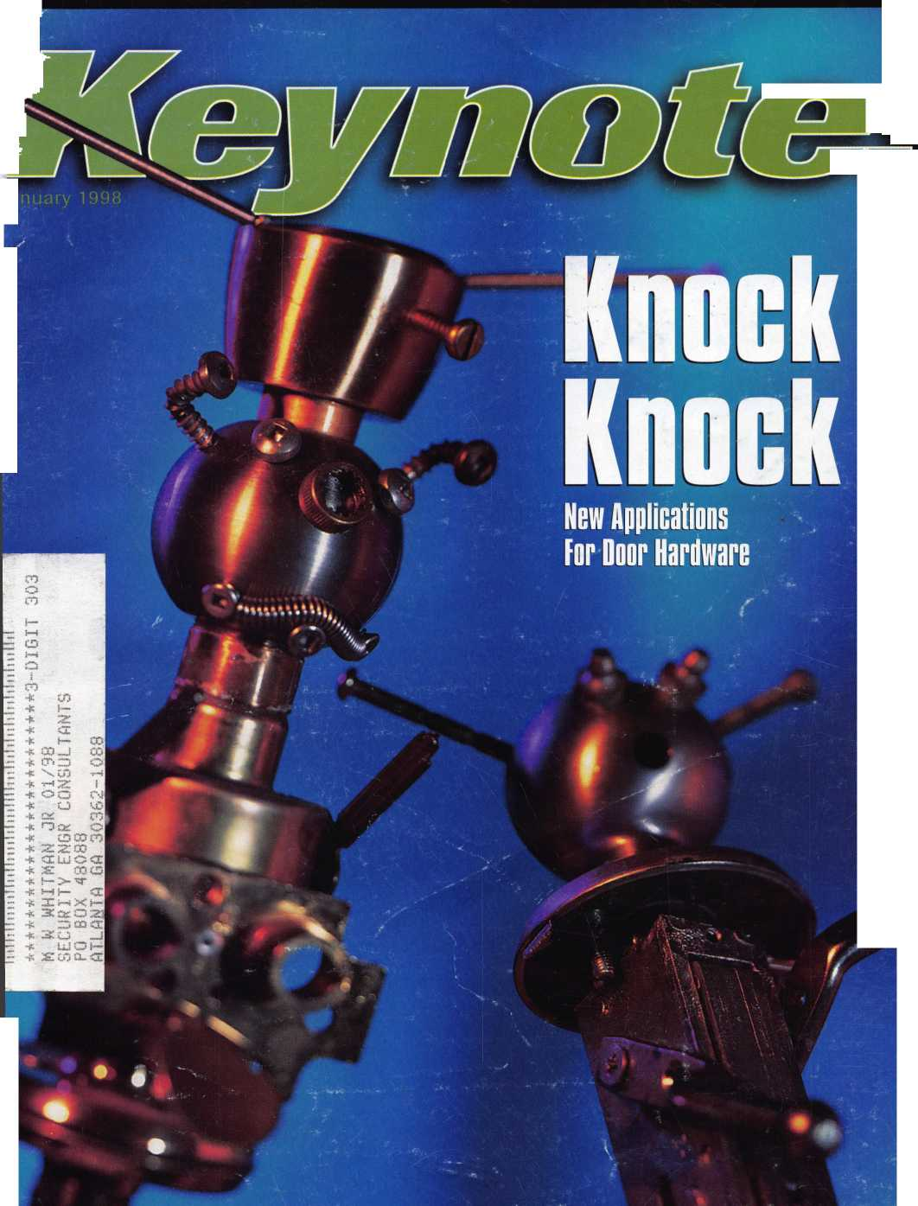

AN INVESTMENT

YOU CAN'T AFFORD NOT TO MAKE

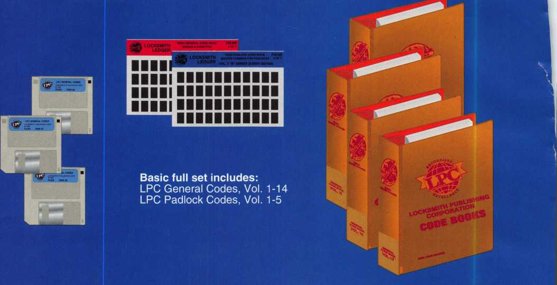

The Locksmith Publishing Corporation’s Code System contains the most accurate, up-to-date code information available anywhere, and provides you with more codes than any other system on the market today.

* Available in 3 formats: books, microfiche, software.
* Card and key guide numbers and hand cutter information are included to facilitate use of the codes with all of today’s popular code cutting equipment, including llco, HPC, Curtis, Framon and ITL.

• Spacings and depths data is provided with code series. Keyblank cross-reference information is also included.

* Codes are provided for the most popular makes of utility and vehicle locks, and also for the more obscure series not found in any other system, but still in circulation today.
* Our codes are NEVER deleted. We continually update and expand existing code series, and add new codes as soon as they become available.
* When applicable, code series are cross referenced to codes for similar locks designed on the same general principles.

*Specialty books/microfiche for Chrysler, GM, Ford, BMW, Motorcycle Master and Tubular Codes also available*



**Locksmith Publishing Corp.**

**Reed Code Division**

**850 Busse Hwy., Park Ridge, IL 60068 Tel: 847-692-5940 Fax: 847-692-4604**Or visit us On-Line at <http://www.lpc.simon-net.com>

r- i n i o ■ /■> i u *

ALOA ’98 International Convention & Security Expo

*‘No one succeeds alone*. *The*

*input, tolerance and sharing*

*of knowledge from others in*

*this industry account for most*

*of my success. My part was to*

*learn—a lifetime process*

Nashville Convention Center

Dan Graffeo, CRL, CMS  
ALOA Member #8188  
1996 recipient, ALOA Lifetime  
of Outstanding Achievement

Nashville, Tennessee

*Associated Locksmiths of America 3003 Live Oak Street Dallas, Texas 75204*

*e-mail [convtion@anet-dfw.com](mailto:convtion@anet-dfw.com)*

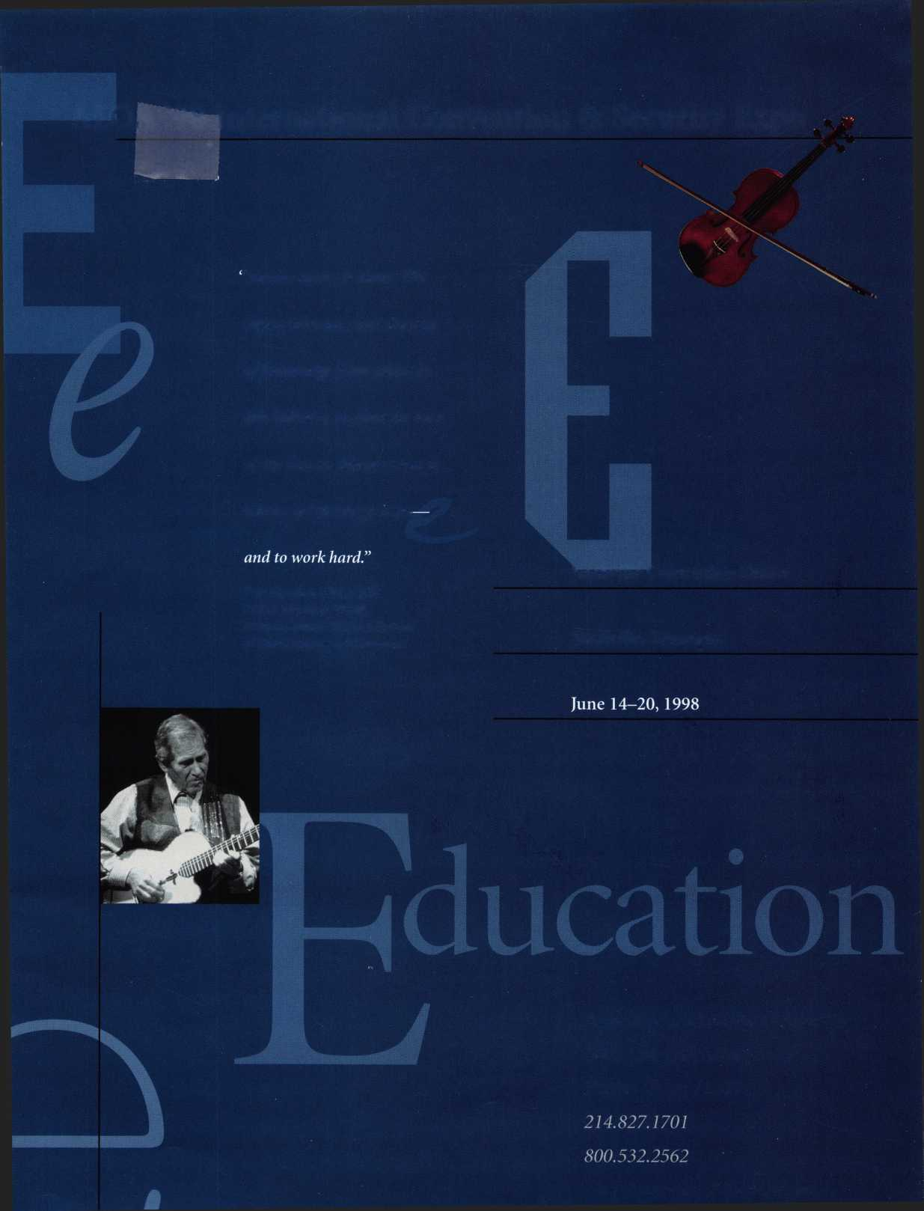

**Contends**

Features

**January**

16

Why Join An Association?

From A to Z, it all adds up.

By Richard Ensman

18

Business Not As Usual

The 1997 Fall ALOA Board meeting a remarkable  
change for association operations.

22

iTitan’s Nightsight

This manufacturer is aggresively marketing its latest

offering to the residential door hardware consumer.

Installation by Julie Robinson, RL

e ABCs of CCTV: “S” is For Signal

|Don’t miss the last in our authors CCTV series.

By Paul Chandler, CPL

The Cover Locksmith artist Bill Hampson created our unique view of door hardware. Sort of a literal interpretation of the proverbial “installation nightmare”

Cover photograph ©Steve Hinds

26

Cylinder Guard Rings

Security guard plates can shield mortise cylinders. Cylinder

Iguard rings, however, install much faster and, with a much

lower cost, are a more sure fire sale.

By Sal Dulcamara, CML

Portrait of an Artist

The creator of our cover art sees art in locksmithing, and

locksmithing in art.

By Mike Emery

32

Specialty Locks from Fort Lock

When you need to secure drawers or cabinets, ordinary door

hardware won’t fill the bill.

By Sal Dulcamara, CML

36

New and Improved at Unican

The leading manufacturer of mechanical keyless locks had

some interesting new models out at year end.

By Paul Chandler, CPL

38

Previewing the Alarm Lock 3000

It uses the same housing, the same keypad, the same Grade  
One clutched lever and the same deadlatch. It's what you  
can't see that makes it special.

By Paul Chandler, CPL

41

The Case Against Single Step Keying

Yes, people do it. It’s not a good idea.

By Jerome Andrews, CML

President s Journey It s been a busy year already.

9

Focus on Education  
New classes, new manager.

44

Legislative Comment

New legislation, new manager.

54

PRP Report

Welcome to Dallas.

55

Trade Tips

Welock/Toyota and one on peening pins.

56

Chapter News  
Mountains and molehills.

■■

6

Mail Box

Support for vote-by-mail.

-7

Upcoming Events  
Mark June 15-20, Nashville.

10

Applicants for Membership  
Scheduled for clearance February 1.

12

Industry News

Hirings, mergers, new branches.

14

Security Marketplace

More door hardware offerings.

58

ALOA Extra

60

Back Page

I

**Advertising**

Keynotes

January 1998

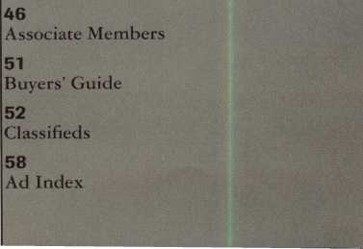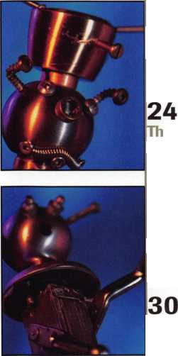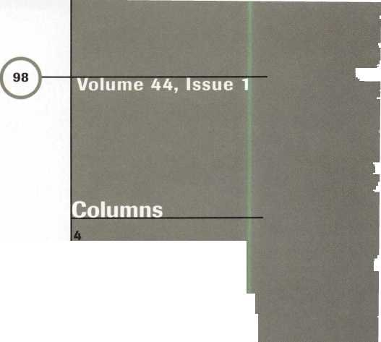

Advertising Sales Manager Sales Assistant Contributing Authors

Publications Committee

ALOA Professional Staff Executive Director Office Manager Receptionist Comptroller Financial Assistant Associate Executive Director Meetings & Education Coordinator Administrative Assistant Legislative Manager PRP/Education Manager

Anelia M. Banda D’Anna Weber Jerome V. Andrews, CML Kim Bowers,CML Paul Chandler, CRL Claire Cohen, CML Brian Costley, CML, CMS Bob De Weese, CPL Ray D’Adamo, CML Sal Dulcamaro, CML James Glazier, CML Wayne Gurnee, CRL A.J. Hoffman, CML Ken Holmlund, CRL Ray Lusk, CML Mark Ohno David Parrott Randy Simpson, CML Robert Stafford, CPL Dave Thielen

John D. Cannon, CML, Chairman Jerome Andrews, CML A.J. Hoffman, CML Leonard J. Passarello, CPL Randy Simpson, CML Robert Stafford, CPL

Charles W. Gibson, Jr.

Mary May

Margo E. Vela

Kathy J. Romo

Debra Bradshaw

Carmen D. Murphey, CMP

Jessica Vasquez

Janelle Vergara

Tim McMullen

David Lowell, CML, CMS

Complete address and phone number listings for the ALOA Board and Keynotes authors are available in your membership directory or by contacting the ALOA office at 3003 Live Oak Street; Dallas, TX 75204; [214)827-1701; FAX (214) 827-1810; e-mail aloa@anet-dfw. com; website [www.aioa](http://www.aioa). org

President

Dallas C. Brooks C334J 826-8990

Regional Vice Presidents Southeast

•Jeffrey S. Nunberg, CML, CMS

Chairman: Finance and Personnel

C305J 324-8800

North Central

•John J. Greenan, CPL, CPS

Chairman: Legislative Committee

C773J 486-2030

South Central

*Randy L. Simpson, CML

Chairman: Bylaws Committee

C713J 780-7026

Southwest

John I. Shandy, CML

Chairman: Membership Committee

C303J 776-7898

Northeast

James H. Glazier, CML

Chairman: Education Committee

C301J 831-5454

Northwest

Raymond C. Lusk CML

Chairman: Convention Committee

C509J 624-3152

Secretary

John D. Cannon, CML

Chairman: Publications and Public Relations

(703] 960-6413

David M. Lowell, CML, CMS

Chairman: Nominating, PRP and Trustees

(214] 827-1701

Breck H. Camp, CML

(770] 455-6244

Henry H. Printz, CML

(201] 538-2737

Leonard J. Passarello, CPL

(416] 752-7210

Edwin Toepfer, RL

(416] 225-5589

Directors

*These officers also serve as directors.

PRP Assistant Membership Coordinator Membership Assistant Mailroom Assistant

Angelica Farraro Brandon Durrett Jackie Arnett Jesse Morales Jr.



Mission Statement: The Associated Locksmiths of America, Inc. is dedicated to enhancing the professionalism, education and ethics among locksmiths and those in related sectors of the physical security industry. With approximately 10,000 members in the United States, Canada and the freeworld, ALOA is poised to help members obtain the knowledge, the strength, and the confidence to perform their role in the physical security field with pride and dignity. But it is only through active involvement and participation that ALOA can fully achieve its potential-and can help members to achieve theirs.

Policies: Keynotes® is the official publication of the Associated Locksmiths of America, Inc. (ALOA], Keynotes® acts as a moderator without approving, disap­proving, or guaranteeing the validity or accuracy of any data, claim, or opinion appearing under a byline or obtained or quoted from an acknowledged source. The opinions expressed by the authors do not necessarily reflect the official views of ALOA. Also, appearance of advertisements and new products or service information does not constitute an endorsement of products or services featured by the Association. The Association does not accept responsibility for the inac­curacy of any data, claim, or opinion appearing in this publication, due to typographical errors on the part of the authors, Association staff or its agents.

Editor’s Note: This publication is designed to provide accurate and authoritative information in regard to the subject matter covered. It is provided and dis­seminated with the understanding that the publisher is not engaged in rendering legal or other professional services. If legal advice and other expert assistance is required, the services of a competent professional should be sought.

Authors’ Payment: Effective Nov. 1, 1995, payment will be made for original articles submitted exclusively to Keynotes® magazine at a rate of: technical arti­cles—$75 per page, double-spaced with standard one-inch margins; and business/human interest articles—$50 per page, double-spaced with standard one- inch margins. (If only a portion of an eligible article is published, payment will be made for that portion only.] Authors will be paid $10 for each photograph, chart, exhibit or illustration that is utilized for their article. Maximum payment for both copy and photos is $350 for technical articles and $150 for business/human interest articles.

Payment will not be offered for articles submitted by ALOA employees or members of the ALOA Board of Directors (unless material is of a technical nature], nor for articles submitted by a company that promote that company’s products or services. ALOA reserves the right not to pay for articles submitted by an individ­ual (s] that promote a particular company’s products or services.

Disclaimer: The Associated Locksmiths of America, Inc., (ALOA], reserves the right to refuse any article for any reason. Additionally, ALOA reserves the right to edit, amend or modify any article submitted for publication in order to preserve technical accuracy, clarity, fairness or grammatical correctness. ALOA will make the best efforts to notify the author of any changes. The extent of ALOA’s liability for any article or information contained therein will be a notice of correc­tion or retraction in the next possible issue.

Keynotes® (ISSN 0277 0792] is published monthly except for the combined July/August issue by The Associated Locksmiths of America, Inc., 3003 Live Oak St., Dallas, TX 75204-6186. Telephone: (214] 827-1701; FAX (214] 827-1810; e-mail [aloa@anet-dfw.com](mailto:aloa@anet-dfw.com). Subscription rates for members-$15.00 per year. Second class postage paid at Dallas, Texas. POSTMASTER: Send address changes to: Keynotes, 3003 Live Oak St., Dallas, TX 75204-6186. © Copyright 1997, All rights reserved. No part of the contents may be reproduced or reprinted in any form without prior written permission of the publisher.

Dana L. Barnum, CML Chairman: Chapters Committee (610] 565-9900 Mark E. Blum, CML, CPS (517] 482-5809 AJ. Hoffman, CML

Chairman: Library/Museum Committee

(714] 474-8877

Barry K. Leas, CRL

(610] 272-9292

Clyde Roberson, CML, CPS

(540] 380-5000

Donald E. Rule', CML

(601] 324-2658

Anthony J. Ramunno, CML, CPS

(330] 782-6204

Robert H. Stafford, CPL

Chairman: Grievance Committee

(860] 768-7917

Bruce J. Tarbet, CML

(601] 924-4184

Chairmen of International Affairs

Laurence P. Mills/Australia

(129] 958-0445

Hans Mejlshede, CML/Europe

FAX (453] 139-1004

Members-at-Large

Jerome V. Andrews, CM L

(860] 621-3601

Steven G. Engel, CML, CPP

Chairman: Strategic Planning Committee

(414] 731-5400

Past Presidents

1995-1997 David Lowell, CML, CMS 1993-1995 Breck Camp, CML 1991-1993 Henry Printz, CML 1989-1991 Evelyn Wersonick CML 1987-1989 Leonard Passarello, CPL 1985-1987 Joe Jackman, CML 1983-1985 Stanley Haney, CPL 1981-1983 Louis LaGreco, CPL 1979-1981 John Kerr, RL 1977-1979 Clifford Cox, CML 1974-1977 Charles Hetherington 1972-1974 Gene Laughridge 1970-1972 William Dutcher, RL 1968-1970 Constant Maffrey, RL 1966-1968 Harold Edelstein, RL 1964-1966 William Meacham 1962-1964 Robert Rackliffe, CPL 1960-1962 Edwin Toepfer, RL 1956-1960 Ernest Johannesen

January 1998

Keynotes

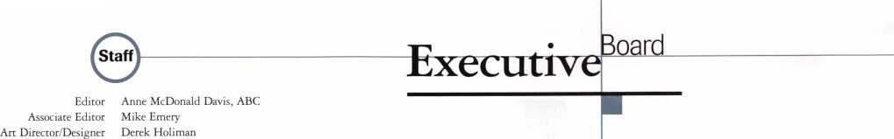

with Dallas Brooks

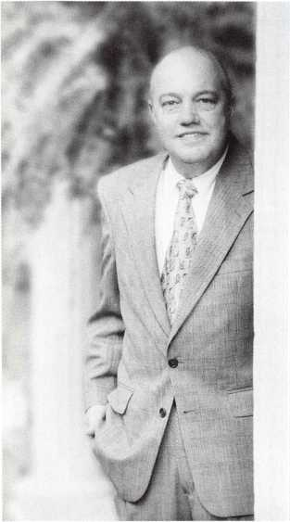

Lift Off.

The beginning of 1998 is exciting and intimidating—at the same  
time. In the six months since I came on board as ALOA president,  
we’ve made many plans that are now being launched. We’ve hired a  
Legislative Manager (see p. 44) who is putting together an aggres-  
sive program to protect and support our members’ best interests.  
We’ve hired a PRP/Education Manager (see p. 54) who will be  
responsible for enhancing and expanding ALOA’s long-term efforts

_ to increase the professionalism and business success of ALOA lock-  
11 smiths. We’re in the process of formulating a new governance docu-  
■ ment to help the ALOA board function with efficiency and account-  
I ability (see p. 18) and we’re consulting with our attorneys to bring  
f about vote-by-mail. In March, we will be partnering—for the first  
I time—with the International Security Conference (ISC) at their  
I spring exposition in Las Vegas to bring an additional slate of ACE  
I classes to professionals. And also on the “partnering” front, we’re  
I exchanging convention advertising packages with the Door and  
Hardware Institute as well as several builder’s magazines. We intend  
to go for a new record at the ALOA ’98 Security Expo in Nashville  
by encouraging professionals in related fields to join locksmiths for  
this learning and fellowship experience.

For all of these innovations our thanks goes out to you, our mem­bers, who made these suggestions and pledged in the spring mem­bership survey to make this possible by support for the new dues structure and attendance at the June/July convention and trade show. ALOA has made a concentrated effort in the past months to find out what our members need and to determine ways we can meet those needs. I have every confidence that we’re off to a good | start.

Yet here it is so soon—1998. Time to take a deep breath and push forward.



Keynotes

January 1998

Kwok-kei Leung 159 Henry Raymond73 Stewart Levine, CML 67 Mary Ohmit, CPL 63 Toshihiro Asano59 || Alien Konrath49 J Jack Hobin, CPL47 Charles Robertson, CML_46 Yuriko Yanai jjj38

William Neff, CML |36

Myeong-Rae Cho \ ,136

Salvatore Dulcamara, CML35 Thomas Freehling, CML 32

Jeanne Lodge, CML pip7

Roy Renderer, CML.^ life 5 Danny Rudd, CPL J?3 Robert Carroll, CPLJ23 Barbara Watt23 David M A Federico 23 James Watt, CML 22 Diana Barnum, CRL 22 J Thomas Hood, CML22 Robert DeWeese, CPL22 John Elliott, CML 21 Larry Warnick, CML21 Jerome Cohen, CML 21 John Heckman, CML 21 Eugene Altobella 21 Jim Williams 21 D. Michael Lee, CPL 18 James Fowler, CML18 David Harris, CML 18 Elvis Hammerschmidt, CPL18 John Kerr, RL_17 Marian Swann, CRL 17 Ronald Heidzig 17 John Dorsey, CPL 16 Joseph Ferrero, CML 16 Charles Cole, CML 16 William Grant, CRL16 Brian Reetz 16 Walter Lascar, RL 15 James Cawby, CML15 William McElheney, CML15 Michael Robinson, CRL 15 Rex Parmelee, RL 14 Thomas Vandersteen, CML14 Edwin W Scott 13 James Gruber13 Peter Gauthier, CPL 13 Philip Rovenolt, CPL13 Russell Fuller, CRL13 Robert Rodocker, CRL12 Gary Teams, CPL12 Rolando Bouza 12 Lonnie McKinney, CML 12 James Brickler, CRL 12 Frank Hartung, CML 11

Herbert Dusenberry, CML 11

Robert Duman, CML 11 Jon Griswold, CML11 Robin Horsley11 Daniel Landry11 Ernest Wright.10 William Wickward, CML10 Lester Brodsky 10 Joseph Whitaker, CPL10 Dale Knowles, CPL10 John Engel, CRL10 Richard Sievers 10

The Brightest aisi And The Best.

How can I join the President's Club?

You can earn membership in this prestigious dub by recruiting just 10 new members for ALOA.

*Any ALOA member may participate.

What do I get?

When you recruit 10 members, you receive a handsome blue blazer with a President's Club crest. For each additional five members you recruit, you receive a lapel pin with gold-filled numbers, indicating your recruiting successes.

You also get the satisfaction of knowing that you are helping your association, helping your industry grow, and you are helping fellow locksmiths achieve success.

How do I get started?

Contact the ALOA office for a supply of applications (214) 827-1701 or FAX (214) 827-1810. One President's Club credit is awarded for each new applicant. Credit is awarded only after the membership application is approved. However, the credit will apply for the period in which the application is received. Failure to identify yourself as the sponsor on the application form at the time it is submitted to ALOA for processing will forfeit any credit.

*AL0A Board of Directors not eligible for membership in the President's Club.

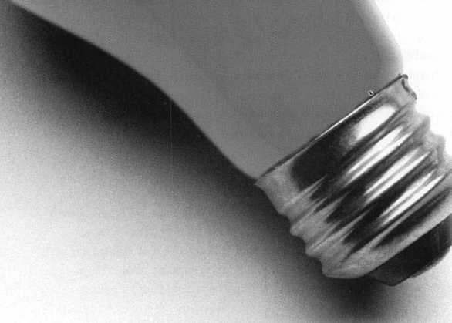

Keynotes

Mail Box



If you have an opinion to offer on the letter(s) printed in **Keynotes** each month, let us know! Submissions to the “Keynotes Mail Box” department are printed on a space-available basis. Write to: Keynotes Mail Box; Associated Locksmiths of America, Inc.; 3003 Live Oak Street; Dallas TX 75204; or FAX (214) 827-1810.

Open Letter to ALOA Members and Board:

The Membership of the South Florida Chap­ter of the Associated Locksmiths of America wishes to express support for ALOA Presi­dent Dallas Brooks in his efforts to restruc­ture the association in a state which permits mail-in voting. The chapter further agrees that due to progress in the industry, growth of membership, and forward thinking lead­ership, the Bylaws should be considered for needed alterations as part of the re-incorpo­ration activities. Our membership enjoys a spectrum of ability to attend conventions and meetings, all of which tend to be expen­sive. Mail-in voting is a must for the future of our Association. Regional representation of membership needs is adequate for policy setting, but burdensome in terms of task achievement, therefore paid professionals should be considered for task assignments. We urge other members and chapters to support Dallas Brooks, president of the only international locksmith association, as he leads us toward the next century of lock- smithing.

Wayne Gurnee, CRL

Wake Up and Smell the Motor Clubs

It seems that I can’t pick up a trade maga­zine any more without reading about some­one slamming motor clubs such as CCMC, RNC, etc. in regards to payments, rates, etc. Well, you guys better wake up! Who else do you think reads these articles? Yes, that’s right, the motor clubs too! While you think that you are doing the locksmith world a great service by these letters, you’re actually hurting us. The road clubs are getting tired of reading these also and are drifting toward sending the work to the tow services. Yes, that’s right, they can open cars too. They welcome the clubs with open arms! Of course you know that, based on the number of letters written about tow companies tak­ing away from our car openings. Well, you can’t have it both ways. The motor clubs are in a fight for their lives with competitive bidding just like we are with the trunk slamming know-nothings deluding the gen-

6 | Keynotes January 1998

eral public into thinking they are lock­smiths. If the motor clubs don’t keep their rates down when they bid a contract, they won’t have a job; then we don’t get work. Case in point, AAA just got General Motors Roadside work! So before you put your idle fingers to work slamming the clubs, I sug­gest you spend the time cleaning out your truck, shop or personal appearance. Based on what I’ve seen at shows, odds are you proba­bly need it. If you want to take action with the clubs, call them personally. I did and worked all my problems out. So the next time you think you’re doing us a favor with these insulting letters, keep me out of it. I don’t need your need your help.

Paul A. Keen, Jr., CPL

Too Old to Drive

In answer to the question posed in the ALOA Extra department, being 92 doesn’t mean you do not have rights. A family physician, although he may think he is god, is not. If he feels strongly about the woman not driving, he should express in writing, his opinion about the woman’s qualifications to drive. If the drivers’ license bureau is con­cerned enough, they can follow the proce­dures (such as a hearing or retest) for that particular state. Now, for the locksmith’s part. I have a policy of never making keys in a civil dispute where keys do exist. If keys exist, your services are not needed. If custody of a car is in question, the lawyers and courts are there to settle claims. If custody needs to change hands and keys are not surrendered, the car should be towed to a safe place, and the locks changed. You do no service just originating keys. I would rekey at least the ignition lock or would turn the work down. Families mean well, but just taking keys away does not insure a car will not be used. Also, if they are truly concerned, they will volunteer to drive her on her errands.

Al Davenport, CML

A Second Opinion

The only answer to the question of making the keys for the person that you know should not be driving is to refuse to make

them. Legal or not, that would be the only ethical and morally correct answer. I had the exact same thing happen to me and I refused to make the keys.

* I recently had a request to do work for a developer on a local project. First job was to repin a front door lock on a new house where the wrong lock had been installed, not providing ‘keyed alike’ condition as promised. After re-keying, I checked for proper operation of the deadbolt lock. Upon closing the bolt, I heard that famil­iar thump of the bolt against wood. Bolt not deadlocking because of hole of insuffi­cient depth. Do you ignore the situation, tell the developer that his people were installing locks improperly?
* I service a large community of senior housing. I often get requests from resi­dents to change or repin locks because ‘someone has my key and is coming in and taking things.’ After the second or third time for the same resident, when do you stop taking their money when you know that there is no one getting into the house?
* In the same community I get requests to install double cylinder deadbolt locks. As it is legal to install them, I explain in detail the danger to life safety that they present. If the resident insists they still want them, I will install it. Sometimes, they need to prevent their spouse from walking away, as they have Alzheimer’s. What then?

Bill Staples, CPL ALOA #10176

It pays

to have new faces  
in the crowd.



During 1998  
each ALOA member  
who sponsors  
a new applicant  
will receive $40 cash  
(upon clearance,  
and payment

of application fee and dues).

**Upcoming**

Events

**Januaty ’98**

23-25

S.C. Association Meeting Greenville, S.C. (864)233-4651 (800) 257-3529

26

S.C. Association Meeting Columbia, S.C. (803)736-1600

**February ’98**

2-4

Lockmasters, Inc.

New Advanced 3-day GSA Red Label Course Lexington, Ky.

(800) 654-0637

1. 8

21st West Coast Collectors Show

Contact: Bob Heilmann (310)-454-7295, evenings

1. 11

Lockmasters, Inc.

Electronic Safe Lock Course Lexington, Ky.

(800) 654-0637

10-15

Texas Locksmiths’ Association Convention and Trade Show Waco, Texas Contact: Ken Warden (210) 379-5923

21-22

mark bates Associates Manipulation class Nicholasville, Ky.

(888) 622-5495

**March ’98**

28-29

GCLA

13 th Annual Midwest Trade Show and Classes (708) 386-3695 FAX (708) 366-2094

**April ’98**

8-13

MLA of Great Britain

Convention

Birmingham, England

Contact: Peter Hall

14 Olive Grove; Burton Joyce;

Nottingham. NG14 5FG

**May ’98**

18-23

SAFETECH ’98 Valley Forge, Pa.

(214) 827-SAFE (7233)

(214) 827-1810 fax

e-mail: [convtion@anet-dfw.com](mailto:convtion@anet-dfw.com)

**June ’98**

14-20

ALOA ’98 Security Expo

Nashville, Tenn.

(800)532-2562

(214) 827-1810 fax

e-mail: [convtion@anet-dfw.com](mailto:convtion@anet-dfw.com)

**July ’98**

17-19

S. C. Association Meeting Columbia, So. Car. (803)735-1600

**August ’98**

13-16

SAVTA Fall Board Meeting Las Vegas, Nev.

(214) 827-SAFE (7233)

(214) 827-1810 fax

**October ’98**

17-19

S. C. Association Meeting Columbia, So. Car. (803)735-1600

13-18

ALOA Fall Board Meeting

Dallas, Texas

(800) 532-2562

(214) 827-1810 fax

e-mail: [convtion@anet-dfw.com](mailto:convtion@anet-dfw.com)



Z' **Future Conventions**

1998

ALOA ’98 June 14—20 Nashville, Tenn.

SAFETECH ’98 May 18-23 Valley Forge, Pa.

1999

ALOA ’99 July 26-31 Cincinnati, Ohio

SAFETECH ’99 May 3-8 Las Vegas, Nev.

2000

ALOA 2000 Date TBA Nev.

SAFETECH 2000 May 5—6

Birmingham, Ala.

2001

ALOA 2001 July 15-21 Baltimore, Md.

2002

ALOA 2002 July 21-27 Rosemont, 111.

For PRP dates, see p. 54. For ACE dates, see p. 9. Send in the dates of your organization’s activities today!



January 1998

Keynotes

Get the best master keying textbook



**3**

a

**3**

3

**Jerome V. Andrews, CML ft**

**3**

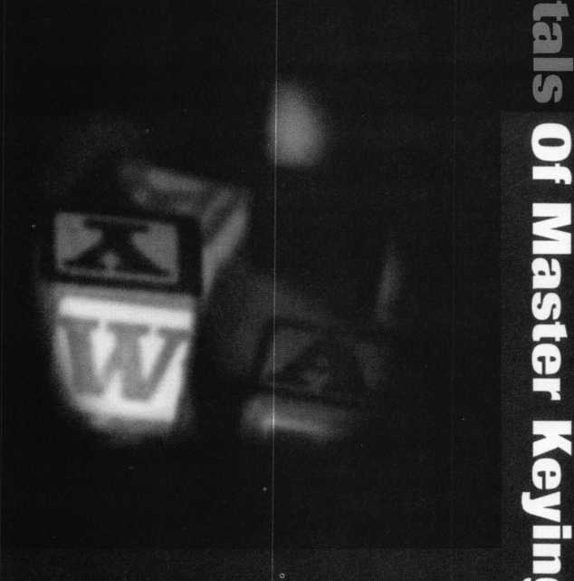

around, written by one of the most well- known locksmith instructors in the profession. Just $44,00 (including shipping and handling), Fundamentals of Master Keying covers system structure and recort keeping; basic mechanical and arithmetic concepts; and how to write a system.

*An Introduction to Split Pin Master Keying*

To order, write or FAX:

Associated Locksmiths of America, Inc.; 3003 Live

Oak Street  
Dallas TX 75204  
FAX (214) 827-1810

Credit card orders:  
Phone (214) 827-1701

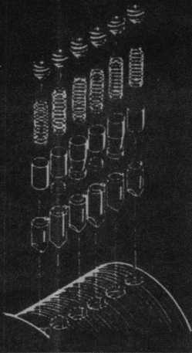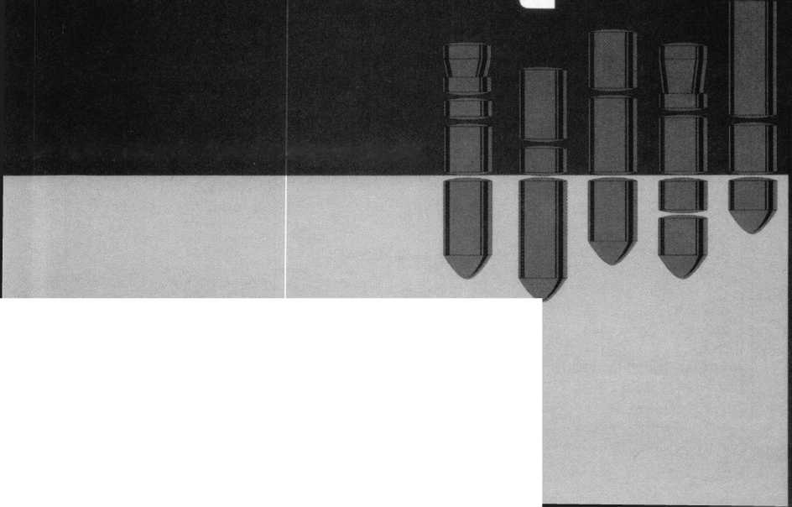

|  |  |
| --- | --- |
|  | On Education. |
| _ v  rocus |  |
|  | ^ James Ulazier, civil  Education Chairman |

A New Year brings a new education manager and new classes.

Well, it is now a new year and I hope you and your families had an outstanding Holi­day and are now ready for some new and exciting education in 1998. ACE (ALOA Continuing Education) has some great plans for the year. As I write this, I am preparing for our November Board meeting which I know will be exciting and hopefully we shall accomplish much for the member’s benefit. By the time you read this, David Lowell, CML, CPS, will be settled in at the Dallas office as the Interim Education Manager. Please give David your best next time you call the Dallas office. He will be available to answer your education or PRP questions as of Jan. 1, 1998. Happy New Year, David!

I would like to mention some other classes which should interest you. Lockmasters has now opened their new educational facility which I visited recently and was truly impressed. They have moved the Harry Miller lock collection, one of the largest in the United States to their new facility, where they also have two beautiful classrooms with all of the finest teaching materials. I will list just a few of their upcoming classes here.

* Jan. 12-23, 1998 Professional Locksmithing
* Jan. 18, 1998

Push Button Manipulation

* Feb. 5, 1998

Push Button Manipulation

* Feb. 8-11, 1998 Electronic Safe Lock Course
* Mar. 3-5, 1998 CCTV for the Locksmith
* Mar. 7-9, 1998

Auto Opening & Service For full details on these and other classes, you can call 1(800) 654-0637. Lockmasters is also handling a great line of locksmith tools for your future needs. Ask them for their latest catalog.

ACE will premier their new S&G Group 2 Certification class this month for the Key­stone Chapter ALOA on Jan. 24,1998, at the Sheraton Valley Forge Hotel in King of Prussia, Penn. On Sunday, there will be a PRP exam, so plan on attending and be one of the first to take this class and also take the

PRP. Contact Barry Leas, CRL, at (610) 272- 9292 for full details and costs.

Better start planning to attend Master Locksmiths of New Jersey Convention in Somerset, N.J., from March 26 to 29, 1998. ACE has planned 23 full day classes and two evening seminars for this event. You don’t want to miss a great time, which will be had by all at their annual convention. Contact MLANJ at (201) 267-8884 for a brochure and details.

ALOA ’98 will soon be here, so start plan­ning now to attend this great convention in beautiful Nashville, Tenn., at the Renas- siance Hotel and Exhibit Center, June 18—20, 1998. ACE has planned 60 full day classes for four days beginning on Sunday, June 14. There will be four evening semi­nars, which are free to registrants on Monday and Tuesday of that week. On Thursday and Friday, ACE has planned 32 half day classes with the show in the afternoon, and these are free to any member who is registered for the convention. This will be the first year, we have tried this and it is just one more benefit that the Education and Convention Commit­tee are bringing to the membership in 1998!

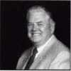

About the Chairman: James

Glazier, CML, #14240, is a retired police officer and operates Security Plus in Mount Airy, MD. He serves as ALOAs Northeast vice president. He also serves on the Finance, Convention and Griev­ance committees of the ALOA Board.

Upcoming ACE Classes

Keystone Chapter

January 10, 1998 King of Prussia, Penn.

[610] 272-9292 Contact: Barry K. Leas, CRL S&G Group II Certification Instructor: James H. Glazier CML

Fox Valley Chapter

February 7, 1998 Appleton, Wis.

(920) 731-5400 Contact: John F. Engel, CRL Investigative Locksmithing Instructor: Donald H. Shi/es, RL

International Security Conference and Exposition

March 22-2^, 1998 Las Vegas, Nev.

Contact: Customer Service (800) 840-5602 (203) 840-5602

Master Keying Methods and Formats Comprehensive Interchangeable Core Safe Lock Troubleshooting Access Control

Servicing Aluminum Storefront Doors Commercial Grade Locksets Mas-Hamilton Auditcon System 2100 Certification

S&G Electronic Safe Locks Introduction to Closed Circuit Television The Complete Door and Door Closers Exit Devices

Investigative Locksmithing

Master Locksmith Association of New Jersey

March 26-29, 1998 Somerset, NJ.

(908) 788-9696 Contact: Charles Green 3 Full Day Classes and Two Evening Seminars

January 1998 Keynotes \ 9

Applicants

For Membership

**ARIZONA**

Phoenix

027664, Richard P Dyer, A Sponsor: James Hawley 027635, Carlos A Matamoros, A

Tucson

027670, Joe Pielech, A Sponsor: Charles Robertson

**CALIFORNIA**

Pacifica

027628, David M Lowe, A Sponsor: Brian Lamb

Pomona

027646, Jaime R Lobos, AP Sponsor: Thomas Beller

**CONNECTICUT** New Britain

027640, Robert L Menard, AP Sponsor: David Mitchell

**FLORIDA**

Clearwater

027666, Watson L Shelia, A Sponsor: Grant Grein

Fern Park

027663, Allen J Spry, AP

Pinellas Park

027632, Bill Underwood, AP

Port Charlotte

027655, Michael Trentadue, A Sponsor: Robert Guariglia

Tallahassee

027656, Reginald L Davis, A Sponsor: Charles Hauck

**GEORGIA**

Atlanta

027662, Virl Mullins, A

Norcross

027651, Ronnie C Johnson, AP Sponsor: Michael Robinson

**ILLINOIS**

Elmhurst

027631, Karen Heathcott, AP 027629, Joe Kozak, AP 027630, Dave Mack, AP

**INDIANA** Ft Wayne

027658, Fern T Wigner, A Sponsor: James Hawley

Terre Haute

027667, Terry L Jeffers, A

Keynotes January 1998

Sponsor: Herbert Dusenberry

**KANSAS** White City

027672, Denver R Oliver, A Sponsor: Elvis Hammerschmidt

**LOUISIANA**

Minden

027647, Michael A Delano, AP Sponsor: Jerry DeLano

New Orleans

027649, William J Laughlin, AP 027650, John M O’Brien, AP

Waggaman

027654, Brian J Fontenot, AP Sponsor: James Portie

**MASSACHUSETTS**

Boston

027671, Heriberto Ruiz, A

**MARYLAND**

Laurel

027648, Charles A Williams, AP Sponsor: Ed Thomas

Ocean City

027626, William D Logwood, A

**MINNESOTA**

Minneapolis

027645, Paul J Svenold, A

**NORTH CAROLINA** Raleigh

027633, Thomas L Eatmon, A Sponsor: Granger Marley

**NEW MEXICO** Albuquerque

027641, Charles E Avent, A Sponsor: Cory Beach

Santa Fe

027652, Sally Thayer, AP

**NEVADA** Las Vegas

027643, Walter Beckett, A Sponsor: Eugene Altobella 027642, Steve A Lauricella, A Sponsor: Eugene Altobella

**OHIO**

Akron

027637, David S Powell, A Sponsor: Dave Powell

**OREGON**

Medford

027644, Gary W Stockfleth, A

*The following applicants are scheduled for clearance*

*^as members of ALOA The names are published for  
member review and comment prior to February 1, 1997,  
to ensure applicants meet standards of ALOAs Code of  
Ethics. Protests, if any, should be addressed to the Mem-  
bership Department and must be signed. Active Mem-  
bership applicants (A) have worked in the industry two  
or more years. Allied Membership (AL) applicants are  
not locksmiths, but work in a security-related field.  
Apprentice Membership (AP) applicants have worked in  
the industry less than two years. 1*

Sponsor: Don Sweet

PENNSYLVANIA

Beaver

027665, James E Minearo, A

Clifton Heights

027659, William G Knoell, A Sponsor: Harvey Sanet

Frazer

027668, Diana L Bayer, A Sponsor: Joseph Hedglin

Lehighton

027653, Ernest A Binder, AP

TENNESSEE

Knoxville

027625, Hobert C Banks, AL Sponsor: Marian Swann

TEXAS

Dallas

027639, Robert Rabel, AL

Fort Worth

027634, Dimmitt A Keith, AP Sponsor: Joe Preston

Lewisville

027638, Margaret T Cotten, AP

Tyler

025101, Christopher N Clark, A Sponsor: Ralph Warren

UTAH

Layton

027636, Ronald D Fuller, A Sponsor: Herbert Martin

VIRGINIA

Springfield

027669, James R Parker, A Sponsor: Edward Miller

Williamsburg

027657, Ray A Wingfield, AP Sponsor: James Loftus

WASHINGTON

Acb

027678, Joseph M Henderson, A

Sedro-Woolley

027677, Kenneth J Rosencrantz, A

Spokane

027675, Bryan A Mckeehan, A

WISCONSIN

Kenosha

027627, Paul F Dewester, AP Sponsor: Christopher Olson

CANADA

BRITISH COLUMBIA Nivane

027676, Alex C Dobie, A Sponsor: James Glazier

Surrey

027674, Micheal C Behreug, A

Vancouver

027679, Terry Sue, A Sponsor: James Glazier

ALOA SCHOLARSHIP FOUNDATION, INC.

ALOA/SAVTA SCHOLARSHIP APPLICATION  
3003 LIVE OAK ST., DALLAS TX 75204-6186  
(214) 827-1701

Please print or type

NAME PRP LEVELALOA/SAVTA # HOME ADDRESSCITYSTATE ZIP_

HOME PHONEDOBEDUCATIONAL LEVEL (YEARS) DEGREE, IF ANY

PRESENT EMPLOYERWORK PHONEFAX WORK ADDRESSCITYSTATE ZIP

POSITIONFULL TIME PART TIME_ TAKE HOME PAY

LENGTH OF TIME IN LOCKSMITHINGOWNER/SUPERVISOR’S FULL NAME MEMBERSHIP IN TRADE ASSOCIATIONS (LIST BY NAME)

MARITAL STATUSSPOUSE’S OCCUPATIONSPOUSE’S TAKE HOME PAY

COMBINED HOUSEHOLD ADJUSTED GROSS INCOMENUMBER OF DEPENDENTS

CLASSES DESIREDDATE OF CLASSES_____

ORGANIZATION SPONSORING CLASSES: ALOA SAVTA OTHERLOCATION

ALOA Scholarships are granted to selected individuals desirous of entering the locksmithing field or to selected individuals already in the locksmithing field who wish to improve their professional skills through education.

Applications for classes being taken locally must be received a minimum of 60 days prior to the date of the class, and will be reviewed as they are submitted. Scholarships for classes at the ALOA or SAVTA convention will be awarded each year at the ALOA Scholarship Foundation meeting preceding the convention and must be received by February 1.

Please attach to this form a letter stating your reasons for applying for a scholarship, what you plan to do with the knowledge you obtain and any other information you feel may be helpful to the committee in making its decision. A list of the names, addresses and phone numbers of three references who have personal knowledge of your background and character should also be attached to the form. It would be helpful to have at least one of these references be an ALOA or SAVTA member. PLEASE BE SURE TO CONTACT REFERENCES BEFORE SUBMITTING THEIR NAMES.

All scholarship recipients will be required to provide a 3 X 5 inch photograph of themselves and a copy of their last year’s tax return.

CERTIFICATION OF APPLICANT:

I CERTIFY THAT THE INFORMATION CONTAINED HEREIN, AND ALL SUPPLEMENTAL FORMS ARE COM­PLETE AND CORRECT TO THE BEST OF MY KNOWLEDGE. I FURTHER CERTIFY THAT IF I AM SELECT­ED AS A SCHOLARSHIP RECIPIENT I WILL USE THE KNOWLEDGE GAINED FOR THE IMPROVEMENT, DEVELOPMENT AND ADVANCEMENT OF THE LOCKSMITHING PROFESSION.

SignatureDate

5/96

APPLICATION AND FEES

A $40 application fee, appropriate annual dues, and your business card, company letterhead or suitable proof of employment must accompany this application.

ANNUAL DUES: ACTIVE/ALLIED MEMBER 598 APPRENTICE MEMBER 575

• Dues include $15 subscription to monthly magazine. Keynotes

NOTE: Your second year's dues will be prorated based on the date your application was received by ALOA.

Have you ever been convicted of a felony? Yes No

If yes, please give details on a separate sheet. All felonies are reported to the Membership Committee for review.

I certify that ail statements are true and if accepted as a member, I agree to abide by the rules, regulations, and Bylaws of ALOA and further agree to adopt the Code of Ethics of ALOA as my own and adhere to it to the best of my ability. Should yny membership be dis­continued, I agree to return my membership card and cease iise of all ALOA Insignia.

Signatur**e** r_ **-** . Dat**e .' ' - - „ -■ _ i.**

METHOD OF PAYMENT

* CHECK (Payable to ALOA in US funds)
* CREDIT CARD

□ American Express □ VISA □ MasterCard □ Discover Card Number Expiration Date

Please print name as appears on card

Cardholder Signature

FINAL CHECKLIST:

* $40 Application Fee
* $98 Active/Allied Membership dues □ Letterhead or Business
* $75 Apprentice Membership dues Card or Proof of
* $15.40 for Canadian Air Mail Employment
* $37.40 for Overseas Air Mail

TOTAL ENCLOSED $

Return to: Associated Locksmiths of America, Inc.

3003 Live Oak Street; Dallas, TX 75204 Phone: (214) 827-1701; FAX (214) 827-1810

|  |  |
| --- | --- |
|  | For office use only |
| Received $ | Number _ |
| AppL Fee | Dues DateRec'd. |
| Bv | DateApp'd. : |
| Apprentice transfer | Applicant listed |
|  | in Kevnotes : : |

Sold On

Key Envelopes

$30.00/1000 (Minimum order)

Let your customers know that you’re a cut above. When you"re a member of ALOA and/or certified, it inspires confidence in your proffessionalism.

ALOA

Keynotes Binders

$15.00

Jacket patches

$5.00 Large/$2.50 Small

Pressure Sensitive Decals

$3.00 914 x 714/$1.50 414 x 314

ALOA Pins

$5.00

PRP Designation Golf Shirts CRL, CPL, CML S, M, L, XL, XXL

$25.00

Certificate Pocket Plaques

-$1*00—

$10.00 while supplies last!

Resource Guide: Study Aids for the PRP

$18.00

Fundamentals of Master Keying

$44.00

Other Publications For Sale

The Complete Simplex Unican Manipulation Manual

$37.00

Locksmithing: From Apprentice to Master

$27.00

o request an order form for the above, or to order by phone using your credit card, call (214) 827-1701 or FAX (214) 827- 810. Whether ordering by phone or mail, please be sure to carefully specify quantity, size and designation.

note: prices are subject to an additional 8.25% sales tax for Texas orders and $20.00 additional postage for foriegn shipment (except Canada).

II prices include shipping.

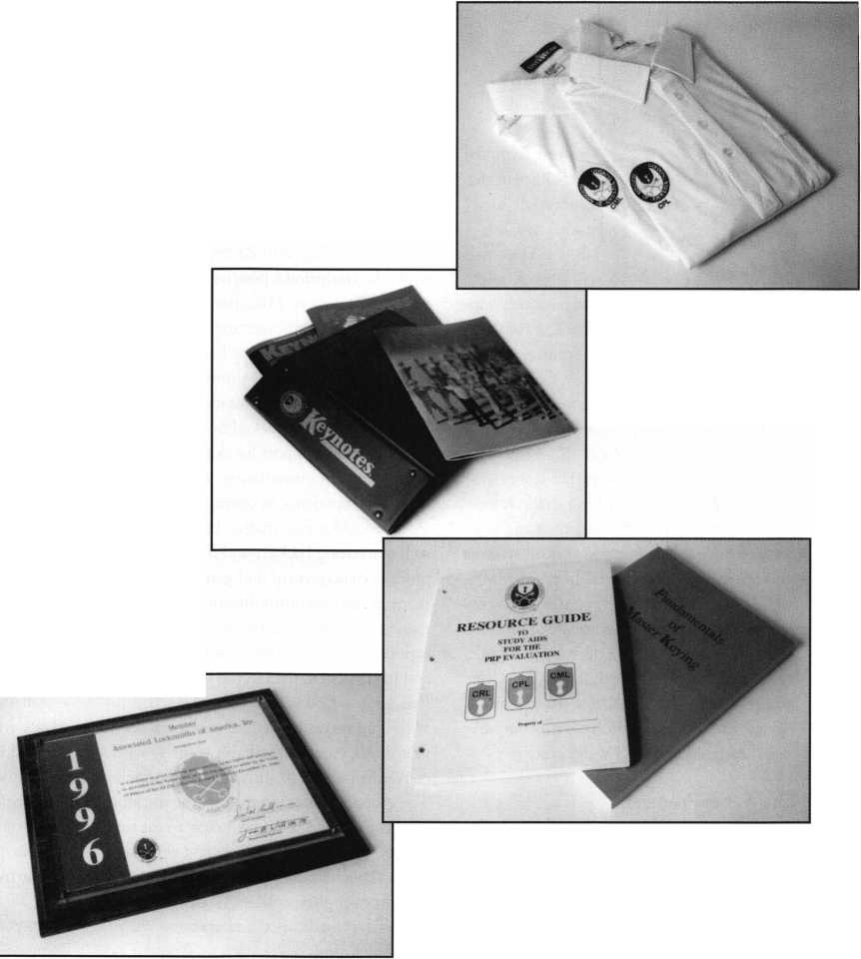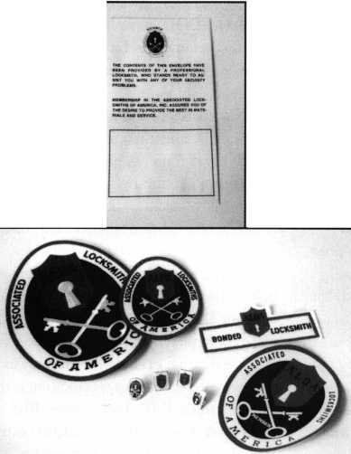

Industry

News



[Dept)

**Continental Hits Midwest**

Continental  
Instruments LLC  
announces the  
opening of its  
Midwest Regional  
Sales Office in the  
Minneapolis area,  
headed by Chris  
Jahnke. The office  
will provide sales  
and customer sup-

port for Continental’s line of access control  
access control and industrial security systems  
in Minn., Wis., Iowa, 111., Ind., Col., Utah,  
N.D., Neb. and Mich. Chris may be con-  
tacted in the Minneapolis office at (612)  
483-5611 or by fax at (612) 483-5789. This  
is one of five regional offices that Continen-  
tal Instruments is establishing to service its  
existing and future independent dealer base  
for its growing line of access control systems  
and accessories. Continental Instmments  
LLC, a 36-year-old pioneer in the access con-  
trol industry offers a broad range of products  
from its legendary single door Cypher Lock  
to its largest integrated security system, Car-  
dAccess 495, which utilizes a true 32 bit  
Windows 95 based platform with computer  
video badging and CCTV integration.

**Stop the Presses**

In an effort to keep customers informed of product introductions, engineering modifica­tions and successful applications, Pearpoint introduces The View. The four-page newslet­ter will be published quarterly. The first issue was mailed in early July to the entire Pear- point customer base as well as many poten­tial system buyers. Pearpoint is committed to serving as an educational conduit to the secu­rity industry. For additional information or to request a copy of The View, call Pearpoint’s sales group at (760) 343-7350 extension 222. The Pearpoint web site can be accessed at <http://www.pearpoint.com>. Pearpoint has been designing video systems for 15 years and provides video technology around the world.

Crypto Code

On June 2, 1997, the assets of MRL, Inc. were purchased by George Zachmann, who will manage the business and continue to manufacture and market Crypto Code and other security products under the revised name, Moniteq Research Laboratories, Inc. Carlton Moorefield Jr., MRL’s previous own­er will remain with the company for a few months, working with Zachmann to help make the transition a positive one for cus­tomers and dealers. MRL has been a leading supplier of electronics security systems and the U.S. government since 1969- The new ownership/management immediately embarked on a plan to provide new and improved products backed by a new, higher level of factory support for dealers before, during and after installation. Zachmann has extensive experience in operating technolo­gy-based industrial product businesses as well as a strong background in marketing, product management and general manage­ment in the telecommunications and instru­mentation industries. He plans to use his experience to aggressively grow Moniteq, and in particular, the Crypto Code product line. Crypto Code access control systems ful­fill requirements for central control of one to four doors, balancing reliable security with convenient access to authorized personnel. These stand-alone systems provide the abili­ty to control and record who has access to a facility, through which doors and at what times. They require no separate computers or power supplies, and can be easily installed, programmed and operated with­out special skills or equipment. Crypto Code systems are compatible with a full range of readers, including magnetic, proximity, Wiegland, bar code cards, token keys and biometric readers. Existing orders placed with MRL, Inc. will continue to be processed, delivered and invoiced at current pricing. Future orders and inquiries to Moniteq Research Laboratories can be placed using MRL’s existing address and tele­phone/fax numbers. For more information, contact Moniteq Research Laboratories, Inc., 7640 Fullerton Road, Springfield, Va.

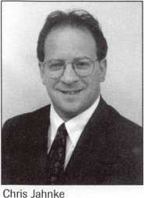

22153, (703) 569-0195 or (800) 989-9891- FAX (703) 569-0196.

Lockmasters Updates GSA Red Label Class

In 1993, Congress directed the Department of Defense (DOD) to replace combination locks on containers and spaces that protect classified information. The Navy was desig­nated as the technical agent for this project. The Navy develops and maintains data bases of lock replacement requirements, ensures availability of training, provides technical assistance, and publishes technical documen­tation. All mechanical combination locks on DOD-owned, General Services Administra­tion (GSA) approved security containers, vault doors, and Sensitive Compartmented Information Facilities (SCIF) that secure Secret or Top Secret material, must be replaced. Replacement locks must meet Fed­eral Specification FF-L-2740. The only lock that currently meets this specification is the Mas-Hamilton X-07. Lockmasters’ Red Label GSA class certifies its students on the Mas-Hamilton X-07 lock. Lockmasters has now updated this class to include a complete installation of the Lockmasters’ 5100 SCI- FLock with X-07, for Sensitive Compart­mented Information Facilities (SCIF). Each student will complete a SCIFLock installa­tion during the course. For a free copy of the 1998 course schedule or for enrollment infor­mation, please call Lockmasters Education Department at 1-800-654-0636. ext. 200.

Everyone’s Happy

Integrated Security Systems, Inc. and PSA Security Network, Inc. located in Denver, Colo., jointly announced today a sales and marketing agreement between PSA and Innovative Security Technologies, Inc. to reach rapidly growing markets. 1ST is a wholly-owned subsidiary of ISSI. The agree­ment provides for PSA to market ISSI’s Intelli-Site software program to integrate other security security products sold by PSA into a centralized single point of control sys­tem. The announcement was made at the opening of the American Society for Indus-

***Keynotes***

January 1998

trial Security 43rd annual Seminar and Exhibits. PSA, formed in 1974, is a mem­ber-owned cooperative of independent secu­rity and communications systems integra­tors and dealers, with over 114 member companies throughout the United States, Canada, Mexico, Latin America, and Eng­land, that design, install and service elec­tronic security systems and products. PSA members provide products from over 200 manufacturers, selecting the equipment that best meets a specific client’s needs. Annual end-user sales by PSA and its member orga­nization exceeded $800,000,000 in 1996. PSAs products and services are marketed by over 475 salesmen, supported by over 1,200 technicians, from over 175 office locations. ISSIs Intelli-Site is a real-time user-defined PC-based security systems integration soft­ware platform designed to allow users to select devices and subsystems, including those currently installed, from across the industry’s offerings and integrate them into a centralized point-of-control.

DORMA Spins New Website

The DORMA Group has announced the availability of a new Internet website. The site can be accessed at [www.dorma-usa.com](http://www.dorma-usa.com). The new website provides valuable reference information for the entire construction team. Items featured in the site include: a brief company history, product information on door controls, exit devices, postal specialties and DORMA Glass, complete Sweets brochures, which can be downloaded; litera­ture request forms to obtain additional prod­uct information; localized DORMA repre­sentative information; information on signif­icant DORMA projects, direct e-mail to DORMA by personnel name; and hypertext to other related industry sites. The DORMA group manufactures and markets a complete line of postal specialties under the American Device name. The DORMA Group is the U.S. arm of DORMA GmbH, the world’s largest manufacturer of door controls.

|  |  |
| --- | --- |
|  | Industry |
|  | News |

**LAB Flood Relief Donation**

Thanks to product donations from LAB, the Minnesota Chapter of ALOA was able to raise $ 1,200 for the Locksmith Flood Relief Fund. The items donated by LAB were auc­tioned at silent auction at one of the chap­ter’s regular monthly meetings.

Other donors to the relief fund were rec­ognized on p. 60 of the October 1997 issue of Keynotes.

**Dorma/DHI Scholarships**

For the second year, the DORMA Group has supported the Door and Hardware Insti­tute’s (DHI) scholarship program. Eight scholarships were awarded this year, with recipients anonymously selected by a DHI- appointed panel of architectural hardware industry peers.

The DORMA Group manufactures and markets a complete line of door controls and exit devices.

**Hong Kong Show Success**

Almost 6,000 visitors showed up for Hong Kong’s first hardware product show last fall. The Hong Kong International Hardware Show was organized by the Hong Kong Development Council to strengthen the ter­ritory's position as a sourcing center for hardware products in Asia.

There were 173 exhibitors on hand to showcase their products. The president of Special Rivets Corp. said, “It’s great to make so many new contacts. Buyers from Central and South American countries such as Brazil and Panama have already placed orders, as have Israel, Lebanon and the Netherlands.”

More than 30 percent of visitors to the show were from outside Hong Kong. The next Hong Kong show is scheduled for Oct. 29-31, 1998. For more information, contact the Hong Kong Trade Developmental Council at (212) 838-8688; fax (212) 838- 8941; e-mail [nytdc@mailserver.tdc.org.hk](mailto:nytdc@mailserver.tdc.org.hk)

Executive News

**Welcome Ott**

Willard B. Ott III has been appointed busi­ness development manager at the Schlage Commercial Lock Division of Ingersoll- Rand Architectural Hardware Group, it was announced by Charles V. Havill, vice presi­dent and general manager of the division. In his new position, Ott will be responsible for distribution channel strategy, competitor analysis, pricing policy and new product launches.

**Hail to the Chief**

TESA Industry Systems has announced the appointment of Robert Aquilno to the posi­tion of president of TESA Worldwide. Aquilno’s role will include directing the efforts of the company on a global basis. His background includes 16 years at PepsiCo in both domestic and international assign­ments. Recently, as vice-president of Busi­ness Development for Frito Lay, he was responsible for domestic and international market expansion. Already established in over 100 countries, TESA is expected to fur­ther strengthen its position globally. The company’s line of electronic locking systems and access control products have allowed it to achieve a strong position in the hospitali­ty industry. TESA is part of Williams, the second largest security provider in the world. Other Williams companies include Kidde Fire Protection, Corbin Russwin,

Yale Security, Folger Adams and Chubb Security.

**New Sheriff in Town**

Thomas J. Riordan adds the title of corpo­rate officer to his current position as presi­dent of SPX Corporation’s OE Tool and Equipment Group. He joined the company in 1996 from Consolidated Sawmill Machinery International Inc., Portland Ore.where he was president. Prior to that, he was vice-president of Manufacturing at IVEX Corporation. Riordan also held posi­tions with J.L. Case in North America and Europe, and with Borg-Warner Automotive.

January 1998

Keynotes



Chicago Lock

Chicago Lock Company introduced four new service kits containing the necessary fac­tory-quality parts for almost any cabinet lock job. They are: ACE® Tumbler, ACE® Locking Cams, Single Bitted Locks, and Double Bitted Locks. Also introduced from Chicago Lock is a new tamper-evident key ring for the purpose of “protecting” impor­tant keys. Called “KeyLOC,” it is a unique, new security system that assures account­ability for keys. For a free copy of their lock­smith catalog, call:

Chicago Lock Company (800)445-3204.

Reader Service **#2**

Norton

Norton® Door Closers expanded its Security Closer offering to include a new shallow depth track mount. This application keeps the closer arm concealed and out of harms way. The movable stop mechanism makes installation easier and field changes less cumbersome. In addition, a variation of that track is being offered on the heavy duty 7700/7500 surface closers. It offers a fully adjustable stop and hold open for any degree of door opening. Available for mounting on the push or pull side of the door, track closers eliminate unsightly arm projections and their potential vandalism. Norton® has also modified the slide mechanism in the 7900 Series Overhead Concealed Closer. **Norton®—Division of Yale Security PO Box 25288 Charlotte, NC 28229 (800) 457-5670 (704) 289-8401 fax Reader Service #3**

Ingersoll-Rand

A brochure presents features of the Von Duprin LP9247 Low Profile Exit Device. The device installs inside a maximum open­ing clearance by protruding only 1 3/8” from the face of the door. The brochure describes mounting styles available, includ­ing standard top and bottom concealed ver­tical rod with LBR (less bottom rod) option.

14 Y KeynotesJanuary 1998

Available in three-foot or four foot widths, the UL-listed device is intended primarily for cross-corridor fire applications. Copies of the brochure may be obtained from:

Von Duprin Division,

PO Box 6023 Indianapolis, IN 46206 Reader Service #4

Corbin Russwin

The DC46900 Safeguard electromechanical closer has incorporated a full feature closer as part of the standard Safegard™ product. Backcheck and a full metal cover are just some of the new “basics.” Also available is the 26900 electromechanical closer with a free swing arm application. The model DC26940 is to be used in patient room installations or any areas where a closing device is needed in fire/life safety locations. In addition, Corbin Russwin has added a new dead stop arm with a built in shock absorber to the heavy duty DC2000 series closers. Designed for use in high traffic, potentially abusive installations, this arm can extend to the life of exterior doors. For more information, contact **Corbin Russwin®**

(800) 461-3007 (905) 672-9022fax

Reader Service **#5**

NT Falcon Lock

Strength, security and simple through bolt­ed mounting are benefits of NT Falcon Lock’s new B Series Grade 2 key-in-lever locksets. The B series product is NT Falcon Lock’s first cylindrical key-in-lever lockset for Grade 2 applications and is designed to exceed the new ANSI A156.2-1996 stan­dard for bored locks and latches, including all strength and operational requirements. For more information, on the NT Falcon B Series Grade 2 key-in lockset, or the full line of NT Falcon locks, contact:

Don Johnson, National Sales Manager,

NT Falcon hock, 2650 Orbiter Street,

Brea, Calif, 92821-6265 (800) 266-4456 (800) 777-8229 fax

tvww.NewmanTonks.com.

Reader Service **#6**

DoorKing

DoorKing, Inc. announced that their PC programmable series of access control sys­tems, model 1815 and model 1817, can control up to eight doors or gates in addition to the main entry door or gate, and the mod­el 1818 access control system can now be expanded to control up to 16 doors or gates. These access control systems keep a detailed report of transaction activity at each individ­ual entry point allowing customized transac­tion reports from PCs. DoorKing was estab­lished in 1948 and is a leading manufacturer of access control products. For information, call:

DoorKing Sales Department (800) 826-7493.

Reader Service **#7**

ADI

ADI reports that despite the virtual freeze on moving products, some extradordinary measures translated into “business as usual” for ADI customers. True to their motto,

“The Service People,” ADI made contin­gency plans in anticipation of the threatened strike. In addition to substantially increasing inventory levels prior to the strike ADI’s sales team rented trucks, packed them up and made personal deliveries (even to the most remote areas) to guarantee that cus­tomers would get their products on time. Throughout the strike, the products kept flowing and ADI’s 98 branches remained stocked. For the ADI location nearest you, please call:

(800) 233-6261.

Reader Service #8

Control Concepts

Control Concepts/Liebert® has begin mar­keting a new line of telephone, data, and sig­nal line transient voltage surge suppression products. Combined there are over 40 prod­ucts that can be utilized in more than 30 different applications. These applications range from industrial controls and PLCs to



|  |  |
| --- | --- |
|  | Security |
|  | Marketplace |

coaxial and category 5 LAN protection, as well as data/signal and voice telephone surge suppression devices. These new products are available through all Liebert representatives. Also, a new catalog of these products is available by calling:

***(888) 49SURGE*** Reader Service#9

Sisco

Revealing the first line of retail products to carry the Brinks Home Security™ brand name, Sisco announced it is introducing 11 models of Brinks brand fire safes at the National Hardware Show in August. The new models include two modest-sized fire­rated safes using plastic shell construction and, at the top of the line, a floor-standing steel safe providing two-hour protection of papers from fires as hot as 1700 degrees. Officials for Sisco, a leading manufacturer of anti-theft and fire safes for 10 years, said the new models; suggested retail prices range from $34.99 to $1795.00 **Sisco**

1062 E. Del Amo Blvd.

***Carson, CA*** Reader Service#10

Continental Instruments LLC

Continental Instruments LLC announces the introduction of a new line of rugged mag stripe readers with architectural finishes. A cast stainless steel housing, coupled with a new and innovative mounting design, pro­vides the underlying strength and durability in the harhsest environment and offers pro­tection against serious vandalism. Distinc­tive architectural finishes include matte black, high gloss polished stainless steel, brushed stainless steel, off-whole matte, gray matter, and bright brass. For more informa­tion, contact Stan Wand at:

(516)254-0044

Reader Service #11

GBC

GBC introduces the CW-530. An ultra­miniature, ceiling/wall camera, so small it can fit in the palm of your hand. The GBC

CW-350 is smallest, most stylish, lowest profile ceiling wall camera on the market! Measuring only 2 1/4 “ W x 1 3/4” H x 3 1/4 “ L and weighing less than two ounces, this discreet camera is designed to replace bulky, hard-to-mount ceiling cameras. The unique design of the CW-350 allows it to be mounted easily on ceilings or walls. Its miniature size inconspicuously blends into any decor.

CCTV Corp.

280 Huyler Street South Hackensack, NJ 07606 (201) 489-9595 (800) 221-2240 (201) 489-0111 fax ***Reader Service #12***

Merritt Publishing

Merritt Publishig celebrates ASIS’s 43rd year by leading the industry to a new level of technical sophistication with SecureNet - Protection of Assets on CD-ROM.

SecureNet is the only one-source, interactive tool that lets security professionals find the answers to any security issue. Based on the internationally-acclaimed Protection of Assets Manual, this comprehensive, high speed resource represents the cutting edge in technology and security management. SecureNet enables security professionals to expand their expertise in their field, empow­ering them the identify, analyze and research all security topics. It is the only interactive information reference available that cuts through the industry and legal jargon and offers applicable illustrations of problems— with practical solutions.

Merritt Publishing 401 Wilshire Blvd. Suite 800 Santa Monica, CA 90401-1430 ***Reader Service* #*1*3**

Checkmate® Redesign

Rixson-Firemark s Checkmate® stop and holder line has been enhanced. New finish­ing processes, stainless steel base metal offer­ing and multi-function kits for standard duty units are just a few of the new features of this industry standard product.

Rixson-Firemark PO Box 25288 Charlotte, NC 28229 (800) 457-5670 (704) 289-8401 fax ***Reader Service #14***

New Lenox Industries, Inc.

A new concept in automotive child restraint was unveiled at the 1997 Juvenile Products Association Show in Dallas this past Sep­tember. Developed by New Lenox Indus­tries, the TattleTale, both protects the infant and speaks to the parent if the child is improperly positioned in the seat, or has moved into an unsafe position during travel. The built-in intelligence acts as a “Surrogate Voice” for the infant telling the parent the seat is properly installed and the child is safely harnessesd by announcing “Child Secure”. This tells the parent all aspects of the unique, state-of-the-art New Lenox design are being used as intended.

New Lenox, Industries, Inc.

20359 East Pennsylvania Avenue. Ste. E

Dunnellon, FLA 34432

(904) 489-7354

(904) 489-5074 fax

Reader Service #15

Nadtec

A recent Australian invention was designed with the residential home and garage bur­glar in mind. The Nadtec Multi-Function Security Lock has no exposed bolts or pad­lock shackle to be tampered with and can be fitted to most types of doors including roller doors, tilta-doors, sliding doors and swing­ing doors. The unit is portable and can be used on the inside or outside of any door.

For more information Nadtec

(02) 9664-2626

Reader Service #16

January 1998

*Keynotes* in

16

Keynotes



Why bother to join a trade of professional association? After all, association member­ship usually involves a commitment of time and money, and with so many other obliga­tions pressing in on your busy life, is one more commitment really worth it? In case you’ve forgotten what association membership is all about—or in case you nev­er really knew—browse through these 25 reasons for becoming involved. If you’re already convinced of your association’s value, don’t turn the page. Clip it. And pass it along to a friend or acquaintance who might benefit from membership. All right then. Why should you join an

association?

By Richard Ensman

Advocacy

An association represents your interests before the busi­ness community and government. And if your business or industry faces major threats, your association is right there fighting for you. (As you will see by turning to page 44, ALOA is dead serious about legislation these days. Our new legislative manager—along with key members of ALOA leadership and industry—will see that you have a voice in government.)

Benefits

Many associations offer a variety of tangible benefits to members. (ALOA members enjoy purchasing discounts, member discounts to the ALOA Security Expo, member discounts to ACE classes, a monthly magazine, a web page ..and much more.)

Convenience

When you’re facing a problem, isn’t it great to be able to shop for a variety of solutions under one roof? An associa­tion is a “one-stop” center for advice, contacts, inspira­tion and suggestions on a wide range of topics.

Data

Just this spring ALOA conducted a membership opinion survey to let both its members and its leadership know what locksmiths are thinking about membership and about the industry.

Economy

Don’t reinvent the wheel when it comes time to save money, consolidate an operation or enhance efficiency.

Tell your association what you’re trying to do —and your association can tell you how your peers have already done it! (Every month, Keynotes authors share their expe­rience through “Trade Tips,” product reviews and “how to” feature articles.)

Friendship

Your association’s members are people who have many of the same concerns, needs and interests as you. They’re the kind of people you’ll enjoy meeting. And they’re the kind of people who will probably end up as your friends.

Give-and-Take

An association provides members with the opportunity to discuss their mutual problems...probe new direc­tions...share and criticize each other’s thoughts...all with a high degree of respect and candor.

Happenings

Associations sponsor a variety of enriching events and

January 1998

Assoc aton?

activities: conferences, receptions, luncheons, forums, parties...and more. (Don’t forget to mark your calendar for the big 1998 event— the ALOA Security Expo in Nashville, Tenn., June 14—20.)

Ideas

One of the most valuable benefits of association membership is the opportunity to “listen in” on the creativity of peers. Associations are like rich farm soil; once fertilized with the participation of members, bold new ideas sprout up everywhere.

Journals

Associations are known for their expert publications: journals chock full of news, trend information, research and commentary, all avail­able to you at your fingertips.

Know-How

Got a problem? Need technical advice? Help with a thorny accounting issue? Your association is as near as the telephone. And if you need more detailed information, your association can put you in touch with one or more individuals who have the “know-how” you need.

Leadership

Your business or trade needs leaders—people who can actively mobi­lize you and your peers toward industry-wide action, and who can chart your industry’s future. An association produces voluntary lead­ership that can make a difference.

Management

An association is the most cost-effective vehicle for managing indus­try-wide concerns and activities. More important, an association fre­quently provides in-depth management assistance and support to members.

Networking

“Networking” is today’s buzzword. Association events, meetings, and information exchanges make networking a reality for you and your peers.

Observation

An association is much like a telescope: it gives its members the opportunity to survey the national scene. And it’s like a microscope: an association gives its members the chance to probe importance industry and economic issues with great precision.

Profit

Face it, you’re in business to make a profit. Your ability to generate profit is your association’s primary concern, and the association’s pro­grams are ultimately geared to help you survive and prosper.

Quality

In this quality-conscious age, the degree to which you’re able to sus­tain high standards of product quality and customer service will strongly influence your ability to grow. An association provides you

L

with examples of firms “doing things right,” and gives you the chance to learn from them.

Recommendations

Trying to solve a thorny problem? Trying to set the stage for a new project? Your association can often point you in the direction of solu­tions and strategies.

Seminars

One of the greatest pleasures of association membership in annual or bi-annual seminars—thought provoking educational sessions led by successful peers as well as regionally and nationally-recognized busi­ness experts.

Travel

Whether it’s strictly for business and educational purposes, or for combination business and pleasure, association membership offers you and your family the opportunity to attend association events held at memorable destinations across North America.

Unity

You’re never alone when you join an association. Membership gives you and your peers the opportunity to speak with a single voice on matters of importance to your industry.

Vision

A wise sage once said that the characteristic of a true leader is the ability to mobilize toward the future. An association helps you visu­alize the opportunities that lay ahead—and find the tools necessary to turn those opportunities into sound business plans.

Warnings

Bad news on the economic horizon? The regulatory front? In the courts? Associations serve as “early warning systems” for their mem­bers and help ward off potential industry-wide problems.

Youth

An increasing number of associations provide a variety of educational materials and public service programs to educate youth about the workings of their industries. Today’s youth will become the leaders of your industry in the years ahead; your association membership helps bring this leadership to fruition.

Zest

There’s something special about celebrating your successes and tri­umphs with like-minded people, of achieving recognition for the good work you’ve done, and of feeling the tremendous satisfaction true accomplishment. These are the true rewards of your business. Your association helps you make the most of them.

About the Author: Richard Ensman is a freelance writer based in Rochester; New York.

January 1998 Keynotes ill

Board News

Business

Not As Usual

The 1997 Fall ALOA Board

The final ALOA board of directors assembly for 1997 was a groundbreaking departure from business as usual. The result? A contemporary governance policy that structures the association to be more volunteer controlled and to let day-to-day operations be conducted more effi­ciently The goal is to have a leaner more responsive asso­ciation that can serve members in a way that matters.

History

In the past, ALOA leadership conducted two main meet­ings each year—in the spring and in the fall—each for a full week. During the week the board would break out into 18 committees made up of about 30 officers, direc­tors, members-at-large and trustees. Each of these com­mittees would then confer for either full-day or half-day sessions. It was the minutes from these sessions that were consequently published in Keynotes. The committees would largely review existing projects and specific tasks performed by the ALOA staff in the months immediate­ly past, then give some input on how those tasks and projects would or might be administered during the next several months. At the end of the week, the board would gather as a whole and review the same information in the larger group. Additional discussion could then take place on narrow issues, but the structure didn’t lend itself well to long-term policy determination and goal setting. The result was that often a significant amount of volunteer time and association funds were expended on routine bureaucracy with relatively little time spent planning for

future issues of greater consequence.

“It had become clear to many of us that the board’s traditional methods of leadership weren’t up to the chal­lenges faced by our association and our industry today,” says ALOA President Dallas Brooks. “The important questions weren’t even being asked, much less answered, much less integrated into usable ALOA policy. We need to know why ALOA exists—what our members need to get out of membership. We need to focus on the ends, not the means. For example, it seems really crazy looking back that a board meeting could take place during the onset of a crisis legislative period and ... we’re debating things like whether or not to polybag the magazine or sell jewelry at the ALOA booth. It’s certainly time we set some realistic priorities. And it’s time for us have a rule book that everyone follows.”

The Rule Book

Rules and referees go hand in hand. For its referee the ALOA board contracted with an association management consultant, Miriam Carver, co-author of several books such as Reinventing Your Board and conductor of such workshops as “Governance Isn't Ceremonial—It's a RealJob Requiring Real Skills. ” The week of fall committee meet­ings was replaced with two-and-one-half days spent in intensive training with Carver. At the end of that time, the ALOA board emerged with two crucial tools: a gov­ernance document and a new attitude about ALOA lead­ership.



***Keynotes***

January 1998

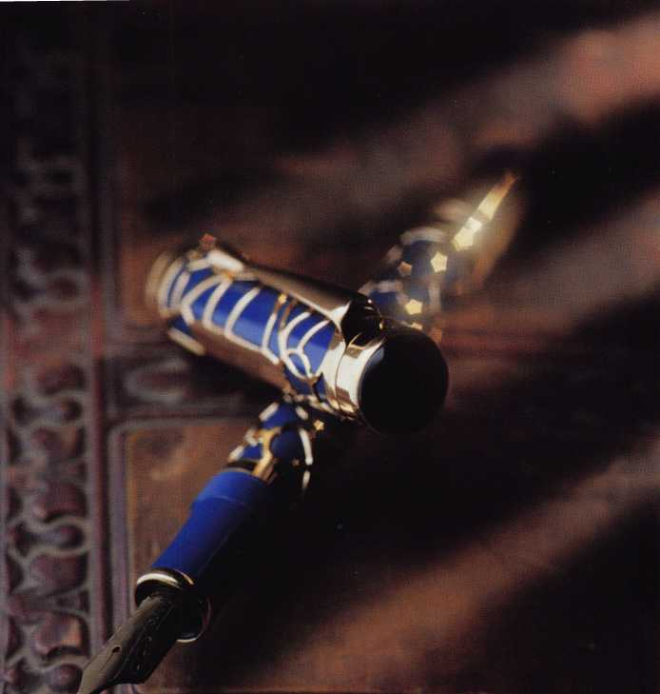

}f Directors Meeting

What the Ref Says

“I think that the members of your trade asso­ciation should be really very well informed that this board has undertaken a radical change—it really is a very big difference— and they have done this because they think that it will make the association more useful to the members,” says Carver.

What exactly is the big difference? A great deal, it seems.

“The staff will be working under very overt and clearly stated specifications that did not exist,” Carver explains.” This puts the board in much greater control than it was before. What happens when you have a board that does not set these specifications is that a bit of a vacuum develops that often gets filled by individual committee members or staff. That’s a really poor system for getting an accountable organization.

“Also, the specifications that the board

is going to be setting will have much more to do with what the members should get from the organization than how members should get it. The thinking is that if the board can make it clear enough what it is that is supposed to be made available to members, then how it gets made available is really a secondary question that can be left to staff. So this focus means that the board is going to be speaking on behalf of members saying ‘If you belong to this asso­ciation and pay your dues, this is what you will get out of it.’

Carver went on to explain more about how the ALOA board is now going to be focusing on those ‘ends’—the equivalent of ‘products’ for members. “This is so that members can be very clear about what they can expect from the association,” she emphasized. “And the board can make sure that they get it. That is the biggest service

that a board can provide on behalf of its membership.”

According to this consultant, it is these ‘ends’ issues that often slip by the wayside for boards that have conventional gover­nance. The part that usually gets turned over to staff is the biggest question of all: ‘What should the members get?’

Was Our Board Any Different?

The up-to-now organization of the ALOA board isn’t unusual among the associations Carver has worked with. “It’s very, very typi­cal. It’s a structure that if it works, it works actually in spite of itself. It’s a very hit-and- miss structure that does not produce accountability. The staff has no idea what responsibilities they have, what responsibili­ties they don’t have. And it is absolutely wide open to partisan politics—and I mean ‘small’ politics—within the organization and the members deserve more than that. If you have a traditional ineffective structure, it’s very easy for the association to be run by the most powerful, the most ‘loud,’ mem­bers or board members as if it were their own toy instead of being there on behalf of the full membership. Even if those strong personalities are very well intentioned, as quite often they are, they are exercising authority that is not legitimate authority. Legitimate authority comes from the board, not from a handful of board members or anybody else,” she explains.

No More Easy Answers

Will the work of the board as a unified body be simple, perhaps even easier? Not really.

“The work of deciding the ‘ends’ of the organization will involve setting priorities among conflicting needs. It would be nice if you could do everything for everyone but that’s not likely to be the case. Someone has to decide.” Carver says that ‘someone’ should be the association board.

What kind of feedback has Carver received from organizations who have adopt­ed this update mode of governance?

“The clarity is very much appreciated at all levels of the organization—that much greater clarity about what the organization is for—which allows more realistic judgments to be made. What I’ve also heard is that the

January 1998Keynotes \ 19



board—because it focuses so much on its need to represent the views of the mem­bers—finds it also has a more thorough con­tact with the members. There will be a much more organized and structured way to get input from the members, and members feel much more consulted. Those are very, very important changes.”

How does that board make sure it sticks to the new methods, not reverting to habit? “The board can self-correct simply by refer­ring back to the rules that it set,” she advises. “Ask, ‘Now what did we say we were going to do? Does this look like were doing it?’

The policies must be kept absolutely up-to- date, because that is the reference point. As long as the board keeps checking its behavior against what it said its behavior would be, then it’s going to be able to stay on track.” Carver adds in conclusion, “The ALOA board was a great group. They asked prob­ing questions and really struggled with some of the issues. There was a lot of laugh­ter and enthusiasm. And they did a lot of good work.”

Where We Are Now

The ALOA governance process policy is functional at this point as well the policies about how the board will delegate to the chief executive and the executive limitations policies. Those policies are in place in as much as they don’t appear to conflict with existing association bylaws. (Any adjust­ments deemed necessary to the bylaws will be set forth for membership.) The ‘ends’ poli­cies have just begun formulation—there’s much more work to be done.

President Brooks says, “In a way, I imag­ine this is what it was like when our found­ing members first met to form ALOA. All the programs and projects that we have in place four decades later originally came from their first questions—‘What should ALOA be? What should it do for its members?’ Not one thing about ALOA should continue to exist if it doesn’t support that original intent. I agreed with Miriam Carver when she said to us, ‘If you can keep the board’s eyes firmly fixed on the purpose of the organization, then the rest of it kind of takes care of itself.’

This is a very exciting time. We’re pio­neers again.”

*Motions*

*Some committees did meet after the training  
session to wrap up unfinished business. The  
resulting motions were as follows:*

Adoption of Governance Policy  
The Bylaws Committee brought a  
motion, which carried, to adopt the  
policy governance model except such  
portions such as may be in conflict

L fi with present bylaws, to be effective  
I / Jan. 1, 1998.

*Election of Directors*

President Brooks reported a letter of resignation for ALOA Director William Straub and it is accepted.

In addition, officers Raymond Lusk and James Glazier resigned from their additional positions as directors.

A motion carried to elect A.J. Hoffman, Donald Rule and Clyde Roberson to serve as directors through the 1998 ALOA convention.

*Election of the Nominating Committee*

The following were elected to serve on the Nominating

Committee: John Greenan; Jeff Nunberg; John Shandy;

Ray Lusk; and Steve Engel.

*1998 Budget*

The Finance Committee brought a motion, which carried, to accept the 1998 budget as presented.

*Retired Member Dues*

The Membership Committee brought a motion, which car­ried, to reduce the current cost of membership for retired persons from $75 to $40.

ACE Credit for Lockmasters Classes The Education Committee brought a motion, which car­ried, to credit students at Lockmasters classes—where an ACE certified instructor is used—with one AEU for each eight-hour class day.

*Member Expulsions*

The Grievance Committee brought a report to the Board and Executive Session was held. The results were that the following members were expelled: Robert D. Hale; Jeffrey McGee; and Salvatore Cuccia.

Keynotes

January 1998

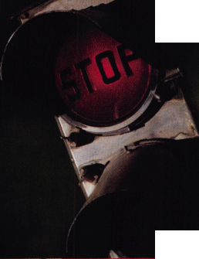

***To Boldly Go Where l\lo Key Has Gone Before***

***PATENTED Reversible Key and Blank with Unique Floating Insert***

***PATENTED “Sphrerotation****99* ***ribbed cylinder plug,***

***PATENTED combined telescopic pin tumblers*.**

***Superior Tamper Resistance*•**

**\* *Call now 1-800 MULTLOCK***

***Mul-T-Lock USA Inc. 300-1 Route 17 South, Suite A, Lodi, N.J. 07644 * Tel: 201-778-3222 • 1-800-MULTLOCK • Fax: 201-778-4007***

Reader Service **#17**

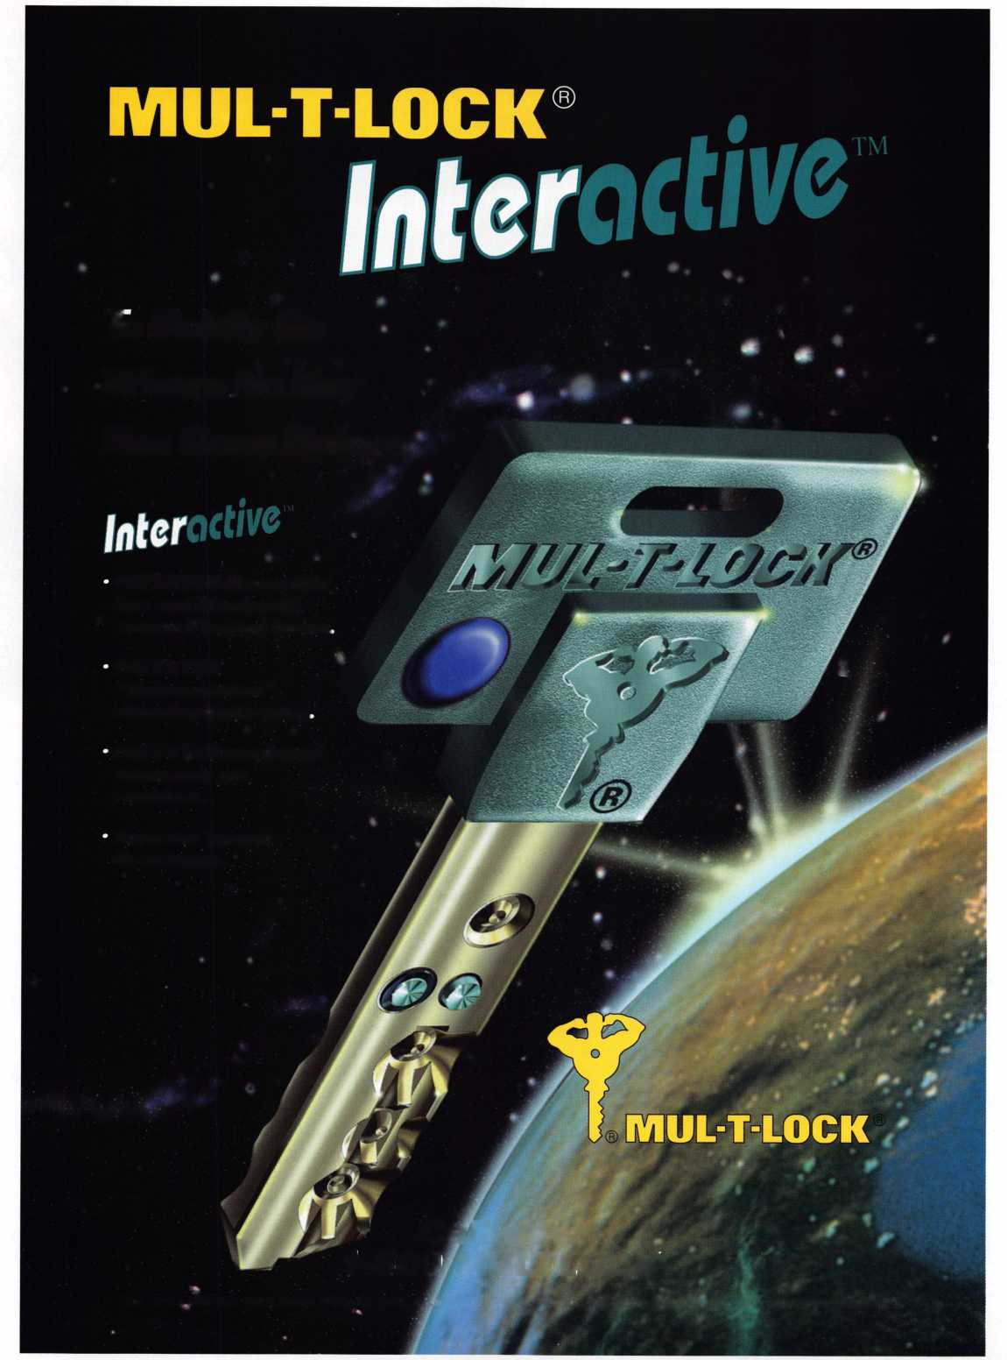

**Product Specifications**

Power Voltage Sensing Angle Trigger Response Battery Life

**Two AA batteries 2.2 to 3.3 volts dc 40° to 80°**

**.05 seconds Up to one year**

Titan’s Nighsight

**Product installation by Julie Robinson, RL**

One of Titan’s most recent residential consumer offerings is a motion-acti- vated keyway deadbolt. Nightsight (Deadbolt Model 864) incorporates pho- tocell technology to provide a lighted keyway on the exterior of the doorway when motion is detected within a three-to-five foot range of the lock. (The system defaults to “sleep” mode during daylight.) The keyway shuts off four to eight seconds after motion has stopped.

The new product also includes a LockMinder feature—an indicator light on the interior side of the door that indicates whether the bolt has been engaged. Following is coverage of a product installation.

**Deadbolt**

Installation

We installed this Titan Nighsight deadbolt on the front door of a new home under constmction. Our door and jamb had already been prepared. It was unfortunate that the jamb had been prepared for a lower security strike than comes standard with the Nightsight. That left us with the uncomfortable choice between cosmetic appearance and security. If your door and jamb are being prepared in advance seperately from the installation, be sure they understand what kind of strike you’re going to use. (The product comes with a template on how to prepare the door and jamb.) The only tools we needed were flatblade and cross-recess screwdrivers, although using long-nosed pliers are helpful when connecting wires to the module.

One Insert the latch assembly through the hole in the edge of the door. Be sure that the assembly is facing in the proper direction by observing the “UP” markings stamped on the latch.

Two Secure the latch assembly in the door edge with the mounting screws provided.

Three Assemble the exterior (key operated) deadbolt components—cylinder assembly, cylinder guard cover, cylinder guard and adapter. (Note: the adapter can be reversed to accommodate either all/2 inch or 2 1/8 inch mounting hole.)

22 I ***Keynotes***

January 1998

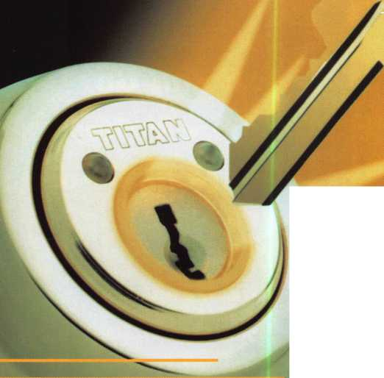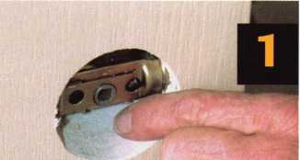

*rm*

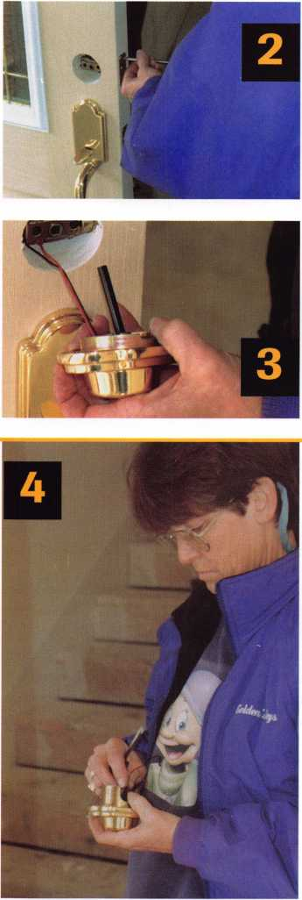

Four Make sure that the black and red wires protrude through the center of the adapter plate.

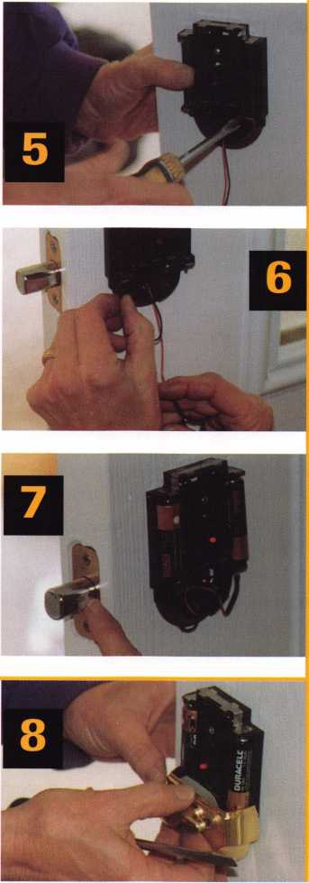

Five Hold the assembled components of the exterior lock together and insert the cylinder torque blade through the opening in the cen­ter of the latch assembly. (Position the cylin­der with the “TITAN” logo face up.)

Six Secure the battery module on the interi­or side of the door to the exterior cylinder on the other side of the door. Hold the flat area face up and fasten with the two black mount­ing screws provided. (Prior to tightening the mounting screws, make sure that the flat top module surface is level and that the wires are routed through the small square opening at the bottom of the battery module.)

Seven Connect the spade terminals to the terminals on the battery module (note the black and red wire codes, of course).

Eight Install the batteries and check the operation before finishing. (Unless you are doing your installation in the dead of night, you will need to cup your hands over the deadbolt to prevent light from reaching the sensor lens for about 45 seconds to see if it will light up properly. And don’t forget to check the interior LED light to see if it acti­vates when the bolt is engaged.)

Nine Attach the turn piece to the battery module using the screws provided. Don’t screw down too tight. This part is plastic and you do not want to crack it. (It would be wise of the manufacturer to consider making this part metallic in keeping with the higher quality of the rest of the product.) The turn piece must be in a vertical position—latch bolt extended—to gain access to the screw holes. Make sure the excess wires clear the screw holes and shaft before tightening the screws. Make sure also that the wires are not pinched.

Troubleshooting

If you reach step eight and the LED interior light remains “on” in the unlocked position, the bottom interior housing needs adjusting. In that case:

* Set the deadbolt in the LOCK position, bolt extended;
* Loosen the two screws on the bottem inte­rior housing slightly;

Set the deadbolt in the UNLOCK posi­tion, bolt retracted;

* Adjust the bottom housing until the LED light goes off;
* Set the deadbolt back in the LOCK posi­tion and fasten the bottom housing screws.

(Note: Don’t be lulled into a false sense of security. Be sure that the deadbolt is fully thrown as the LED light can often be activat­ed at the slightest turn of the latch.)

For more information about this product, contact your local distributor or write Titan at: Kwikset Corporation; 1 Park Plaza, Suite 100; Irvine, CA 92714.

About the Author: Julie Robinson is an RL at Gold­en’s Casa Linda Keys in Dallas, Texas

January 1998

Keynotes



THE ABC'S OF CCIV

BY PAUL F. [HANDIER, CRL

S I G

M

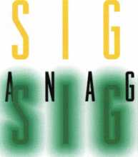

I:

n its simplest form, a CCTV system  
would be comprised of a number of

fixed cameras connected by coaxial cable to  
an equal number of monitors. The scene  
from each camera would be displayed on  
it’s own dedicated monitor. Sometimes  
simple is best. But sometimes simple just

isn’t enough.

There is a variety of equipment on the market that  
allows the signals from two or more cameras to be  
viewed on a single monitor and to be recorded on a sin-  
gle VCR. The way you choose to do this is called signal  
management. Before you can determine the best way to  
manage your camera signals, however, you must be clear  
as to the purpose of your CCTV system.

CCTV can be effectively used for observation,  
preservation, identification and/or prevention.

Observation, or surveillance, means that someone is  
going to use electronic means to watch closely the actions  
of other persons.

Preservation implies that a permanent record of the activity  
in a specific area will be made for future reference.

Identification is a more specific form of observation

N A L

N A L

N T

or preservation, with the focus on recognition of an individual or object.

Prevention results from the deterrent value that occurs when persons know that they are being watched electron­ically and change their behavior accordingly.

Knowing which purpose, or purposes you are trying to achieve determines the equipment necessary. For exam­ple, observation can be accomplished with just a monitor but preservation requires some form of video recorder. By the same token, with a single camera equipped with a wide angle lens, you might be able to determine that someone is shoplifting. But, with only that single camera you probably would not be able to positively identify who the shoplifter is.

Another consideration in selecting proper signal man­agement equipment is the types of activity you need to be able to observe and/or record. A single camera on a dedicated monitor presents the scene in “real-time.” What that means is, if you watch the scene continuously you will see everything that happens, as it happens. This is not the case with some signal management systems.

For example, consider the video switcher. A switcher takes the signal from two or more cameras and displays



24

***Keynotes***

January 1998



them, one at a time, on a single monitor. Most switchers can be programmed to cycle through each camera, dis­playing each scene for a predetermined amount of time (referred to as the switching interval). You can also select a camera manually by pressing the appropriate button. A switcher with alarming inputs can also call up a specific camera when an electronic signal is sent, for example, from a motion sensor.

The thing to remember when considering a switcher for signal management is that, while you are looking at (or recording) one camera, you cannot see what is hap­pening in front of the other cameras. In one application this might not be very crucial, but in another it could be the difference between effective CCTV and wasted mon­ey. Events that happen very quickly, like a purse snatch­ing, are poor candidates for a switching system. Activities that require a little more time, like car theft, might be effectively dealt with using a switcher.

If you opt for a switcher, the most common models are four and eight camera configurations. A switcher with “looping outputs” will have an “in” and an “out” connec­tion for each camera. This allows you to send a camera signal to both the switcher and to a dedicated monitor or recorder as well. This would be useful if, for example, you want the security guard to watch four sequencing cam­eras but want another observer, perhaps a department supervisor, to observe just a single camera.

For situations where you cannot afford to leave three cameras unobserved while the switcher sequences around, a quad may be the best choice. A quad system takes four camera inputs and displays them all at the same time, dividing the monitor screen into four equal segments. Of course, since each image only occupies one fourth of the screen, a larger monitor is desirable.

A quad system described as “real-time” is one that refreshes each image 30 times per second, giving the impression of normal, continuous movement. Most of the quads on the market today are real-time. Also be sure that you buy a color quad if you plan to use any color cameras. This will cost you more.

Most quad processors can be programmed to act like full-screen sequential switchers and/or to respond to alarming inputs by replacing the quad images with a full screen of the alarming camera. Look for a unit with indi­vidual camera titling, and perhaps date and time display as well.

If you need more than four cameras you might choose a “two-page” quad. This unit displays four cameras for a time then switches to another four. Sort of like a switch­er/quad hybrid. This allows up to eight camera inputs. If there is a camera you want to display all the time, simply connect it to both “pages”(which, of course, reduces the number of cameras in your system by one).

A number of very good, very easy to install, single

cable surveillance systems are currently available. Most combine a switcher and a monitor, but some offer a mon­itor with a built-in quad processor. For installations with relatively short wire runs, or where audio is desired, these systems are hard to beat.

Perhaps the best signal management technology is the digital multiplexer. A multiplexer is especially useful when video recording is an important part of your objec­tive. The multiplexer takes four, eight, 16 or more cam­era inputs and displays them virtually any way you wish, sequentially, in quads, or all at once. The important thing about a multiplexer though is what it allows you to record. A 16-camera multiplexer sends the signal from every camera to the recorder at virtually the same time. It then allows you to rewind and watch any one of the cam­era signals you choose, number one through number 16, just like you’d recorded only that camera. How does it do that? Put simply, the multiplexer records each camera input, one at a time, in very rapid succession, on a single videotape. Then ,when you play the tape back, through the multiplexer, it selects only the tiny segments that coincide with the camera you want to review, ignoring all the other electronic data from all the other cameras that is on the same tape. In effect, the multiplexer makes one video recorder do what four, or eight or 16 recorders would be required to do without it.

One thing to realize, though, is that multiplexed video is not “real-time.” The more cameras the system is multiplexing, the more unreal the images will be. That is to say, a hand moving across the screen from right to left: will not look the way it does to your naked eye. It will appear somewhat jerky, kind of like an old Charlie Chaplin movie.

Multiplexers are available in “simplex” and “duplex” models. A simplex unit is connected to a single VCR and you must choose whether you will record or playback a previously recorded tape. You cannot do both at once. A duplex unit can be connected to two VCRs, allowing you to review a tape while simultaneously recording live action on the other machine.

As you may have guessed, multiplexers are not cheap. Where a switcher or a quad processor is adequate for the task, it would be prudent to use them. But, when multi­ple cameras need to be simultaneously recorded and played back individually the multiplexer earns its keep.

Signal management is at the cutting edge of the video revolution. That means that what I’ve written here is dated material and may not be of much use in two or three years. Once you take the plunge into CCTV plan to keep learning, keep reading and be ready for anything.

About the Author: Paul Chandler, CRL, Is the manager of the Electronic Security Department for I.D.N. -ACME in Houston, TX.

*Keynotes*

**January 1998**

by Sal Dulcamara, CML

Cylinder Guard Rings



M

ortise lock cylinders are generally vulnerable  
to wrenching as a means of compromising  
their security. A pair of locking pliers can  
grab a firm hold of the outside diameter of

the lock s round face, and usually a set screw is the only  
thing keeping the cylinder from being twisted out of the  
mortise lockset.

The cylinders in the locks found on narrow stile alu­minum doors are secured by a relatively short (and rather brittle) set screw. Just a slight amount of counterclock­wise rotation will usually break the set screw in two, and the cylinder will generally unscrew with little or no resis­tance. Full size mortise locksets, found on wood or metal doors, will generally hold a mortise cylinder a bit more securely. The mortise cylinders used in those locks are normally held in place by either a longer (and much less brittle) set screw or a screw actuated retaining device. A wrench can be used to forcefully unscrew those cylinders, but the physical effort is usually greater. You will also probably cause much greater damage to the mortise cylinder.

The set screw may bend during forceful rotation of the cylinder and rub the outside surface of the cylinder’s threads, wearing them down. Depending on the method of cylinder retention, the threads will be damaged super­ficially or they may be completely rubbed off the surface. Sometimes when the threads are completely destroyed,

the resulting surface created by the friction of the der retainer will look like a new thread pattern cut the surface but only much coarser than the originalpne thread pattern.

Special security guard plates are available to shjlld or guard the mortise cylinders, and they can be projpable to install. Cylinder guard rings, however, install nwch faster and, with a much lower cost, are a more sure fij? sale to a typical customer.

Photo 1 shows two styles of hardened cylijfler guard rings from Keedex. The standard size guardlnng is at the left and the large size (extra long) ring is aJthe right. Both include a steel spacing ring and a sjJinless steel wave washer. The standard guard ring ijraesigned for mortise cylinders up to 1 1/8 inch logg. The large rings are for 1 1/4 to 1 3/8 inch cylinder^

From left to right, in photo 2,<pPe mortise cylinders of three different lengths: 1 inch, Jp4/8 inch and 1 1/4 inch. Behind them are the two different size cylinder guard rings. I will demonstrate hJw the guard rings and spacers work with different lenjpn mortise cylinders. The differ­ent applications willjpply most specifically to narrow stile aluminum **dgpr** locks, because the construction of the Adams Rij^focks limits how far a mortise cylinder will threacUHto it without interfering with the operation of the J

) 3, the standard guard ring is used with a 1

*Keynotes*

January 199H

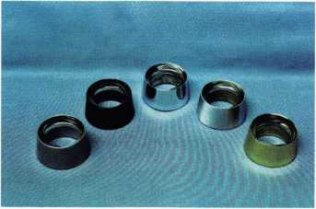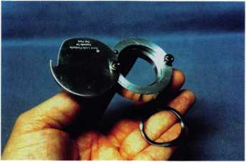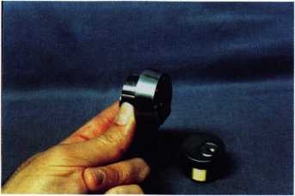

inch length mortise cylinder. Most 1 inch length cylin­ders have no more than five pin chambers. The spacer ring is not used with a 1 inch cylinder, but the wave washer is used to take out slack so that the ring doesn’t seem loose when installed on a door.

A six pin cylinder will usually have a minimum length of 1 1/8 inch. When used on narrow stile alu­minum doors with the standard Keedex cylinder guard ring, the spacing ring is needed. If the guard ring was

Photo 1 Photo 5

Photo 6

Photo 7

Photo 8

used without the spacer, the face of the cylinder would  
extend beyond the protection of the guard ring. The  
cylinder could then be adequately gripped by locking  
pliers and forced out of the cylinder opening. Photo 4  
shows an ASSA high security 11/8 inch mortise cylinder  
surrounded by the guard ring. None of the cylinder’s face  
extends beyond the guard ring, so all a wrench could  
grab would be the hardened ring. Using a wrench on the  
guard ring will just make it free spin without grabbing

the cylinder itself.

The large cylinder  
guard rings are a rela-  
tively recent addition  
to the Keedex prod-  
uct line. When  
installing an IC  
cylinder with a mini-  
mum length of 1 1/4  
inch such as Yale or  
ASSA, I don’t know  
of any other product  
that will protect a  
cylinder that extends  
that far out from the  
surface of the door.  
The large ring is  
being used with an  
ASSA 11/4 inch  
length IC cylinder in  
photo 5. The spacing  
ring is not used. If a 1  
3/8 inch cylinder was  
used with the guard  
ring, the spacer  
would be needed.

The standard size  
rings are available in  
seven finishes shown  
in photo 6. Starting  
at the top left to right  
and continuing on  
the bottom are: K-  
24A in Powder Coat-  
Aluminum, K-24B  
in Powder Coat-  
Duranodic, K24-10  
in US 10 Satin  
Bronze, K-24-26 in  
US26 Polished  
Chrome, K-24-26D  
in US26D Satin  
Chrome, K-24-3 in  
US3 Bright Brass and

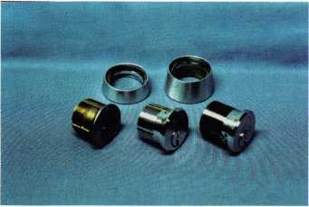

Photo 2

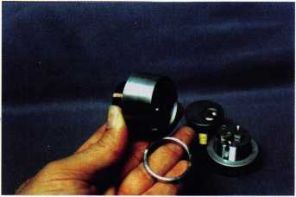

Photo 3

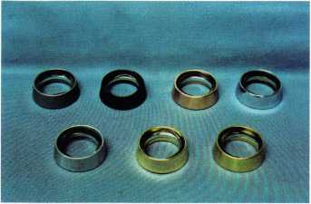

Photo 4

January 1998

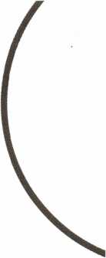

Keynotes

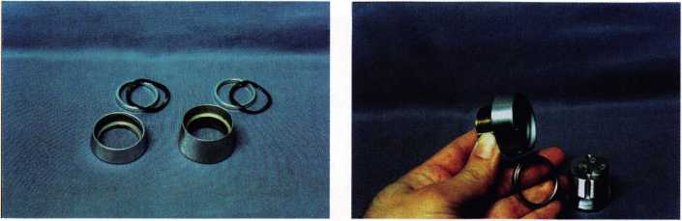

Photo 10

Photo 9

K-24-4 in US4 Satin Brass.

The large size rings are shown in photo 7 with five available finishes. From left to right, they are: K-24LA in Powder Coat-Aluminum, K-24LB in Powder Coat- Duranodic, K-24L-26 in US26 Polished Chrome, K- 24L-26D in US26D Satin Chrome and K-24L-3 in US3 Bright Brass.

The Keedex cylinder guard rings are very high quality

with very smooth surfaces. There are no apparent  
machining lines that might otherwise be generated by  
machining on a lathe. Both sizes of guard rings are avail-  
able in custom finishes other than the standard finishes  
listed above, if special ordered.

Standard sized guard rings (in standard finishes) are  
available in six packs wholesale priced at about $16.95,  
from most locksmith suppliers. That breaks down to

about $2.82 each. With a retail price from $7  
to $15, it is an easy add-on sale to almost any  
rekeying job. The cost is relatively low for the  
customer and the installation is almost effort-  
less for the locksmith. Plus, the cylinder  
guard ring dramatically increases the security  
of the mortise lock cylinder.

Cylinder Shields

An interesting variation to the standard cylin-  
der guard ring was introduced at the recent  
ALOA trade show in Reno. Shown in photo

1. this product is called a Cylinder Shield.  
   Made of a hard aluminum, it looks similar to  
   a standard cylinder guard ring, except that it  
   has a cover. It will act as a free spinning collar  
   to resist wrenching, but its main claim to  
   fame is its ability to shield a mortise lock  
   cylinder from adverse environmental condi-  
   tions. With the cover in place, it will prevent  
   dirt and grime or just water (and icing) from  
   interfering with the smooth operation of the  
   lock cylinder.

Used with a wave washer (to remove slack),  
a mortise cylinder fits into the collar in photo

1. The face of the cylinder must fit below the  
   cover to allow it to close. A small spring  
   loaded ball bearing keeps the cover snug  
   (when closed) for a tighter fit. The cover  
   rotates around a spanner type security screw  
   in photo 10. When fully rotated, a notch on  
   the cover hooks around the other spanner  
   head screw in photo 11.

Photo 11

Photo 15

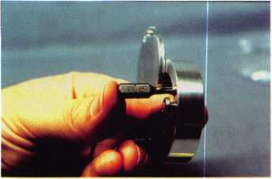

Photo 12

**Keynotes** **January 1998**

Photo 16

Hie Security Shield

The original company name was “Cylinder  
Shield”, the same as the name of the product.  
Since a new product has been introduced, the  
company name has been changed to Rose  
Lock Products (named after owner Tony  
Rose). The new product is a modification of  
the Cylinder Shield, and is called the Security  
Shield. Shown in photo 12, it looks the same  
except for the addition of an access hole in the  
cover and a security torx screw in the collar

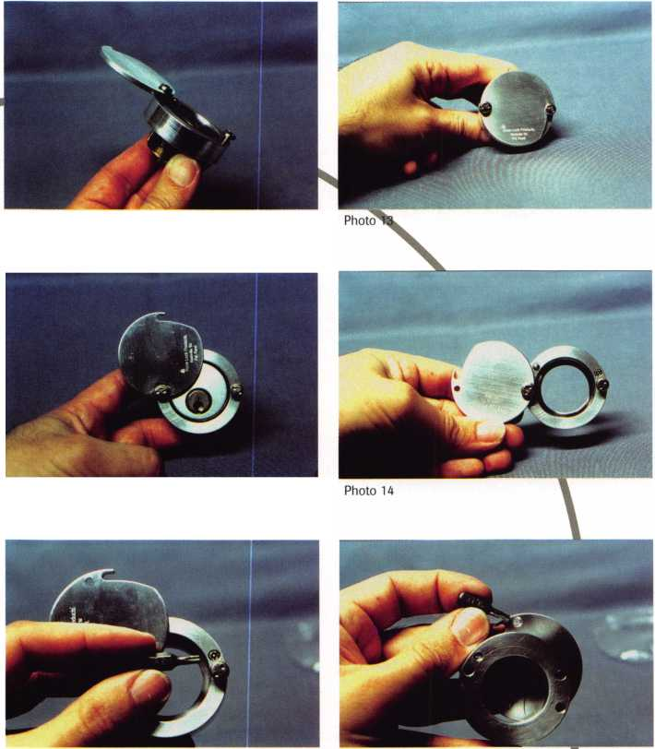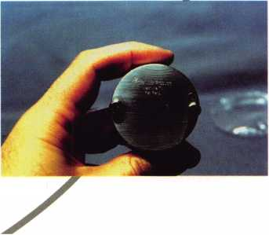

itself. A closer view and a TT-15 security torx screwdriver tip can be seen in photo 13. When the product is introduced, the security torx tip will be part of some kind of key fob.

Photo 14 shows how the security torx screw unscrews to protrude from the face of the collar. The screwdriver tip points to the recessed opening on the inside surface of the cover, in photo 15. When the cover is closed, the tool can rotate the security screw counter­clockwise (through the access hole in the cov­er) until the screw catches into the recess on the inside surface of the cover, as in photo 16. Then the cover cannot be opened until the tool is used again. This time turning clock­wise, the screw is tightened down into the collar and it releases the cover. This method of securing the cover makes the Security Shield very tamper resistant, but not tamper proof. It is an excellent means of keeping ran­dom vandalism from affecting a building’s lock cylinders. Your typical vandal will not

be carrying around an assortment of tamper resistant screwdriver tips.

Both the Cylinder Shield and Security Shield will be available in two sizes to work with both five and six pin mortise cylinders. They both also come in two finishes: alu­minum and duranodic. They are installed just as easily as a cylinder guard ring. They are more expensive than standard cylinder guard rings, but they are designed for a more specialized purpose. Not every customer that may need a guard ring will need the extra features these two “Shields” offer. They are currently available through McDonald Lock­smith Supply, Phone: (800) 238-7541. For additional information, or the names of other suppliers that stock their products, contact: Rose Lock Products, PO. Box 100372, Nashville, TN 37224-0372. Phone: (615) 292-5537 and toll free (888) 925-LOCK. FAX: (615) 834-9575. Internet address: [www.cylindershield.com](http://www.cylindershield.com).

For additional information about Keedex cylinder guard rings, other products or stock­ing suppliers, contact: Keedex, Inc., 12931 Shackelford Lane, Garden Grove, CA 92841- 5108, Phone: (714) 636-5657. FAX: (714) 636-5680. Internet address: [www.keedex.com](http://www.keedex.com).



Sal Dulcamaro,

CML, has hem in the locksmith business for over  
22 years. He is the presidmt of All Pro Security,  
Inc. in Michigan and has hem an ALOA member  
for 15 years. A past presidmt of the Locksmith  
Security Association of Michigan. Sal currmtly  
serves as editor of the association newsletter. He was  
named “Keynotes Author of the Year” for

1996-97

"Hawkeye™ Products are the professional's choice when **only** the best will do!"

Hawkeye offers three  
size kits:

HEB-7

T fiberoptic probe  
w/ 90 mirror tube and  
power handle $490.00

HEB-12

12M fiberoptic probe w/ 90  
mirror tube and power  
handle $600^0 $580!!!

HEB-17

17” fiberoptic probe w/ 90 mirror tube and power handle $**700.00** $670!!!

Adjustable-Focus allows you to see objects near or far with clarity.

Special... Purchase any Hawkeye Borescope Kit and receive the  
Hi-Lite 150 light generator for only $225.00 ... Save $50!!!

(regularly priced at $275)

127 SE 29th Street ♦ Topeka KS 66605 888 798 8464 ♦ FAX 800 798 TIME (8463)

Reader Service #18

January 1998

Keynotes

29

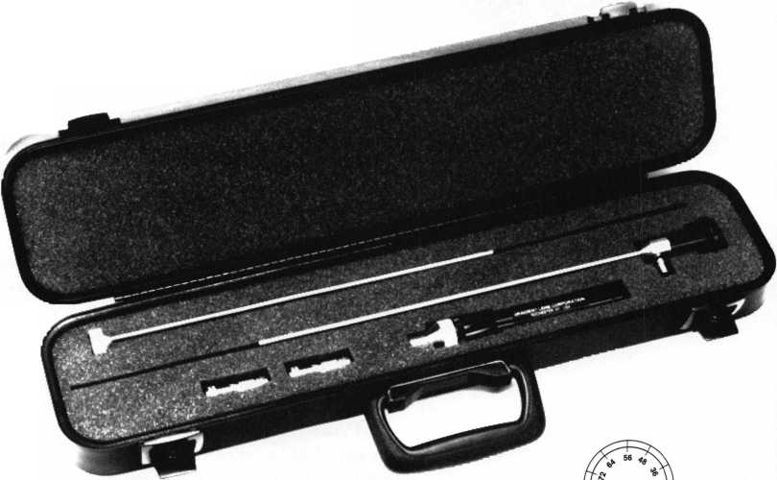

There are  
those who claim  
that locksmithing

is an art. Then again  
there’s Bill Hampson

Portrait of an Artist whose art is a result

of locksmithing

You wont find his various works displayed in the Guggenheim, nor the Lou-  
vre, nor featured in the latest issue of Art Forum. To observe the artistry that is  
Hampson’s “Lock Art,” one must pay a visit to Mt. Pleasant Locksmith in Van-  
couver, British Columbia. There, on display are his many sculptures, all created  
from old locks, keys, hardware, and various other items.

Take for instance, the otherworldly piece entitled, “Alien Totem,” created  
from doorknobs, bits from a safety deposit box, keys, screws, and a thumb-turn.  
Or examine yet another extraterrestrial-inspired statue called “Take Me to Your  
Leader,” a silver, metallic structure composed of similar pieces gazing coldly into  
space with bulging eyes and a gaping hole for a mouth.

Both are undeniably cute despite their robotic appearances and rank among  
some of the 71-year-old ALOA member’s favorites in his collection.

“When I constmcted the ‘Alien Totem’, I took a look at some old doorknobs  
I had. We have some Indian totem poles here, so I thought I could come up  
with something strange and I did.

“As for Take Me to Your Leader,’ I had thought about the movie ‘Star Wars’,  
and made his head movable much like the film’s robot, R2D2.”

Aside from these two cosmic characters, Hampson’s imagination and skills have produced a variety of figures and scenes all created from his collection of old lock hardware and tools he has stored in a box in the back of his shop. “Over the years unserviceable parts become an eyesore in the shop, so what I think I can use, I put away and then go through them when I have a specific thought in mind,” says Hampson. “Ideas often come to me when I go on long walks along the seawall. My mind is free when I walk and the sun is shining, so I think about things I can do for my next sculpture. I’ll get an idea and then go back to the shop and see what I have in my box full of parts and figure out what I’m able to utilize.”

Among the concepts that have sprung from Hampson’s creativity and artistic skills are a “Punk Rock Band” (his all-time favorite), a fuzzy Scotsman appropri­ately named “Jock McLock,” (which gets lots of comments and requests for



By Mike Emery

9

30

***Keynotes***

January 1998

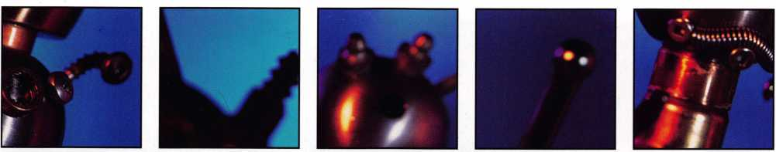

wr: Mike Emery is the A..  
|d the Music Editor fag

duplicates from his Scottish patrons), an airplane called “Snoopys Special” (made of 100 percent lock parts no less), and a jovial three dimensional scene featuring a smiling, winking locksmith working away in his shop entitled “The Happy Locksmith.”

One slightly darker exhibit called “Sorry. This lock­smith is no longer available.” features a toy skeleton rest­ing within a coffin constructed from an old lock. Accord­ing to Hampson, pieces like this are often suggested by customers and vendors who have an item they feel can be incorporated into a statue. “On this particular piece, one of my suppliers gave me a little skeleton and asked if I would make something out of it,” he says. “I had an old Mortise lock that I used for the casket and I put some legs on it with washer nails, added some little flowers and put a spring on it, so you can open it up and see the old locksmith laying there.”

The challenge behind each piece isn’t so much concep­tualization, but rather bringing an idea to life with the tools at hand. While Hampson’s head is filled with images, making them into “Lock Art” isn’t as simple as it may seem.

“What’s in your mind cannot always form on the workbench,” says Hampson.

He adds that each piece he constructs takes approxi­mately three days to complete, but that’s only because he keeps so busy that he’s only able to devote a half-hour here and an hour there to each figurine.

All of his works (presently, they number at 30) have a cartoonish appeal and quirky sense of humor that’s as warming to the spirit as it is pleasing to the eye. Hamp­son says that while growing up in his native Zimbabwe, Africa, he took a fancy to the cartoons of his day like “Betty Boop” and spent time sketching the images of other animated stars like Popeye and Mickey Mouse.

In 1954, Hampson immigrated from Africa to his pre­sent home in Canada. After spending 20 ^MM&a machine shop foreman, he began locksmimm^ffl|B|te| after taking a residential lockmasters course in Florida.

Now, 24 years after mastering the craft of lock- smithing, Hampson is using the dexterity he learned as a locksmith to manipulate its tools and create what he calls “Lock Art.” The inspiration for this medium came from an ALOA convention he attended six years ago.

“This company had a booth and they said if you spent about 500 or 600 bucks, they’d send you a sculpture,” he says. “Over the next few years, I’d been giving sculpting a bit of thought, and using some old keyrings, I started making sculptures.”

After just 18 months of being a lock artist, Hampson

has attracted attention from the local media in Canada, even once appearing on the television news.

But the main source of attention comes from people who visit his lockshop and are able to view the entire col­lection of Hampson “Lock Art” within his shop. “I have them in display cases around the store, and people are always asking to buy them. But what price can you really put on them?” he asks. “They’re one of a kind.”

He feels that they’re certainly more unique than many of the works he sees at various shops. In fact, he’s aston­ished when he spots other artworks made up of a hodge podge of everyday items sitting in store windows. “I live in the West End of Vancouver and they have an art gallery that featured a wooden cross about 18 inches by 12 and it was covered with Scrabble letters that read stings like ‘Repent,’ ‘Love,’ and things like that. And that sold for $150!” he exclaims.

If anything, Hampson is happy to make them for his family and friends and says that his grandchildren are particularly delighted with the sculptures.

At the moment, he’s finishing up a piece based on yet another sci-fi based subject, TV’s “The X-Files” and plans to keep on making more sculptures.

After all, any locksmith will tell you that obsolete keys, useless locks, and bits and pieces of hardware are items that every shop has an abundance of. With that in mind, as long as the scraps keep coming, Bill Hampson will keep on creating. “My right hand man saves all the extra locks and metal pieces for me,” he says. “Rather th^fnraRit away, I give some thought and nine times do something with it.” JB|

Te Editor of

fDallas entertainment

About we Keyno weekly,

tary 1998

Keynotes

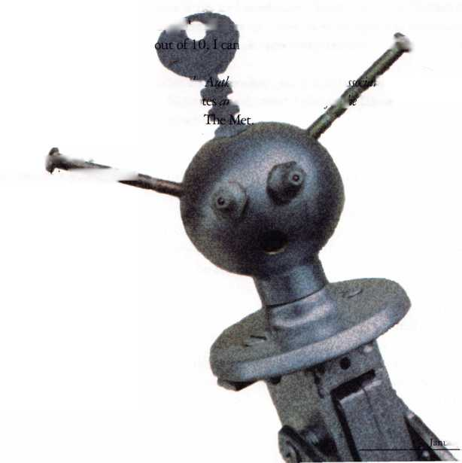

by Sal Dulcamara, CML

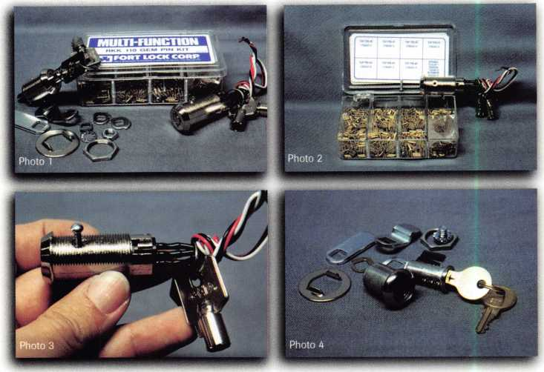

***Keynotes***

When you need to secure drawers or cabinets, ordinary door hardware won’t fill the bill. In other cases, it might just be some miscellaneous containers or compartments. A very broad category called specialty locks is usually the answer. Fort Lock manufactures a very large variety of specialty and cam and cabinet locks.

Photo 1 shows some of the GEM line of rekeyable tubular key locks. At the right is a switch lock. At the left is one of various available lengths of cam locks. The cam lock includes both a straight and offset cam, and two cam stops for either 90 or 180 degree rotation. The GEM cam locks are available in five different sizes:

MFW1038-inch, MFW1058- 23/32 inch, MFW1078- 15/16 inch, MFW1118-1 5/32 inch and MFW1148- inch. The effective length of each size of cam lock can be changed by using the offset cam and positioning the off­set forward or back. A tubular lock pinning kit is set in between the two locks.

The cover of the pin kit is open in photo 2, which exposes eight compartments. There are seven sizes of top pins numbered 0 to 6 in the four compartments in the top row and the three compartments at the left on the bottom. The remaining eighth compartment contains an assortment of springs, driver pins and retainers. The tubular switch lock is leaning against the cover of the pin kit on the right hand side.

The retainer that holds the cylinder together can be seen on the top surface of the switch lock. It is toward the left side, closer to the face end of the lock. Tubular

locks are usually not very easy to disassemble because of such a press fit retainer pin. Fort’s GEM locks have an interesting variation to the typical retainer. Notice a drilled (and tapped ) hole in the center of the retainer pin. The retainer is already prepared for more simple removal.

A more typical tubular lock will have a solid retainer pin that will require the service technician to do the drilling and tapping in order to pull the retainer pin. It can be an awkward task if you don’t have a special hold­ing fixture to hold the lock securely while drilling.

The GEM retainer pin found in Fort Lock brand tubu­lar locks is definitely more service technician friendly. It has already been prepared at the factory, so drilling is not required. A matching thread machine screw is included in the service kit. It can be seen in the middle of the service kit cover. The screw can be used to pull the retainer pin.

Photo 3 shows the screw attached to the retainer pin. The screw can be used to pull out the retainer pin in order to disassemble the lock cylinder for rekeying pur­poses. All of the GEM tubular locks are equipped as such, which includes all of the different size switch and cam locks. The GEM switch locks are available in three different versions: MFSW3-1138, which is momentary and maintaining; SW2-1138AD, which is maintaining; and SW20-1138MC, which is momentary. GEM tubular key locks also come in other types such as drawer, sliding door and assorted vending machine locks.

Fort also makes a variety of key resettable tubular key locks called the GEMATIC series. They are not shown.

January 1998

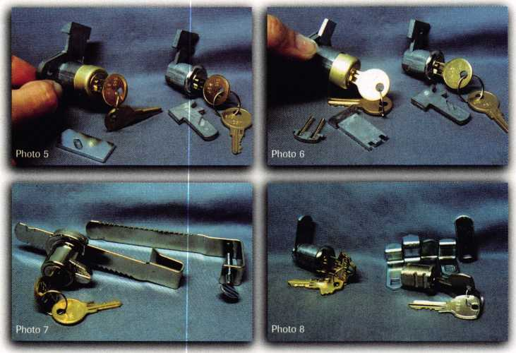

The GEMATIC locks are factory assembled to be reset to eight different key combinations without lock disassem­bly. The GEMATIC line includes cam and vending machine type locks.

One of a variety of different size disc tumbler cam locks is shown in photo 4. Like the GEM cam locks, these include both a straight and offset cam and cam stops for 90 or 180 degree rotation. Also included are spline fillers to allow conversion back and forth from key

retaining to non-key retaining. These cam locks are avail­able in six lengths and two finishes.

Photo 5 shows two different multi-function drawer locks. The wood drawer lock is at the left and the metal drawer lock is at the right. The wood drawer lock is cur­rently set to operate as a spring latch. It is available in three lengths and two finishes. It can also be converted to a deadbolt function with the bolt in front of the lock.

The lock has a 90 degree rotation. Use of the spline fillers can convert the non-key retaining operation to key retaining.

The metal drawer lock, at the right, uses a deadlock­ing bolt. It is convertible, but both functions are dead­locking. The conversion involves the length of the bolt. The long bolt is currently attached, with the shorter bolt loose in front of the lock. The use of spline fillers also allows switching back and forth from non-key retaining to key retaining and vice versa.

Both locks have been converted in photo 6. The wood drawer lock (left) is now deadlocking, with the spring latch parts loose in front of the lock. The metal drawer lock now has the shorter bolt attached.

The MFWSG 23000 showcase lock is shown in photo 7. This type of lock is designed for securing showcase

style sliding doors. It has ratchet action locking with two  
styles of sliding bars. The one currently attached to the  
lock is for 1/4 inch thick doors. The extra bar (to the  
right) is designed to attach to doors of varying thickness.  
Notice the thumbscrew device that tightens the bar onto  
doors of different thicknesses.

Photo 8 shows a cam lock at the left and a mail box  
lock at the right. The lock at the left is one of four sizes of  
double bitted disc tumbler cam locks. Like the other Fort

cam locks, they include both a straight  
and offset cam and 90 and 180 degree cam  
stops. Like the single bitted disc tumbler  
locks, using spline fillers can make the  
lock key retaining. Other versions of Fort  
double bitted disc tumbler locks include:  
showcase, threaded shaft and trailer & gate  
locks.

The mail box lock at the right is of the  
small pin tumbler design. This lock is  
compatible with the National Cabinet  
Lock key blank D4292. Fort makes anoth-  
er version with the Hudson H20 keyway.  
Both versions include five different cams  
to allow replacement of the following  
manufacturers! locks: American Device,  
Auth Electric, Bommer, Dura Steel and  
Miami-Carey.

Fort Lock makes its own tumblers and  
key blanks, not to mention all the assorted

cast and stamped parts to the locks. Tumbler and service  
kits are available for many of the Fort Lock products. Fort  
locks are OEM for many products and devices that have  
locking mechanisms or compartments. They custom  
make locks for special requirements, too.

Fort locks (and product catalogs) are available through  
many different locksmith supply companies. For addi-  
tional information, contact: Fort Lock Corporation, 3000  
N. River Road, River Grove, IL 60171. Phone: (708)  
456-1100. FAX: (708) 456-9476.

m About the Author: Sal Dulcamaro, CML, has been in the locksmith business for over 22 years. He is the presi­dent of All Pro Security, Inc. in Michigan and has been an ALOA member for 15 years. A past president of the Locksmith Security Association of Michigan. Sal currently serves as editor of the association newsletter. He was named “Keynotes Author of the YeaS’ for 1996-97.

34 | ***Keynotes***

January 1998

March ^2-23, 1998 Las Vegas Convention Cerfter Las Vegas, Nevada

**^ %ALOA Conference Program at International Security Conferei**

* - x l* j,

**osition**

Ma^teikKeying Methods & Formats

Comprehensive Inte^h^pgeable Core Safe Lock ^oubleshool|df •

Access Control

ServicingiWuminum Storefront Doors

Aluminum it^rerroni l Commercial Grade Lock

Mas-Hapten Auditcon System 2100 Certification •

Electronic Safe Locks • Introduction to Closed Cirdnt Television •

The Complete Door and Door Closers

J

ixit Devices •  
:ksmithfng •

investigate

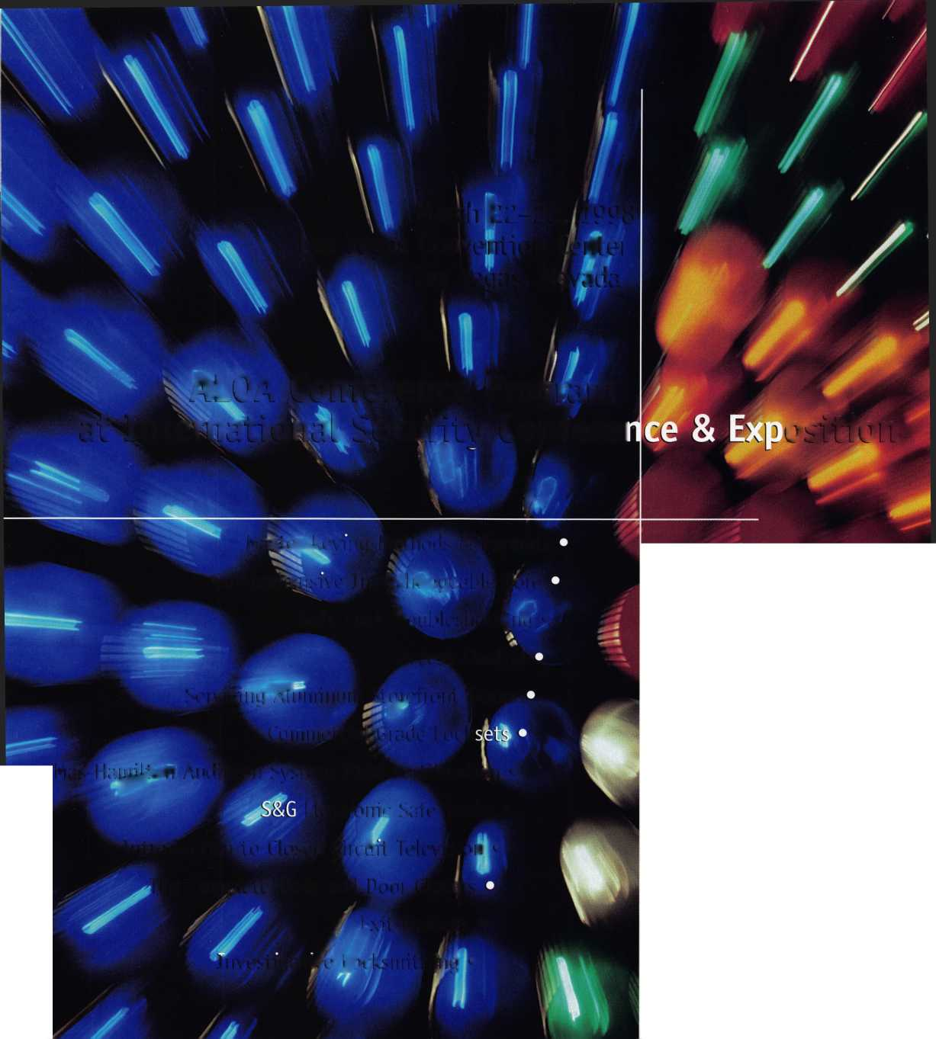

co Unican, the leading

manufacturer of mechanical

eyless locks had some

interesting new models to show

at the DHI convention in

Chaflotte, N.C., Sept. 27-29.

by Paul Chandler

I

36 I Keynotes

January 1998

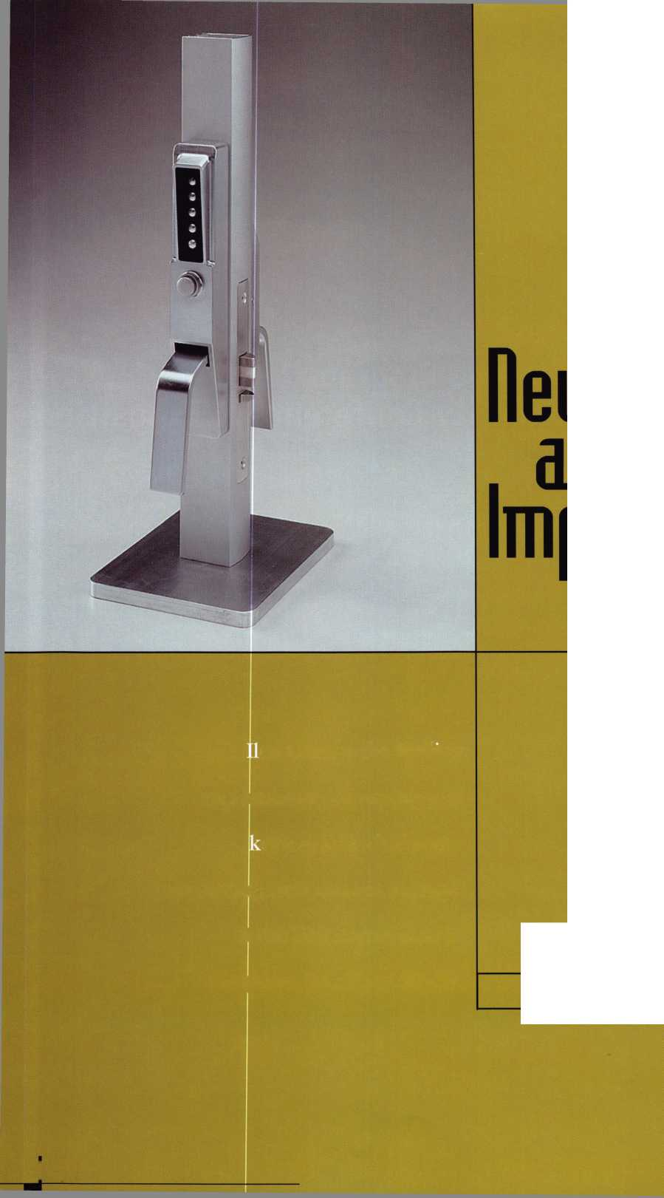

Ilco Unican

The 3100 series has been designed for use on narrow-stile aluminum and glass doors. Until now you had to combine a model 3000 push­button assembly with the appropriate “drive assembly,” an Adams Rite 4710 narrow mortise deadlatch, and a paddle or lever device on the inside to allow free egress. The new 3100 series is a complete lock. On the outside you have a five button keypad and a single, larg­er button. After entering the correct code, you depress the big button to unlock the trim. Then you pull the integral paddle, which retracts the latch and gives you something to pull the door open with. On the inside there is a similar paddle that you push to exit. These paddles look similar to hospital push/pull sets, only narrower. The outside housing is through-bolted for security and is fully weather resistant. The lock is handed and not field reversible. Model 3111 is for 1 1/8" backset preps and model 3112 fits 31/32" preps. The lock will be available in 26D satin chrome and 55 Duranodic dark bronze finish­es. This new keyless lock for storefront style doors looks like an improvement over the old 3000. The paddle mechanism seems stur­dy and this should be easier to operate, especially for persons with disabilities than the small thumbturn actuator on the old product. And since it comes complete it should be easier to buy and stock than the old menagerie.

Another new offering from Ilco-Unican is The 8100 series full mortise lock. In the past, if you had a mortise lock and wanted to convert to Unican, you had to use adapters or wraparound plates to adapt the door for the cylindrical 1000/Ll000 lock. Now, using the existing mortise prep, you can install a Grade 1 UL listed mortise lock with an ADA compliant lever and mechanical key override. The mortise lock features both a deadlocking latch and a deadbolt. The deadbolt can be thrown from the outside using the lever trim. Upon entering a valid code, the outside lever retracts both the deadbolt and the deadlatch. The inside lever, of course, is always able to retract both. The basic model is the 8128B. Model 8148B adds an internal turnknob that puts the lock into passage mode. Model 8168B uses an inside key to activate/deactivate the passage function.

This lock features through-bolted trim, and is available in 26D and US3 bright brass. The lock is factory handed and not field reversible.

This product offers a good alternative when converting a mortise lock to keyless access. Where physical security is especially impor­tant, the mortise Unican with a deadbolt should outperform the cylindrical versions.

Finally, how about using keyless technology on your file cabinet? Ilco has been manufacturing auxiliary file cabinet locking bars for a number of years. The new Unican File Guard comes in 2,3 or 4 drawer sizes and permits keyless access to secured file cabinets. These bars do not swing out of the way—they lift completely off and are set aside when not in use. Since the locking mechanism is part of the bar you can never misplace it. The File Guard is available in black and almond baked enamel finishes

Unican’s new offerings bring us three steps closer to the keyless office. Now what about a Unican ignition for my car? Where did I put those keys?

About the Author: Paul Chandler is an ACE instructor and manages the Access Control and CCTV department at I.D.N.

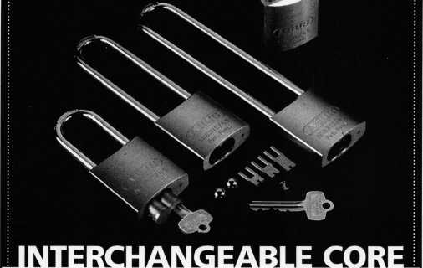

PADLOCK WITH Z-BAR

The ABUS 83IC/45 convertible  
interchangeable core brass padlock  
is a very flexible locking system. It's  
available with a 1" 2" 4" or 6" hard-  
ened Boron-steel shackle. You can use  
it for any application where you need  
interchangeable core key control.

The 83IC/45 uses stainless steel  
locking balls for greater strength and  
corrosion resistance. Each lock comes  
with three fork drivers, which provide  
compatibility with 5-, 6-, and 7-pin  
cores - and emergency security lock-  
out. The Z-Bar lets you configure each

lock as either key-retaining or non­key retaining. While the cores aren't included, the 83IC/45 accepts cores from Bestf Arrowf Falcon? KSP? Medeco? and Peaks?

Call us today at 800-225-5348 to reduce your lock inventory. Our low prices, precision-made German quality, and rugged reliability make the 83IC/45 system a great value!

ABUS Lock, USA 3555 Holly Lane North Plymouth, MN 55447-0507

Reader Service #19

NEW ILCO DISTRIBUTOR!!

Monday Security Corporation  
1-800-886-6721

Contact Laura for details  
on dealer discounts

We carry almost every make  
and model of new and  
used safe deposit locks,  
and safe parts, specializing  
in the antique parts.

Have you received our  
catalog?

Reader Service #20

**January 1998Keynotes** **| 37**

S8l ***Keynotes***

January 1998

By Paul Chandler, CRL

The annual Door and Hardware Institute (DHI) show is the last of the big national expositions on the security hardware industry calendar. For sales and marketing people, it marks the end of a nomadic summer that includes theALQA Security Expo, ISC East (International Security Conference) in New York City and the annual ASIS (American Society for Industrial Security) convention.You can see it in their faces, just one more show and they can resume normal lives — until the next convention season that is. DHI also represents the last chance of the year to launch a new product with major national exposure. Even products that won’t be ready to ship for a couple of months may debut at DHI.This year’s convention in Charlotte N.C., was no excep­tion. One eagerly awaited product that was unveiled

Previewing The Alarm Lock

in Charlotte is the Alarm Lock DL3000Trilogy with audit trail capabilities.To look at it, the DL3000 does­n’t look much different from the DL2700 that most of us are familiar with. In fact, the folks at Alarm Lock planned it that way. When they redesigned the origi­nal Trilogy lock, and created the DL2700, they had future products in mind.Tlte DL3000 uses the same housing, the same keypad, the same Grade one clutched lever and the same deadlatch. It’s what you can’t see that makes it special.

For one thing, instead of the 15 user codes available in the DL2700, the DL3O0O can accommodate up to 300 different codes. Codes may be of varying lengths, from three to six digits. The aster­isk, or “star” key, which doesn’t do anything on the DL2700, is required to be pressed at the end of a code entry. This reduces greatly the chance of someone stumbling upon a valid code by simply punching random numbers.

The new lock also adds an event memory that retains the last 1600 transactions. You may recover this information in either of two ways. For a simple audit trail history you may use a hand-held printer that communicates with the lock via an infrared light beam. This is the same printer, manufactured by Hewlett-Packard, which the OSI Omnilock and the 1EI Secured Series use. Events are printed, in reverse chronological order, on a thermal paper roll that is slightly wider than most cash register tapes. Since many locksmiths have already invested in one of these devices I think Alarm Lock was wise to utilize this technology.

While the HP printer offers an economical and portable means of obtaining transaction history, many users prefer ro recover their audit trails into a personal computer. This eliminates the problem of stor­ing hard copy printouts and allows the data to be re-configured into a variety of reports and printed on standard size paper. For this reason, Alarm Lock decided to provide a computer port on the lock in addi­tion to the i/r link.

If you want to use a PC with your DL3000 you will need one you

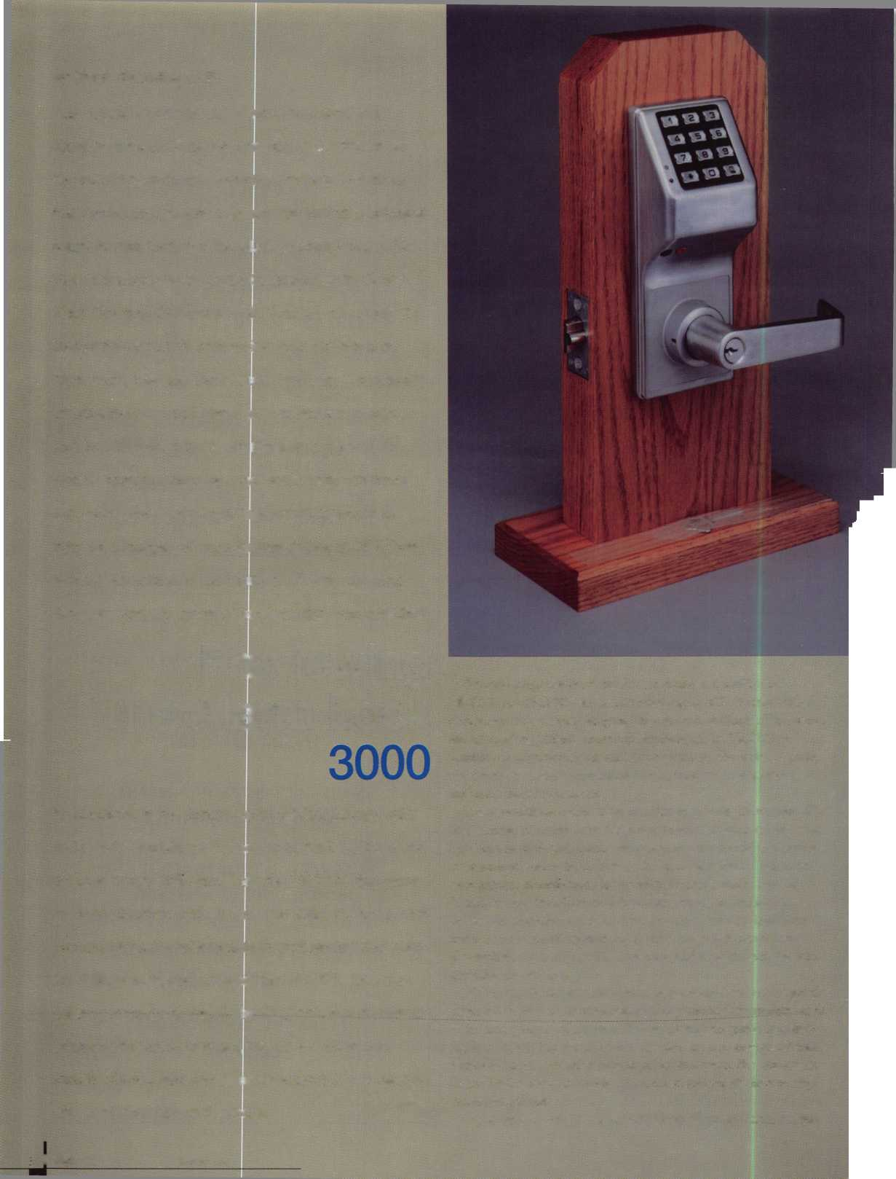

can take to the door (laptop or notebook). It has to be IBM compati­ble, 486 or better, running Windows 3.1 or Windows 95. You will need 8 megs of RAM if you use Windows 3.1 or 16 megs if you use Windows 95. At the time of the show they were still tinkering with the software package but what I saw looked versatile and easy to use (maybe even easy enough for me).

*To look at it, the DL3000 doesn’t look much different from the DL2700 that most of us are familiar with.*

If you do utilize the computer interface with the DL3000 you can do more than copy audit trails. The software will allow you to pro­gram locks, add and delete users and schedule time zones and lock/unlock events. In a system with multiple locks you will be able to do all of this programming at your desk, then visit each lock and quickly upload the data.

While there are other self contained, stand-alone access control units that can be programmed from a portable computer, a real strength of the DL3000 is that it does not have to be. Any program­ming that you can do from a computer can also be done directly into the lock via the keypad.

I think that’s what I like best about the DL3000, its flexibility.

Some people may want a keypad technology lockset and require more than 15 users, but they don’t care anything about audit trail or time zones. They can purchase this lock and it requires no extra equipment or software to add and delete up to 300 users.

Other customers may want a multi-user keyless lock and may only need an audit trail record once in a blue moon, typically after there has been an incident. These folks can have a DL3000 installed by a locksmith who possesses a handheld printer, and who can come out and interrogate the lock (for a fee, of course) whenever it becomes necessary. An astute dealer who is already selling DL2700 Trilogy locks, and other keyless locksets, can offer this service and upsell his prospects to the DL3000.

For end-users who want full-featured access control, with all the bells and whistles, but who don’t want to run a lot of wire or spend a ton of money, the DL3000 also fits the bill. While you will find peo­ple who believe that a keypad is inherently less secure than a system that requires device custody (such as a key or card), you will also find customers who want the convenience of keyless access. That’s why there’s chocolate and vanilla.

This new product should be ready to ship very early in 1998. At the time of this writing Alarm Lock had not announced the list price of the DL3000, but it is rumored to be approximately 33% higher than the DL2700, which would make it a very affordable way to pro­vide your customers with the security and control they need.

About the Author: Paul Chandler is an ACE instructor and manages the Access Control and CCTV department at I.D.N.

One Slop Aoppfeq



**Rugged, Dependable Security Products.**

Providing solutions to your

access control dilemmas.

For information

! < ca"our

^ ) Electronic

Access Department today!

Toll Free: ^PJTHERN

800-282-2837 (JVjfjr Fax: 800-447-2299 Sj

Warehouses in: Largo, FL; Miami, FL;

Oakland Park, FL; Charlotte, NC; and Atlanta, GA.

**Serving the Security Industry Since 1946.**

Reader Service #21

Who Says There’s No Such Thing as

Easy Money?

***1-800-UNLOCKS***

Nationwide Automated Dispatch Network

Introducing 1~BOO-UNLOCKS. , the nation's first and only network of quality assured lockout service providers and automated dispatch service. Here's how it works. This advanced AT&T/ULI technology gives you an awesome advantage over your competition. Any lockout in your exclusive and protected territory is automatically routed to you faster than greased lightning. The 1-800- UNLOCKS automated dispatch service turns your phone into a 24 hour cash machine. Its that simple. You get the benefit of exclusive use of a powerful and extremely memorable toll free telephone number, co-op advertising for your local market, and professionally produced yellow page, radio, television and direct mail advertisements that are certain to build and grow your business dramatically.

Licensed territories are going fast. And once they are gone, they're gone. Call immediately to receive your free application to become a quality 1-800-UNLOCKS service provider

Call NOW to reserve your territory before your competitor does! 1-888-865-6257, 24 hours.

Reader Service #22

**January 1998Keynotes** | 39

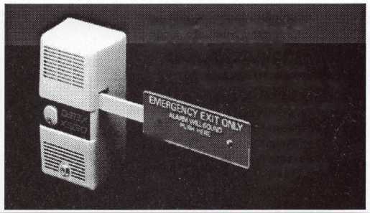

**Are You an  
All-Lock Certified  
VATSmith?**

**“Wanna be?”**

*S417-4926*

Reader Service #30

Locks

Service Kits

Replacement Keys  
Training/Certification

For a Free All-Lock  
"VATSmith"  
Information Packet  
Call

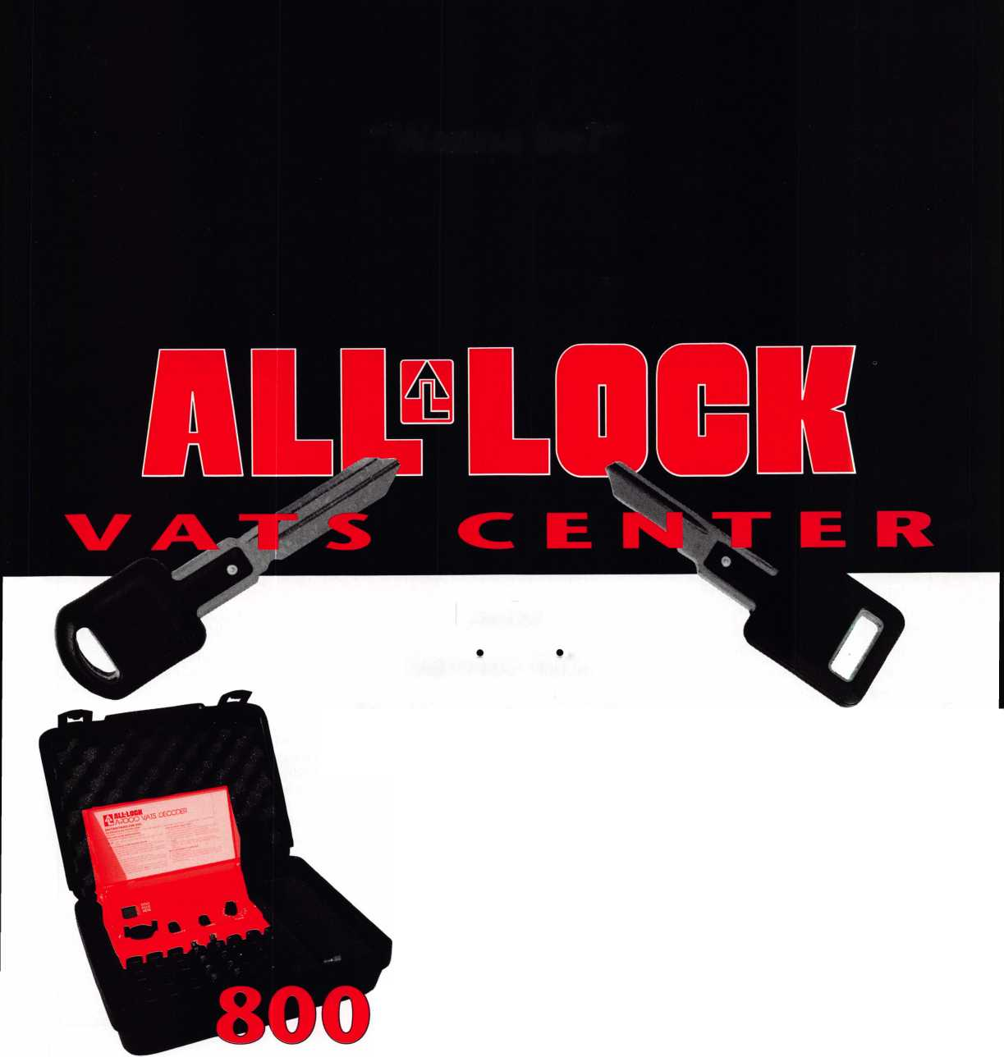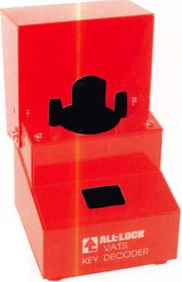

Figure 1: Two single step systems. The B system was written to replace A which was compromised.

Hugh Downs regularly bemoans the “tech­nological imperative”—the tendency to do something just because we can. It applies to master keying. We harbor the notion that it is a good idea. We also got it into our heads that huge, unified master key systems were an even better idea.

Sometimes master keying can be done safely. When Edward O’Keefe gave us the master ring cylinder in 1889, which didn’t require change keys and masters to share common cuts, he provided an admirably secure system.

The O’Keefe cylinder, like Philo Felter’s invention of the sidebar in 1868, is a flash of brilliance illuminating a mass of lesser products.

The flexibility and keying capacity of the master ring cylinder are striking. With a multiplex family, it can produce larger mas­ter key systems than some current high secu­rity locks.

However, the industry has sought less expensive ways to increase the keying capaci­ty of the pin tumbler cylinder.

Multiplex keyways, invented in the 1890s, remain the most common answer. Developing increment systems with greater numbers of progressives is another.

Two step vs. single step

Most manufacturers have developed single step key bitting specifications to supplement

January 1998

Keynotes

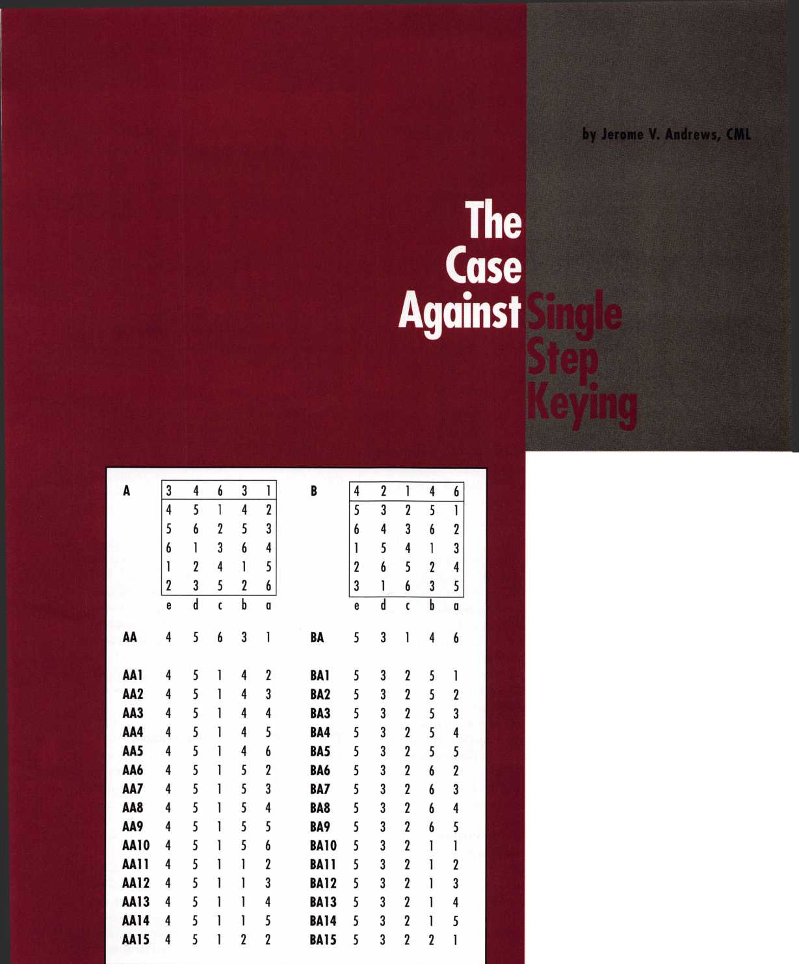

Master keying has always been a concession to convenience. It diminishes, rather than enhances security

|  |  |  |  |  |  |
| --- | --- | --- | --- | --- | --- |
| B | 4 | 2 | 1 | 4 | 6 |
| BA | 5 | 3 | 1 | 4 | 6 |
| BB | 5 | 4 | 1 | 4 | 6 |
| BC | 5 | 5 | 1 | 4 | 6 ® |
| BD | 5 | 1 | 1 | 4 | 6 |
| BE | 6 | 3 | 1 | 4 | 6 |
| BF | 6 | 4 | 1 | 4 | 6 |
| BG | 6 | 5 | 1 | 4 | 6 © |
| BH | 1 | 3 | 1 | 4 | 6 |
| BJ | 1 | 4 | 1 | 4 | 6 |
| BK | 1 | 5 | 1 | 4 | 6 © |
|  | 1 | 1 | 1 | 4 | 6 ~ |
| BL | 2 | 3 | 1 | 4 | 6 |
| BM | 2 | 4 | 1 | 4 | 6 |
| BN | 2 | 5 | 1 | 4 | 6 © |
| BP | 2 | 1 | 1 | 4 | 6 |
| BR | 3 | 3 | 1 | 4 | 6 |
| BS | 3 | 4 | 1 | 4 | 6 |

Figure 2. Inspect the master keys under the B grand. The change key AA5 is an incidental master in system B. It operates all changes under BC, BG, BK and BN

less roomy two step systems.

Two step systems usually employ 10 depths, with only the odd or the even depths used in any given bitting position. One of the five is used in the top master key. The remaining four are used to generate changes and lower level master keys. 6-pin cylinders yield 4,096 theo­retical combinations. 4,096 is 4 to the 6th power.

Single step systems have fewer depths, based on a larg­er increment. However, the increment is judged to be sufficient to permit all the depths to be used in a given position without key interchange.

Most single step systems have six cut possibilities.

One is dedicated to the top master key. The other five produce 15,625 theoreticals in a 6-pin cylinder.

With 4,096 theoreticals versus 15,625, it is easy to see why single step would be desirable for large jobs. Some use it exclusively or indiscriminately.

Fatal flaw of single step keying

There is a serious downside to single step and an ethical problem. Let us begin with an example that shows what happens when a single step system needs to be rekeyed.

Consider two grand master key systems for 5-pin Corbin Russwin System 70. The original A system is compromised and is to be replaced by system B, using the same cylinders.

For both systems, change key partial combinations come from columns a, b and c. Master key partials come from columns d and e.

Figure 1 illustrates the first 15 practical changes in both systems (MACS is 4). At first glance, the systems appear to be distinct. However, on closer inspection, interchange is rampant. See figure 2. AA5 is an inciden­tal master key for system B. It operates groups BC, BG, BK and BN.

Figure 3 show the first few AC change keys. AC5 is 42146. Oops! 42146 is the B grand. AC1,42142, is an incidental master key that will operate all B system com­binations that end in 2.

All of the AC changes in figure 3 are time bombs.

AC1 operates all B system combinations ending in a 2. AC 10 works every combination with a 5 in progression column b. Every key in system A works one or more locks in System B.

The interchange works both ways. All keys in one sys­tem are changes and incidental masters for the other sys­tem, because the same keys are used in both systems. They just have different names.

In conventional hardware, nothing can prevent inter­change between two fully expanded single step systems. Changing the sequence of progression or the order of the progressives in the columns merely causes the identical bittings to be progressed in a different order.

There is only one bucket of bittings in a single step sys­tem. There are no parity patterns, i.e., patterns of even and odd digits, to separate one system from another. On any given key section, all single step systems are identical.

Most manufacturers have faced this issue. For exam­ple, when Best Lock Corporation replaces an A4 system, they furnish new cores of a different, unrelated key sec­tion as a matter of policy. That is the only solution. If they did not do so, they would have to advise the end user that all the old keys still operate in a helter-skelter fashion.

The end user has a right to know

Fortunately, most of the keying systems in the world are small and do not require single step keying. If single step is used on small, geographically close systems, trun­cating the key bitting arrays can prevent interchange. This technique is illustrated in Fundamentals of Master Keying. The larger systems, however, present a severe lia­bility to the end user and locksmith.

End users are beginning to recognize that unified key systems, with controls and masters for large facilities or multiple locations, present a danger from the get go. Master keying has always been a concession to conve­nience. It diminishes, rather than enhances security.

Keying alike whenever possible, and breaking large systems into smaller ones, are much more secure arrange­ments. Master keys, often status symbols, represent a large monetary liability. When a top master key is issued,



Keynotes

January 1998

The Case Against Single Step Keying

|  |  |  |  |  |
| --- | --- | --- | --- | --- |
| AC | 4 | 2 | 6 | 3 1 |
| AC1 | 4 | 2 | 1 | 4 2 |
| AC2 | 4 | 2 | 1 | 4 3 |
| AC3 | 4 | 2 | 1 | 4 4 |
| AC4 | 4 | 2 | 1 | 4 5 |
| AC5 | 4 | 2 | 1 | 4 6 * |
| AC6 | 4 | 2 | 1 | 5 2 |
| AC7 | 4 | 2 | 1 | 5 3 |
| AC8 | 4 | 2 | 1 | 5 4 |
| AC9 | 4 | 2 | 1 | 5 5 |
| AC10 | 4 | 2 | 1 | 5 6 |
| Figure 3. Oops! AC5 is the B grand. What does  AC1 operate in system B? What about the other  AC changes? | | | | |

the cost of rekeying the system should be incised in the bow.

Typically, it is only on large projects that expansion specifications force us into single step keying. At KABA, we explain the downside of single step and suggest that our dealers have a conversation with the end user. It is in the end user’s best interest to revisit the expan­sion specification and we recommend breaking up large systems into smaller ones.

In my opinion, it is unethical to sell a large single step system without advising the end user that the existing cylinders cannot be rekeyed. I believe that selling a large single step system without doing so displays a lack of concern for the end user.

\About the Author: Jerome V Andrews is Key Records Manager

and Director of Training for KABA High Security hocks in Southington, CT  
where he provides system design services for both KABA and Peaks and techni-  
cal support for KABA engineering.

)t JWaster Hocfesmitfjs gfesoctatum J5eto Jersey

The Oldest Locksmith Association in the world

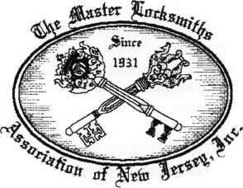

Invites you to attend our

Annual Lock **&** Security Show

March 26 through March 29,1998 in Somerset, New Jersey

For more information  
PO Box 2441

Morristown, NJ 07962-2441

Phone (973) 267-8884 Fax (973) 538-2248 [www.MLANJ.org](http://www.MLANJ.org)

Reader Service **#23**

January 1998

Keynotes

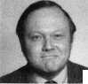

Legislative

Comment

John J. Greenan-Committee Chairman Tim McMullen-Legislative Manager

“If you don’t know where you’re going, you could place else”—**Yogi Berra**

Next year we all need to watch where were going in state capitols across the U.S., or we could very well end up someplace else. Cur­rently there are 19 bills from 12 states that were carried over from last year’s legislative calendars that directly affect the access con­trol industry. Some allow for various tax cred­its for the installation of security systems, but most attempt to license our industry in some manner. Next year, careful monitoring and grassroots involvement will be key. In 1997, three pieces of legislation detrimental to the industry were enacted. They didn’t start out that way—in fact, the members and chapters involved knew exactly where they were going. But in the end, we ended up some­place else primarily because of external forces. This is why we all need to watch where we’re going in 1998.

As you can see by the “Legislative Update,” there is a great deal going on in state capitols all across the nation that direct­ly effect locksmiths. It is important that all of us take the responsibility to know where we are going. If you haven’t joined the Leg­islative Action Network, now is the perfect time (see form). Ninety percent of all the states start their new legislative sessions within the first two weeks of January. Only by working together can we end up exactly where want to for 1998!

LEGISLATIVE UPDATE

ALABAMA

The licensing bill (S.B. 57) as introduced began as a joint effort with the alarm indus­try to set minimum requirements on regulat­ing the security industry. These qualifications were going to be established by the Alabama Electronics Security Board of Licensure, which would be made up of seven members reflecting various industries involved with security. One member was to be an alarm representative from the Alabama Alarm Association and one member from the Alaba­ma Locksmith Association. In a last minute floor amendment, we ended up someplace else. The make-up of the Board was changed, and now consists of five members, two of which are nominees from the Alabama

441 Keynotes January 1998

Alarm Association. No locksmith sits on this Board whatsoever!

CALIFORNIA

S.B. 780 (Enacted)- Provides for fees and licensing applications and renewals for lock­smiths.

GEORGIA

H.B. 191—Provides for the regulation and licensure of alarm systems monitoring con­tractors.

HAWAII

S.B. 722—Gives a tax credit for installation of an electronic burglar alarm system.

S.B. 1700—Gives an income tax credit for home security systems.

ILLINOIS

H.B. 1215—Exempts locksmith agencies having fewer than two employees from the license renewal and issuance fees otherwise applicable to agencies.

H.B. 1216—Exempts from locksmith agency licensing requirements an individual licensed locksmith operating under a busi­ness name other than his or her own name if the licensee does not employ person to engage in locksmith operations.

S.B. 108—Requires licensees to include their license number in any advertising relating to services.

Note: The grandfathering provision under the Illinois Locksmith Act expired on Dec. 31, 1997.

KANSAS

S.B. 78—Concerns licensing and regulation of alarm systems companies and their employees.

LOUISIANA

At first, the licensing bill as introduced (H.B. 2365), used the term “access control” in its definition of locksmithing. This term was adopted by ALOA’s Legislative Commit­tee for our Model Legislation and includes any mechanical electronic, or electrically con­trolled device to control access to any area. Again, in the end, we ended up someplace

wind up some-

else. The final law as enacted leaves out the term “access control,” and what we end up with is a definition of locksmithing that is completely unclear.

MARYLAND

H.B. 1137 (Enacted)- Provides for licensure of security systems companies.

MASSACHUSETTS

H.B. 2288—Relates to the installation of electrical wiring (this bill contains provisions relating to alarm systems installers).

MINNESOTA

H.B. 1097—Requires the use of surveillance cameras for crime prevention.

NEW JERSEY

A.B. 2629—Provides for regulation of alarm businesses.

A.B. 994—Provides for regulation of lock­smiths and burglar, fire alarm and electronic security businesses.

NEW YORK

A.B. 489—Grants income tax credit for cer­tain private security devices in a dwelling. A.B. 972 / S.B. 1107—Provides a tax credit against the corporate franchise tax for the expense of installing a security device.

A.B. 2581 / S.B. 1746—Grants a 10 percent tax credit to businesses in King County that install security systems.

OHIO

H.B. 381—Requires the licensure of lock­smiths and establishes a Locksmith Licensing Board.

OKLAHOMA

S.B. 589—Creates a Building Trades Com­mission that sets the minimum standards of installation, maintenance and service for alarm systems companies.

PENNSYLVANIA

S.B. 286—Regulates the practice of lock­smithing.

**Legislative Manager**

Tim McMullen has been named the new  
legislative manager for the Associated  
Locksmiths of America (ALOA). Tim  
recently graduated from the District of  
Columbia School of Law in Washington,  
D.C., and has an extensive legislative  
background. While in law school, he  
worked as a legislative aid and communi-  
ty development liaison for a District of  
Columbia council member and managed  
the council members re-election cam-  
paign, which resulted in an 82 percent  
victory. In addition, Tim has worked for a  
large lobbying firm in Washington, as  
well as the Justice Department’s Civil  
Rights Division.

As ALOA’s legislative manager, Tim  
will be responsible for monitoring legisla-  
tion at the federal and state levels focus-  
ing on bills that specifically affect the  
locksmith industry. He will be working  
pro-actively with local chapters and  
members to avert the enactment of laws  
that negatively impact the mechanical  
and electronic security industry. He will  
also assist in introducing licensing legis-  
lation and working on developing legisla-  
tive strategies for each individual state.  
Equally important to the industry’s goals,

Tim will be given the mission of con-  
stantly pursuing the education of key  
state legislators about the association, its  
membership, policies and services.

Legislative

omment

RHODE ISLAND

H.B. 5695—Relates to licensing the lock­smith business.

TENNESSEE

H.B. 424—Relates to the renewal of license of alarm systems contractors.

H.B. 676 / S.B. 1006—Redefines “alarm systems” sale of which subject to licensure to include only those alarm systems that are connected to alarm device or still cameras connected to alarm devices.

TEXAS

In 1995 the Texas legislature enacted H.B. 713. Through its definition of “detection device,” the law was interpreted to include all electronic locking devices, meaning that all Texas locksmiths must be registered by the Board of Private Investigators and Private Securities Agencies. In 1997, the Texas Lock­smiths Association worked hard to introduce a number of bills (H.B. 1097, H.B. 2130, H.B. 2999 and S.B. 922) which were designed to exempt locksmiths from this leg­islation. Unfortunately, we ended up some­place else, and these bills did not make it to the floor of the legislature for a vote, but were buried for good with a number of other bills. The worst part is, the Texas legislature does not convene again until 1999!

For movement on these and future bills or regulations, sign on to [www.aloa.org](http://www.aloa.org) every

Monday for the latest update. For copies of these bills, contact your state legislature.

I About the Chairman: John J.

Greenan represents the fifth generation of locksmiths and is vice president of Fink Safe & Lock in Chicago, IL. A locksmith since 1985, John also serves on ALOAs Convention and Strategic Plan­ning committees. He is also chairman of the Allied Locksmiths of Illinois.

I About the Manager: Tim McMullen

oversees legislative affairs for ALOA. He is a  
graduate of the District of Columbia School of  
Law and has an extensive background in legisla-  
tive work. If you have information for Tim con-  
cerning federal or state legislation affecting the  
locksmithing industry, contact him at: ALOA;  
3003 Live Oak Street; Dallas TX 75204;

(214) 827-1701; (214) 827-1810; email: aloa@anet-dfw. com

**Legislative Action Contact Network**

Date

Name

Company Address

I am interested in:

* Working on Legislative Issues
* Fundraising
* Gathering/Giving Information

Home Address

Telephone

FAX

e-mail

January 1998

Keynotes

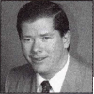

**Associate**

Members

■0

|  |  |
| --- | --- |
| Manufacturers | American Lock Co.  3400 West Exchange Road  Crete, IL 60417-2099 (708) 534-2000; FAX (708) 534-0531 |
|  | 0 0 |
| A & B Safe Corp.  171 S. Delsea Dr.  Glassboro, NJ 08028 (800) 253-1267; FAX (609) 863-1208 | American Security Products  11925 Pacific Ave.  Fontana, CA 92337-6963 (800) 423-1881; FAX (909)685-9685 |
| • • • • |  |
| Adesco Safe Manufacturing Co.  16720 S. Garfield Ave.  Paramount, CA 90723 (800) 821-6803; FAX (310) 408-6427 | Arrow Lock Company  10300 Foster Avenue  Brooklyn, NY 11236 (718) 257-4700; FAX (718) 649-9097 |
| ® | • • • • |
| ASSA Inc.  10300 Foster Ave.  Brooklyn, NY 11236 (800) 235-7482; FAX (718) 257-2772 | Auto Security Products (A. S. P.)  P.O. Box 10  Redmond, WA 98073-0010 (425) 556-1900; FAX (425) 558-1205 |
| 0 |  |
| Abus Lock Company  3555 Holly Lane North  Plymouth, MN 55447-0507 (800) 352-2287; FAX (612) 509-9939 | Baton Locks & Hardware Co.  14275 Commerce Dr.  Garden Grove, CA 92643 (714) 265-3636; FAX (714) 265-3630 |
| # | 0 0 |
| Adams Rite Manufacturing Co.  P.0. Box 1301  LaPuente, CA 91749-1301 (562) 699-0511; FAX (562) 699-5094 | Chicago Lock Company  10100 88th Ave.  Pleasant Prairie, Wl 53158-0069 (800) 445-3204; FAX (414) 947-7178 |
| • 0 | • |
| Adrian Steel Company  906 James St.  Adrian, Ml 49221  (800) 677-2726; FAX (517) 265-5834 | Corbin Russwin Architectural Hardware  P.O. Box 25288  Charlotte, NC 28229 (800) 543-3658; FAX (800) 447-6714 |
| 0 | (j^ |
| Alarm Lock Systems, Inc.  345 Bayview Ave.  Amityville, NY 11701 (800) ALA-LOCK; (516) 789-3383 | Curtis Industries  6140 Parkland Blvd. Ste. 300  Mayfield Heights, OH 44124-4103 (800) 555-5397 |
| m | 0 0 |
| Aiphone Intercom Systems  1700-130th Avenue, NE  Bellevue, WA 98005 (206) 455-0510; FAX (206) 455-0071 | DETEX  302 Detex Dr.  New Braunfels, TX 78130 (800) 729-3839; FAX (210) 620-6711 |
| see | 0 0 0 0 |
| All-Lock Company  900 Ravenwood Dr.  Selma, AL 36701  (334) 874-9001; FAX (334) 874-6011 | Don-Jo Manufacturing, Inc.  P.O. Box 929  Sterling, MA 01564 (508)422-3377; FAX (508) 422-3467 |
| 0 • | 0 0 |
|  |  |

Associate members of the Associated Locksmiths of America (ALO A) manu­facture or distribute materials or equip­ment, or provide services, for the securi­ty industry. Many have donated money, services and equipment to ALOA in addition to their annual dues. Their sup­port of ALOA projects enhances overall membership benefits and we encourage our members to patronize these firms. If you know of a potential candidate for associate membership, please contact the ALOA Sales staff at (214) 827-1701. Associate member dues are $500 per year and entitle the payor to use the ALOA logo, and selected discounts on ALOA products and services.

**legend.**

Alarms: Personal, vehicle, electronic, fire, burglar, and exit

a Lockout equipment, key chains/rings

Builders Hardware: Door closers, fumiture/decorative hardware, viewers, emergency exit devices

Books, reference guides, publications, computer software

CCTlf/Photo Imaging: Cameras, monitors, photo ID equipment, cables

Electric/Electronic Security: Card access control and readers, surveil­lance, electric/magnetic locks and strikes, keypads

Lock Devices: Auto locks, cylinders, emergency exit/entrance control, locks (various types), strikes

Tools A Supplies: Key blanks, cutters, picks, rfngs/hooks, custom van/truck

Keynotes

January 1998

|  |  |  |  |  |
| --- | --- | --- | --- | --- |
|  | Door Controls International  2362 Bishop Circle East  Dexter, Ml 48130  [800)742-3634; FAX (800) 742-0410 |  | Hurd Corporation  503 Bohannon Rd.  Greeneville, TN 37744-1450 (423) 787-8800; (423) 787-8817 | Locksmith Publishing Corp.  850 Busse Hwy.  Park Ridge, IL 60068 (847) 692-5940; FAX (847)692-4604 |
|  | • • • • |  | • • • | • |
|  | Emtek Products, Inc.  15250 E. Stafford St.  City of Industry, CA 91744 (800)356-2741; FAX (800) 577-5771 |  | llco Unican  400 Jeffreys Road  Rocky Mount, NC 27804 (919)446-3321; FAX (919) 446-4702 | Lori Lock  P.O. Box 1040  Southington, CT 06489 (860)621-3605; FAX (203) 621-5972 |
|  | • e |  | ••••••• | • • |
|  | ESP Lock Products, Inc.  375 Harvard Street  Leominster, MA 01453 (508) 537-6121; FAX (508) 537-1699 |  | Industries, C.L. Inc.  9730 Gouin Blvd. West  Pierrefonds (PQ) H8Y 1R5 (514) 683-6282; FAX(514) 683-9015 | Lucky Line Products  7890 Dunbrook Rd.  San Diego, CA 92126 (619)549-6699; FAX (619) 549-0949 |
|  | • |  | • • | • |
|  | Federal Lock Company  14247 E. Don Julian Rd.  City of Industry, CA 91746 (800)682-9851; FAX (708) 378-4767 |  | International Electronics, Inc. (I.E.I.)  427 Turnpike St.  Canton, MA 02021 (800)343-9502; FAX(617) 821-4443 | M.A.G. Engineering & Mfg. Inc.  15261 Transistor Lane  Huntington Beach, CA 92649 (714)891-5100; FAX (714) 892-6845 |
|  | • |  | O | • • • |
|  | Folger Adam Security, Inc.  16300 W. 103rd Street  Lemont, IL 60439  (630) 739-3900; FAX (630) 739-6138 |  | Jet Hardware Mfg. Co.  800 Hinsdale Street  Brooklyn, NY 11207 (718)257-9600; FAX(718) 257-0973 | MARKS USA  5300 New Horizons Blvd.  Amityville, NY 11701 (516) 225-5400; FAX (516) 225-6136 |
|  | • • |  | • | • |
|  | Fort Lock Corp.  3000 N. River Rd.  River Grove, IL 60171 (708) 456-1100; FAX (708) 456-9476 |  | KABA High Security Locks  P.O. Box 490  Southington, CT 06489 (860)621-3601; FAX(860) 621-9727 | Master Lock Company  2600 North 32nd Street  Milwaukee, Wl 53211 (414) 444-2800; FAX (414) 449-3114 |
|  | •••••• |  | • | • ® |
|  | Gardall Safe Corporation  P.O. Box 30  Syracuse, NY 13206 (315) 432-9115; FAX (315) 434-9442 |  | Kenstan Lock Company  101 Commercial St  Plainveiw, NY 11803-2412 (516) 271 -2700; FAX(516) 271 -2759 | Medeco Security Locks  P.O. Box 3075  Salem, VA 24153  (540) 380-5000; FAX (540) 380-5010 |
|  | • |  | • • | • • • |
|  | Grobet File Co. of America  750 Wasahington Ave.  Carlstadt, NJ 07072 (800) 962-7242; FAX (800) 243-2432 |  | KEY-BAK; Div. of W. Coast Chain Mfg. Co.  1460 S. Balboa Ave.  Ontario, CA 91762 (909) 923-7800; FAX0O9) 923-0024 | Meilink Safe Company  111 Security Parkway  New Albany, IN 47150 (800) 634-5465; FAX (800) 896-6606 |
|  | • |  | • • • • | • |
|  | H.E.S., Inc.  2040 W. Quail Ave.  Phoenix, AZ 85027 (602) 582-4626; FAX (602) 582-4641 |  | Knaack Manufacturing Co.  420 E. Terra Cotta Ave.  Crystal Lake, IL 60014 (800) 456-7865; FAX(815) 459-9097 | MUL-T-LOCK USA, Inc.  300-1 Route 17 South Suite A  Lodi, NJ 07644  (800) 562-3511; FAX (201) 778-4007 |
|  | • • • |  | • | • • • |
|  | Highland Glen Products, Inc.  218 Parkdale Ave.; P.O. Box 924 Buffalo, NY 14213 (716) 883-1110; (800) 248-KEYS |  | LCN Closers (Division of Ingersol)  121 W. Railroad Ave.  Princeton, IL 61356 (815)875-3311; FAX (815)875-3222 | National Cabinet Lock  200 Old Mill Road, P. 0. Box 200  Mauldin, SC 29662 (864) 297-6655; FAX (864) 297-9987 |
|  | • • |  | • | • |
|  | Hill Security Products  711 East Walton Avenue  Spokane, WA 99207 (509) 487-1142; (800) 722-1142 |  | LAB Security  700 Emmett St.  Bristol, CT 06010  (800) 243-8242; FAX (203) 583-7838 | The National Locksmith Magazine  1533 Burgundy Parkway  Streamwood, IL 60107 (630) 837-2044; FAX (630) 837-1210 |
|  | e |  | * | • |
|  | HPC, Inc.  3999 N. 25th Avenue  Schiller Park, IL 60176 (847)671-6280; FAX(847) 671-6343 |  | La Gard, Inc.  3330 Kashiwa Street  Torrance, CA 90505 (310)325-5670; FAX (310)325-5615 | Newman Tonks  805 N Buckman St  Shepardsville, KY 40165 (800) 826-5792; FAX (800) 777-8229 |
|  | • • • |  | • | • • |
|  | | |  | n |



January 1998

*Keynotes*

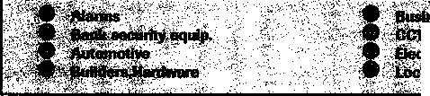

|  |  |  |
| --- | --- | --- |
| NKL Industries Ltd.  1111-13 Cavalier Blvd.  Chesapeake, VA 23323 (800) 528-9900; (757) 485-0271  • • • • | Sully Tools Inc.  3515 Nodding Pine Ct.  Fairfax, VA 22033  (703) 689-3416; FAX (703) 787-0869  • • • | Andrews Wholesale Lock Supply  544 S. 9th St  Lebanon, PA 17042-6608 (717) 272-7422  • |
| Prime-Line Products Company  5405 Industrial Pkwy.  San Bernadino, CA 92407 (800) 255-3505; FAX (909) 880-8968  • • | Trine Products Corporation  1430 Ferris Place  Bronx, NY 10461  (718)829-4796; FAX (718) 792-9127  0 9® | Boyle & Chase Inc.  P. 0. Box 74  Accord, MA 02018-0074 (800) 325-2530; FAX (617) 335-5342  • • • |
| ROFU International Corp.  2004-B 48th Ave.; Court E  Tacoma, WA 98424 (800) 255-7638; FAX (206) 922-1728  • | U-Change Lock Industries  1640 W. Hwy. 152  Mustang, OK 73064 (405) 376-1600; FAX (405) 376-6870  • • • | Clark Security Products, Inc.  4775 Viewridge Ave.  San Diego, CA 92123-1641 (800) 854-2088  •••••••••• |
| Rutherford Controls Inc.  2697 Internal Pkwy, Bid 5 #100  Virginia Beach, VA 23452 (757) 427-1230; FAX (804) 427-9549  • | Vindicator Corp.  3001 Bee Caves Rd.  Austin, TX 78746-5561 (512)314-1200; FAX (512) 314-1270  • • • • | Cook’s Building Specialties  2441 Menaul Blvd. NE; P.O. Box 37320 Albuquerque, NM 87176-7320 (505)883-5701; FAX (505) 883-5704  •••••• |
| Sargent & Greenleaf, Inc.  P.O. Box 930  Nicholasville, KY 40340-0930 (606) 885-9411; FAX (606) 887-2057  • • • • | Weiser Lock Company  6700 Weiser Lock Blvd.  Tucson, AZ 85746  (520) 741-6338; FAX (520) 741-6363  • ® | DiMark International  3117 Liberator St, Unit A  Santa Maria, CA 93455 (800) 235-2435; FAX (805) 928-8034  • • |
| Schlage Lock Co.  1915 Jamboree Suite 165  Colorado Springs, CO 80920 (800) 847-1864; FAX (800) 452-0663  • • | Wilson Safe Company  3031 Island Avenue/P.O. Box 5310  Philadelphia, PA 19153 (215)492-7100; (800)345-8053  • | Dire’s Lock & Key Co.  2201 Broadway  Denver, CO 80205 (303) 294-0176 |
| Schwab Corporation  3000 Main St.  Lafayette, IN 47903-5088 (765) 447-9470; FAX (317) 447-8278  • | Yale Security Inc.  P.O. Box 25288  Charlotte, NC 28229-8010 (800) 438-1951; (800) 338-0965  • • • • | Doyle Lock Supply  2211 W. River Road N.  Minneapolis, MN 55411 (800)333-6953; FAX (612) 521-0166 |
| Securitron Magnalock Corp.  550 Vista Blvd.  Sparks, NV 89434  (800) 624-5625; FAX (702) 355-5636  ® • | Distributors | Dugmore & Duncan Inc.  30 Pond Park Rd.  Hingham, MA 02043 (800)225-1595; FAX (617) 740-4043  ^ ^ |
| Security Door Controls  3580 Willow Lane  Westlake Village, CA 91361 (805) 494-0622; FAX (800) 959-4732 | Accredited Lock Supply Co.  P.O. Box 1442  Secaucus, NJ 07096-1442 (800) 652-2835; FAX (201) 865-5031  ^ ^ | Ewert Wholesale Hardware  4709 W 120th St  Alsip II 60658 (800) 451-0200  ® ^ |
| Sentry Group  900 Linden Ave.  Rochester, NY 14625-2784 (716)381-4900; FAX (716) 381-8559  • | Ace Lock & Security Supply Co.  565 Rahway Ave.  Union, NJ 07083-6631 (908) 688-7666; (800) ACE-FAX4 | Fairway Supply, Inc.  2631 Lombardy Lane  Dallas, TX 75220  (214) 350-0021; FAX (214) 352-4299  ••••••• |
| Silca Key U.S JK. Inc.  400 Jeffreys Rd.  Rocky Mount, NC 27804 (919) 446-3321; FAX (919) 446-4702  • ® | Akron Hardware Consultants, Inc.  2579 South Arlington Road  Akron, OH 44319  (800) 321-9602; FAX (800) 328-6070  • • • | Foley-Belsaw Company  6301 Equitable Road  Kansas City, MO 64120 (800) 821 -3452; FAX (816) 483-5010  ^ |
| STRATTEC Security Corp.  3333 W. Good Hope Rd.  Milwaukee, Wl 53209 (414) 247-3333; FAX (414) 247-3329  ^ (J^ (j} | American Security Distribution  4411 E. La Palma  Anaheim, CA 92807 (714)996-0791; FAX (714) 579-3508  ••••••• | Fried Brothers, Inc.  467 N. 7th St  Philadelphia, PA 19123 (800) 523-2924; FAX (800) 541-3489 |
|  |  |  |
| © Automotive v-: # Et^ri^Etec^nlc5ea ^ X | | |

481 *Keynotes*

January 1998

|  |  |  |
| --- | --- | --- |
| HS&S Wholesale Distributors  12915 West 8 Mile Road  Detroit, Ml 48235 (800) 521-2202  0 0 0 0 0 0 0 | M. Zion Company  17 Murray Street  New York, NY 10007 (212) 349-8677  0 0 0 0 0 0 0 | Top Notch Distributors, Inc.  3151 Goni Rd.  Carson City, NV 89706-7922 (800) 722-4210; FAX (800) 248-3620  0 0 0 |
| Hans Johnsen Company  8901 Chancellor Row  Dallas, TX 75247  (214) 879-1550; FAX (214) 879-1530  0 0 © (0 {0 (0 (0 (0) | McDonald-DASH Locksmith Supply  5767 E. Shelby Dr.  Memphis, TN 38141 (800)238-7541; FAX (901) 366-0005  00000000 | Turn 10  P. 0. Box 746  Marietta, OH m45750 (800) 848-9790; (800) 391-4553  0 0 |
| Hardware Agencies, Ltd.  1220 Dundas Street East  Toronto, ON M4M 1 S3 (416)462-1921  00000000 | McManus Locksmith Supply, Inc.  P.O. Box 9231, 1309 Central Ave.  Charlotte, NC 28299 (702) 333-9112  0 0 0 | U.S. Lock Corporation  77 Rodeo Drive  Brentwood, NY 11717 (800) 925-5000; FAX (800) 338-5625  0 0 0 0 0 |
| Hardware Suppliers of America  P.O. Box 2208  Winterville, NC 28590 (800) 334-5625  0 0 | McMaster-Carr Supply Company  600 County Line Rd,  Elmhurst, IL 60126-2081 (630) 833-0300; FAX (630) 834-9427  0 0 0 0 0 0 | Webster Safe & Lock Company, Inc.  3020 Millbranch  Memphis, TN 38116 (901) 332-2911; FAX (901) 332-2878  0 0 0 0 0 0 0 |
| IDN, Inc.  1000 S. Main, Suite 280  Grapevine, TX 76051 (817) 421-5470; FAX (817) 421-5468  0000000000 | Monaco Lock Co.  339-345 Newark Ave.  Jersey City, NJ 07302 (800) 526-6094; FAX (800) 845-LOCK  0 0 0 | Service |
| Intermountain Lock & Supply Co  2300 W. 2nd Ave., Unit B  Denver, CO 80223  (800) 323-8046; FAX (303) 698-2094  0000000000 | Omaha Wholesale Hardware  1201 Pacific Street, PO Box 3628  Omaha, NE 68108 (800) 238-4566  0 0 0 | Alarm Monitoring Service, Inc.  5021 Fairfield St.  Metairie, LA 70006 (504) 454-2163; (504) 456-8737 |
| Jo-Van Distributors Inc.  929 Warden Ave.  Scarborough, Ontario MIL4C6 (416) 752-7249; FAX (416) 752-3845  00000000000 | E. L. Reinhardt Co., Inc.  3250 Fanum Road  Vadnais Heights, MN 55110 (800) 328-1311; FAX (612) 481-0166  0 0 0 0 0 0 | Allstate Insurance Company  2775 Sanders Road, Suite A5  Northbrook, IL 60062 (847) 402-8196; FAX(847) 326-7509 |
| JLM Wholesale, Inc.  3095 Mullins Ct  Oxford, Ml 48371-1643 (800) 522-2940; FAX (800) 782-1160  0 0 0 | Security Lock Distributors  40 A Street  Needham Heights, MA 02194 (800) 847-5625; FAX (800) 878-6400  0 0 0 | GEICO  One Geico Blvd.  Fredericksburg, VA 22412 (540) 286-4399; FAX (540) 286-7106 |
| Key Sales & Supply Co., Inc.  9950 Freeland Ave.  Detroit, Ml 48227 (313) 931-7720; (313) 931-7758  000000000 | Sentry Security Fasteners  8109 N. University  Peoria, IL 61615  (309) 693-2800; FAX (309) 693-2872  ® ® | The Hartford Financial Services Co.  55 Farmington Ave.; P.O. Box 2908  Hartford, CT 06104 (860) 520-2915; FAX (860) 520-2264 |
| Lockmasters, Inc.  5085 Danville Road  Nicholasville KY, 40356 (606) 885-6041  0 0 0 0 | Southern Lock and Supply Co.  Box 1980, 10910 Endeavor Way  Pinellas Park, FL 34664 (800) 237-2875; FAX: (800) 447-2299  000000000 | Pine Technical College  1000 4th Street  Pine City, MN 55063 (800)521-7463; FAX (612) 629-7603 |
| Locks Company  2050 N.E. 151 St.  N. Miami, FL 33162 (800) 288-0801; FAX (305) 949-3619  0 0 0 0 0 0 0 | Stone & Berg Wholesale  99 Stafford Street  Worcester, MA 01603 (800) 225-7405; FAX (800) 535-5625  0000000000 | Unlocks, Inc.  3505 Tarpon Woods Blvd. G409  Palm Harbor, FL 34685 (800) UNLOCKS; FAX (813) 787-7960 |
| The Locksmith Store Inc.  1229 E Algonquin Rd. Suite E  Arlington Heights, IL 60005 (847) 364-5111; FAX (847) 364-5125  0 0 0 0 | Strauss Safe & Lock Company  1801 Second Avenue  Des Moines, IA 50314 (515) 288-9571; FAX: (515) 288-9752  0 0 0 0 0 0 |  |
|  |  |
| © Alarms ® Business/Tech & Ed. a _ ,  ® Bank security equip. © CCTV/Photo Imaging ^ °°S Upp ,eS  © Automotive © Electric/Electronic Sec. | Safes/Vaults  © Builders Hardware ® Lock Devices er | | |

**January 1998** **Keynotes** **| 49**

ALOA Video Library

**Order Form**

Policies of the ALOA Video Tape Library and procedure for ordering videos:

1. Videos are loaned to ALOA members, chapters and local associations for a period of one (1) week. All tapes

are VHS format. Notice: All video tapes are protected under the US copyright laws and may not be duplicated.

1. Only one tape per order is allowed unless prior arrangements have been made with the ALOA office; e.g., chapters holding educational events.
2. Charges: $7.50 per tape for shipping and handling.

$10.00 per day late charge. Late charges are assessed for tapes more than 2 days late.

$100.00 per tape for loss or damage.

1. Payment for shipping and handling must accompany the order, except for faxed orders. Any additional charges will be billed to the borrower.
2. A credit card account number must be included on the video order form as a deposit. If the video is not returned, your credit card will be billed for late charges or for loss/damages.

Credit card # Expiration date

1. It is the responsibility of the borrower to insure each tape for the $100 against loss or damages when returning videos to the ALOA Library.
2. Failure to remit shipping and handling, late, or any other charges may result in suspension of borrowing privileges.
3. To order a video, indicate 1st, 2nd, and 3rd choices on this form, fill out the bottom portion completely, and

mail the entire form to: ALOA Video Department, 3003 Live Oak St., Dallas, Tx 75204

1. Orders may also be faxed to (214) 827-1810.

Q 99 Rim Device Installation Q Advanced Door Panel Servicing Volume 1

Q Air Bag Steering Columns Volume 1

Q Air Bag Steering Columns Volume 2

* Auto Lock Servicing Update #1 Q Automatic Dialer
* Basic Car Opening, Vol. 1 Q Basic Door Panel Servicing
* Basic Locksmithing, Volume 1 Beretta & Corsica: Opening
* and Fitting Keys Business Locks and

Q Locking Devices Q Car Opening Update #1 Q Car Opening Update #2 Q Car Opening Update #3 Q Car Opening Update #4

* Car Opening Update #5
* Car Opening Update #6
* Car Opening Update #7 Q| Car Opening Update #8

Q Chrysler Double-Bitted Locks

* Chrysler Pin Tumbler Locks O Chrysler Steering Columns

□

□

□

□

□

□

□

□

□

□

□

□

□

□

□

□

O

a

□

□

O

□

□

□

* except for faxed orders and orders from outside the US

Detention Locks

The Door to Business Security

The Door to Home Security

Filing for Dollars

Ford Locks

Ford Steering Columns GM Locks

GM Steering Columns

Home Security Alarms

Home Security Survey

Import Models, Volume 2

Impressioning GM/Ford Sidebar Locks

Labeled Fire Door

Lock Mortiser

Mastering the Art of Impressioning

On the Home Front

Padlocks

Pinning KABA

Plugging for Profit

Precision Key Machines

Residential Locks and Locking Devices

Residential Magnetic Contact Applications

Robbery Prevention Techniques

S&G 6120 Series

S&G Combination Lock Fundamentals for the R6730-TOR (5/90)

Q S&G Commercial Products (2/90)

Q S&G Government Products (8/89)

* S&G Integrating High Security with Life Safety
* S&G Locking Mechanisms (6/89)

S&G Scrambler Servicing

a

Safe Deposit Locks, Volume 1  
Safe Deposit Locks, Volume 2

□ Safe Deposit Locks, Volume 3  
Servicing the Honda and Acura  
□ Servicing the Toyota & Similar Locks

□ Shock and Moisture Sensors:

High Security Risks □ Somebody's Watching □ Standard Steel Door Frames Q Standard Steel Doors Q Thief on the Loose!

Commercial Glass Break Applications □ Toyota Split - Tumbler Locks: Use and Adjustment of Gemini Key □ V.A.T.S. Made Simple Q What's Behind a Fire Door Test Label? Q Yale Door Closers

**9/97**

ALL INFORMATION MUST BE COMPLETE OR PROCESSING MAYBE DELAYED

ALOA Member # Date Needed:

Name **Phone #**

Address (No P.O. Box)

City State ZIP

Enclosed is [1 Check **|H** Money Order for shipping 81 handling

Use this card to obtain more information about the products and services advertised or described in this issue.

**Card valid until May 1, 1998.**

A LILA- Mentor

0 number for

information on  
each item.

Reader Service

‘January1998

Name _

_Title

Company

Use this card to obtain more information about the products and services advertised or described in this issue.

**Card valid until May 1f 1998.**

i

i

i

!

i

I

Street Address _ City

_State

Phone_

_Country _FAX _

_ZIP_



|  |  |  |  |  |  |  |  |  |  |  |  |  |  |  |  |  |  |  |  |
| --- | --- | --- | --- | --- | --- | --- | --- | --- | --- | --- | --- | --- | --- | --- | --- | --- | --- | --- | --- |
| 1 | 6 | 11 | 16 | .21 | 26 | 31 | 36 | 41 | 46 | 51 | 56 | 61 | 66 | 71 | 76 | 81 | 86 | 91 | 96 |
| 2 | 7 | 12 | 17 | 22 | 27 | 32 | 37 | 42 | 47 | 52 | 57 | 62 | 67 | 72 | 77 | 82 | 87 | 92 | 97 |
| 3 | 8 | 13 | 18 | 23 | 28 | 33 | 38 | 43 | 48 | 53 | 58 | 63 | 68 | 73 | 78 | 83 | 88 | 93 | 98 |
| 4 | 9 | 14 | 19 | 24 | 29 | 34 | 39 | 44 | 49 | 54 | 59 | 64 | 69 | 74 | 79 | 84 | 89 | 94 | 99 |
| 5 | 10 | 15 | 20 | 25 | 30 | 35 | 40 | 45 | 50 | 55 | 60 | 65 | 70 | 75 | 80 | 85 | 90 | 95 | 10C |

Card valid until May 1,1998.



number for information on each item.

Reader Service

*January1998

Name .

_Title

Company

Street Address _ City

_State

_Country

_ZIP_

|  |  |  |  |  |  |  |  |  |  |  |  |  |  |  |  |  |  |  |  |  |
| --- | --- | --- | --- | --- | --- | --- | --- | --- | --- | --- | --- | --- | --- | --- | --- | --- | --- | --- | --- | --- |
| 1  :  1 |  | Phone |  |  |  |  |  |  |  |  | FAX |  |  |  |  |  |  |  |  |  |
|  |  |  | | |  |  | ■Hi | mu | HH | HHH | HU | ■Hi |  | Hi | HI |  |  |  |  |
| 1 | 6 | 11 | 16 | .21 | 26 | 31 | 36 | 41 | 46 | 51 | 56 | 61 | 66 | 71 | 76 | 81 | 86 | 91 | 96 |
| s | 2 | 7 | 12 | 17 | 22 | 27 | 32 | 37 | 42 | 47 | 52 | 57 | 62 | 67 | 72 | 77 | 82 | 87 | 92 | 97 |
| 1 | 3 | 8 | 13 | 18 | 23 | 28 | 33 | 38 | 43 | 48 | 53 | 58 | 63 | 68 | 73 | 78 | 83 | 88 | 93 | 98 |
|  | 4 | 9 | 14 | 19 | 24 | 29 | 34 | 39 | 44 | 49 | 54 | 59 | 64 | 69 | 74 | 79 | 84 | 89 | 94 | 99 |
| 5 | 10 | 15 | 20 | 25 | 30 | 35 | 40 | 45 | 50 | 55 | 60 | 65 | 70 | 75 | 80 | 85 | 90 | 95 | 100 |

I

I

It.,

Card valid until May 1,1998.

|  |  |  |  |  |
| --- | --- | --- | --- | --- |
|  | | |  |  |
| Name |  |  | PRP | ALOA# |
|  | | |  |  |
| City |  |  | State | Zip |
| Years Exoerience |  |  |  |  |
| Areas of Locksmi thina that vo u are oroficient in: | | | |  |
| Domestic Auto | C omme r cia l |  | Master Keying |  |
| Foreign Auto | Residential |  | Access Control | |
| Auto Opening | Safe Servicing | | Safe Opening |  |
| CCTV | Computers |  | Business |  |

Other

A v a i.l able for ca L L s ;

JBJb-Qii.£ numbers

Weekdays

Saturday

Sunday

am to

AM tO AM tO

PM

PM

PM

Days

Nights

Pager

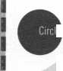

BUSINESS REPLY MAIL

**FIRST-CLASS MAIL PERMIT NO 16501 DALLAS TX**POSTAGE WILL BE PAID BY ADDRESSEE

NO POSTAGE  
NECESSARY  
IF MAILED  
IN THE

UNITED STATES

PO BOX 11602 RIVERTON NJ 08076-7202

BUSINESS REPLY MAIL

**FIRST-CLASS MAIL PERMIT NO 16501 DALLAS TX**POSTAGE WILL BE PAID BY ADDRESSEE

NO POSTAGE  
NECESSARY  
IF MAILED  
IN THE

UNITED STATES

PO BOX 11602 RIVERTON NJ 08076-7202

**IIIiiiIiiI.IIiiiImiIiII.iIii.Ii.IiIII...i.IiIIiiI.I**

P L a ce  
**Stamp  
Here**

Robert DeWeese, CPL Bear Lock & Security, Inc. 205 Cleveland Ave. Baltimore, MD 21222-4237

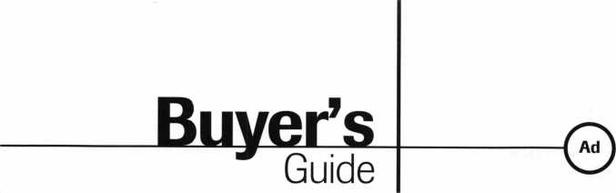

Alternative Tools

Here are new tools  
that address prob-  
lems from an alterna-  
tive point of view.  
When the “usual”  
methods can’t get it  
done, try an alterna-  
tive tool. “The Tool”  
tension wrench is  
designed especially

to allow more room for picks in SCI and  
KW1 keyways. “Lever Up” lifts vertical  
auto lock linkage without disconnect danger  
and without the tool entering the vehicle.  
“Paddle Pusher” operates paddles and  
crash bars like you were standing inside.  
$12.95 (+$4.95 S/H). Allow four to six  
weeks for delivery. Send order on back of  
business card with check or m/o to: Alterna-  
tive Tools, Inc.; 162 Robin Dr.; Loveland,  
CO 80537.

Reader Service #24

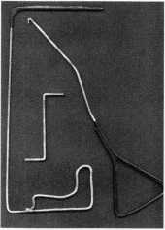

Allstate Locksmith  
Insurance Program

As a retail or mobile  
locksmith, you under-  
stand how important  
it is to rely on a solid,  
reputable company to  
help you with your  
business insurance  
needs. If you have any  
questions about your  
insurance needs in  
general, an Allstate  
Agent can provide you  
with additional infor-

mation. To be referred to an Allstate Agent,  
please call (800) 669-6711.

Reader Service **#25**



Pewter Keychains

Order pewter keychains direct from the fac­tory at our fabulously low wholesale price of $2.45 each. We are so confident in our prod­uct that they are guaranteed. Our high qual­ity unique products are what your customers are looking for and are available at a price

everyone can  
afford.  
Remember,  
time is money,  
so send in  
your order  
today to: Mil-  
man Manufac-  
turing; Cham-

plain Mall Rd., P.O. Box l64l;Champlain,  
NY 12919; (514) 425-5794 or fax (514)  
425-5793.

Reader Service #26

Door Controls International

Door Controls Inter-  
national announces  
our new champion  
lever trim. UL certi-  
fied ANSI/BHMA  
156.3—1994, grade

1. The 08L lever trim  
   is to work in conjunc-  
   tion with our fire rated

security alarmed rim exit device, Pannex.  
The vandal resistant lever is available for  
standard or narrow stile doors, and can also  
be supplied with electric release. Phone  
(313) 426-0400.

Reader Service #27

Pro-Lok has devel-  
oped new  
machined alu-  
minum padlock  
service tools for  
professional lock-  
smiths. The green  
anodized LT605  
Diskbuster is a fix-

ture that automatically lines up your drill  
bit to penetrate the shearline on disk-type  
padlocks, allowing safe, simple openings.  
The gold anodized LT612 Padlock Drill Jig  
lets you drill most rekeyable padlocks open  
while saving the lock body and cylinder.

The black anodized LT612DG Drill Guide is an optional attachment that centers the oval retaining nut on the bottom of many

PRO-LOK

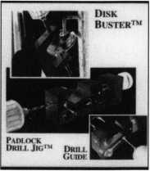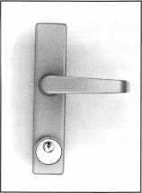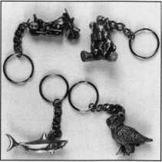

rekeyable padlocks, allowing you to drill it out, service the cylinder and reuse the pad­lock. For more information, contact PRO- LOK. Phone (714) 633-0681

Reader Service #28

The 1998 update  
from PRO-LOK  
will feature over  
100 pages of car  
opening informa-  
tion. From the  
Audi A4 to the  
Volvo 960, you will  
find full color pic-  
tures and an easy to  
follow step-by-step

guide to unlocking the ’98 cars. With each  
page as a self-contained lesson, both the  
beginner and the expert will be able to open  
those new ’98 cars. For more information,  
contact your distributor or PRO-LOK at  
(714) 633-0681.

Reader Service #29

PRO-LOK



January 1998

Keynotes

**Keynotes**

Classified



Deptj

■Employment

Locksmith Wanted

l/F/3: Boston based safe compa­ny needs organized, manage­ment type person to supervise service and delivery crews. Technical background helpful. Salary plus bonuses based on experience.

(800) 367-3453 (617) 497-7542 fax

Locksmith Wanted

l/F/3: Locksmith wanted for shop and mobile unit. Minimum three years experience. Good dri­ving record and good communi­cation skills. Call anytime.

Plaza Locksmith Ventura, CA 93003 (805) 653-6946 (805) 644-6622 Ask for Mike or Darlene

Locksmith

l/F/3: Established lock shop in operation 50 years, friendly staff, looking for a qualified locksmith for outside road work. Knowl­edge and experience in various areas of the industry. Safe open­ing knowledge essential. Mini­mum five years’ experience. Pro­fessional attitude, organized, good communication skills, clean driving record. Benefits include health insurance, paid vacation, holidays. Vehicle, tools, two-way radio provided. We’d like to have you join our team.

Resume and references to:

Dawn Barnes 135 Main St. D12 Wes thorough, MA 01581 (508) 366-8864 fax

record. Background check will be required for state license.

Resume, references and salary require­ments:

Novato Lock 7395 Redwood Blvd.

Novato, CA 94945 (415) 892-9111

Store Manager/Locksmith Wanted

l/F/3: Work in beautiful, grow­ing Denver, Colo. Position now available with 27 year company operating three stores and nine service vehicles. Presently look­ing for a hard working, enthusi­astic individual with good lock­smith skills to operate all facets of store operations including inventory control, sales, pur­chasing, and technical service. No mobile or on-call. Paid vaca­tions, holidays, medical/dental, educational classes, and uni­forms furnished, Salary offering varies with experience level, 33k base for qualified applicants. Resume's to:

Englewood Lock and Safe, Inc.

4310 S. Broadway Englewood, CO 80110 (800) 257-2568 (303) 789-3748fax

Locksmith Wanted

1 l/F/3: Sacramento Valley Lock- works, Inc. has an immediate, full-time position for an experi­enced, well rounded individual to become a member of our team. All levels of experience will be considered. Our compa­ny specializes in Commercial sales and service, Electronic Access Control and Safes. We offer a competitive wage com­pensation package, including Medical/Dental, paid Holidays and vacation. We will consider financially helping in any mov­ing expenses and locating resi­dency if needed. Applicants must have a clean driving record, clean appearance, be self motivated, and possess the capa­bility of working together as a team player. SVL was estab­lished in 1988 and is considered one of the top Commercial Secu­

rity Contractor’s in the Valley. Shane Huff or Carolyn Hamric (916) 733-0324 fax (for resume) (916) 733-0320 (for interview)

Locksmith Wanted

1 l/F/3: Relocate to Southern California. Experience needed. Residential, commercial, safes, and auto. 40IK, medical insur­ance, commissions.

Resume, references, and salary infor­mation:

The Lock Shop, Inc.

73-560 Highway 111 Palm Desert, CA 92260 (760) 346-5214 (760) 779-1811 fax

Help Wanted

10/F/3: Are you a promising, career-minded, responsible sales oriented individual with a for­midable track record for creative marketing and good communi­cation skills? This position is for a serious goal-oriented Cus­tomer Service Representative who demands the ultimate chal­lenge of working hands-on with customers and is seeking the type of opportunity which will afford the pay they are worth! We offer stability, top pay and outstanding benefits in the Hardware/Security field. Knowl­edge of Low Voltage/Access Control would be a definite asset.

Resumes to:

Human Resources 929 Warden Ave.

Scarh, Ontario MIL 4C5, Canada

Wanted

10/F/3: Due to growth of com­mercial business, well-estab­lished Portland, Ore. lock shop is looking for experienced tech­nicians for commercial lock and safe work, high security, and electronic access control work. Excellent salary and benefits.

We need skilled professional security professionals to service our demanding commercial accounts. They must be interest­ed in people and have a commit­ment to quality workmanship. Resume to:

Experienced Locksmith Wanted

l/F/3: Join an established lock­smith company is beautiful Marin County, Calif. Just 35 minutes North of San Francisco. Pleasant year-round conditions. Good base pay plus commission, profit sharing, paid absence.

Paid health and pension also available. Must be proficient in all phases of locksmithing, neat appearance and good driving

A

Keynotes

January 199H

McMahon’s Locksmiths 401 W. Burnside Portland, OR 97209 (203) 228-1128fax

Wanted

10/F/3: Colorado’s largest lock­smith company seeks locksmiths with experience in impression- ing, master keying and automo­tive. Top wages and benefits available for the right persons. Resume to:

Colorado Security Products, Inc.

5005 South Kipling Unit A-8 Littleton, CO 80127 (303) 761-3899

Wanted

10/F/3: Experienced locksmith wanted, minimum five years experience in all facets of com­mercial and industrial lock- smithing. Safe, alarm and access control experience a plus. Must have a clean driving record, good communication skills, be hard working, and neat in

LOCKSMITH

Mystic Lake Casino Hotel, a leader in Minnesota’s gaming industry, is seeking an independent, discreet locksmith with at least three years’ experience in a lockshop environment and training in low voltage electricity to join our team of nearly 4,000 employees. You’ll need extensive knowledge of Medeco and BEST lock hardware, master systems and architectural hardware. Must be proficient in opening cars. We offer a competi­tive salary and benefits package. All tools are supplied. For confi­dential consideration, please send your resume to:

Mystic Lake Casino Hotel  
Team Employment  
2400 Mystic Lake Blvd  
Prior Lake, MN 55372

Classified Advertising Policy

Classified advertising space is provided free of charge to ALOA members, and for a fee of $.60 per word, $1 5  
minimum for non-members. Classified ads may be used to advertise used merchandise and overstocked items  
for sale, “wanted to buy” items, business opportunities, employment opportunities/positions wanted and the like.  
Members or non-members wishing to advertise services or new merchandise for sale October purchase a  
“Commercial Classified Ad,” for a fee of $1.30 per word, with a minimum of $40. Each ad will run for two issues.  
For blind boxes there is a $5 charge to members and non-members. All ads must be submitted in writing to the  
ALOA office by the fifteenth of the month, two months prior to issue date. Send to **Keynotes** Classifieds, 3003  
Live Oak St., Dallas TX 75204-6186. ALOA reserves the right to refuse any classified advertisement that it  
deems inappropriate according to the stated purpose of the classified advertising section.

Keynotes

Classmed

appearance. Salary and benefits commensurate with experience and training. Smoke, drug and alcohol free environment.

Resume and references:

R. Haskell

1613 Wade Hampton Blvd.

Greenville, S.C. 29609 (864) 332-7314

**IBusinesses for Sale** Manufacturing Company for Sale

l/F/3: Lock technology corp. New Rochelle, NY, Lock Manu­facturing company est. 1974. Owner is retiring.

For details, call Frank (914) 632-4373

Businesses for Sale

l/F/3: Commercial, industrial, residential and automotive. Storefront and mobile service.

25 years in Colorado foothills community of 47,000. Busy and productive business with con­tinued growth. Buyer needs experience in all phases of lock­smith applications and hardware installation to meet customer demand.

Keynotes Classifieds 3003 Live Oak St.

Dallas, TX 73203

Sunny Southern California

l/F/3: Established in 1962, same owner since 1977. Locat­ed in suburban, growing com­munity near California’s largest water reservoir project. Well- established commercial accounts. Sale includes van, inventory, equipment and com­mercial property. Training available. Owner willing to stay during transition.

(909) 638-2777

Business For Sale

1 l/F/3: Well-established, large clientele, unlimited potential in fast-growing east Texas com­munity.

(409) 639-1029.

Leave name and telephone number.

For Sale

10/F/3: Locksmith shop in

Southern California. 26 years history of service to Banning/Beaumont area. Full service shop includes inventory, equipment, commercial accounts and 1984 Ford 1/2 ton service van. Owner wants to go fishing. 1800 square foot build­ing also available for sales or lease.

(909) 843-3397

For Sale

10/P/3: Excellent growth potential. Well-established lock and safe company in upper Midwest. 80 percent commer­cial accounts, two equipped ser­vice vans, inventory, full shop equipment. Commercial prop­erty available. Grosses 185,000 to 200,000 per year. Communi­ty and company keeps on grow­ing. Serious inquiries only. Keynotes Classifieds 3003 Live Oak St.

Dallas, TX 73203

Business For Sale

l/P/2: Branson, Mo.—America’s live country music capitol. Ser­vice the start! Established five years and growing. Full service mobile locksmith business. $65,000 net year.

(417) 333-2329

■Wanted to Buy/Sell

Safes for Sale

l/F/3: 100 safes, various sizes. Low prices. For a catalog:

Empire Safe Co (800) 343-3412 (212) 941-9073 fax Attn: Wholesale Department

Tools and Products for Sale

l/F/3: All types. Safe deposit locks, parts, sections of 50 boxes and bank equipment parts, etc. Best source for Security/ Kumhari Locks.

For information, price list, or ordering:

(800) 642-8763 (972) 289-8476fax

Key Blanks Wanted

l/F/3: Wanted, Old Auto key blanks, Hurd, and Briggs and Stratton—will pay $1.00 each.

Douglas Vogel 1100 Shady Oaks Ann Arbor, Ml 48103

Antiques for Sale

l/F/3: Private collection of old key lock antique safes seven in all: Samuel Jones Improved Salamander, Boston E.R. Morse Safe Maker, Boston, E.F. Miller and Sons Safe Maker, Provi­dence, R.I., M.B. Bigelo & Anson Hardy (1884) Valentine Butler, New York, Alum Patent 35" tall, Valentine Butler Alum patent, New York 55" tall. A most distinct collection.

Milton Wolfserder American Safe & Lock Co.

117 N. Main St.

Providence, RI 02903 (701)331-3013

Complete Key System Service

10/F/3: We will create your master system, cut your keys, pin your cylinders, ship to you ready for installation. All stan­dard lock manufacturers includ­ing Medeco.

(201) 818-0333 (973) 778-4021

Wanted

10/F/3: Looking for the follow­ing: Power Star or Redi Line, HPC 1200, Ilco Tubular Key Machine.

(714) 438-7439 Ask for Robert

Wanted to Buy

10/F/3: Ilco Orion KD 55 Sidewinder Key Machine used very little and in new condition. Will let sidewinder keys and guide keys go with it for $1,250 and you pay freight.

Larry Wright 392 Green Acres Rd Gaffney, SC 29341 (864) 489-8417.

For Sale

Norton Powermate 6610POR door operators. Regular dealer $ 1500/each. Will sacrifice for $ 1000/each. Purchase all seven for $850/each.

(783) 823-6237 Ask for Lonnie

For Sale

Scotsman key machine (Ace type), model 747XU, cuts three sizes. Used but in good condi­tion. Asking $250. Also, Taylor 137S (small) and Taylor 137A (large) key blanks. 20 cents each (approximately 200 pieces).

AAA Distributors

286 Franklin Street

Buffalo, NY 14202

(800) 462-8180 (northeast only)

(716) 836-2261

■Commercial Classifieds

Tryout Keys, Depth Keys

l/P/3: Aero Lock does not use key duplicator machines to pro­duce its tryout keys or depth keys. Only original computer controlled code cut. Buy the best.

Aero Lock

3673 New Getwell Rd. #9 Memphis, TN 38118 (800) 627-9433 (901) 362-1197 fax e-mail: [aerolock@ix.netcom.com](mailto:aerolock@ix.netcom.com), http: I Iwww. aerolock. com

Situations Wanted

1 l/F/3: ALOA member since 1973 relocating to Kyiv (for­merly Kiev), Ukraine for next two to three years. Willing to represent your interests or line of products in Eastern European region.

V.M. Roubachewsky, do Dept, of State-Kyiv,

Washington D.C. 20321-3830

(301) 884 - 3913

e-mail: natalier@mail.ameritel. net.

January 1998

Keynotes



If this is January, this must be Dallas.

/PRP Dates

January 18,1998

Richmond, Virg.

Virginia Locksmith Assoc.

R. T. Earll [703] 335-0852

January 25, 1998

King of Prussia, Pa.

Keystone Chapter Barry Leas, CRL [610] 272-9292

January 25, 1998

Greenville, So. Car.

South Carolina Locksmith Association Chris Melton, CRL [803] 791-1553

February 15, 1998

Waco, Texas

Texas Locksmith Association Wanda Robbins-Clark [210] 923-4381

March 24, 1998

Las Vegas, Nev.

ALOA Education Conference at ISC David M. Lowell [800] 532-2562

March 28, 1998

Hammond, La.

Lou-Miss Locksmith Association Thomas L. Hunt, CPL, CPS [205] 833-3333

March 28, 1998

Somerset, NJ.

Master Locksmiths Association of New Jersey

Charles Green, CRL [973] 267-8884

March 28, 1998

Kenosha, Wis.

Greater Chicago Locksmith Association John J. Geeenan [773] 486-2030

May 23, 1998

King of Prussia (Valley Forge], Penn.

SAFETECH

David M. Lowell

[214] 827-7233

30-day application period required

I)

**KeynotesJanuary 1998**

Just a few months ago, I wrote you about our new in-house administration of the PRP pro­gram. Little did I know at this time that I myself would be joining the ALOA staff— moving to Dallas as the new PRP/Education Manager. This is an exciting time for both programs as we embark on a whole new effort to tailor ALOA’s education and profi­ciency testing to better meet our members needs. I’ve got my work cut out for me, its plain to see. Luckily the ALOA support staff is ready and able to assist me in making this transition. I hope it will be a smooth one, and I hope that the results will be to your satisfaction.

We have a number of new sittings sched­uled. Keep looking for a sitting in your area—we want you in the PRP program.

New Certifications

CPLs

Kruysman, James B./Sarasota, Fla.

CRLs

Bailey, Yolanda J./Toledo, Ohio Crume, Walter C./Brookville, Ohio Gerow, Frank H./Lancaster, Pa.

Keister, Alan W./Middleburg, Pa. Kupferman, Ken/Lutz, Fla.

Lampone, Frank/Lakeland, Fla.

Pigue, Charles D. II/Auburn, Wash.

Savarin, Jamie D./Louisville, Ohio Spencer, Samuel J./Ronks, Pa.

PRP History Requests

If you need information about your PRP his­tory, please contact the ALOA office at 3003 Live Oak Street; Dallas, Texas, 75204.

When you do contact (in writing) the PRP staff, please reference your current ALOA membership number and/or any old ALOA membership numbers under which you might have taken the PRP evaluation.

PRP Resource Guide

One excellent resource in preparing for the PRP is the PRP Resource Guide available from the ALOA office for $18 (which includes shipping). The Guide covers PRP registra­tion procedures, categories, a study guide,

sample questions, references to applicable materials in other publications, and a profes­sional glossary of terms.

Mandatory Categories

One the first questions asked by some PRP candidates is, “What is the basic information —what are the basic skills—required of a certified locksmith?” For those of you who are new to the process, the PRP begins with 10 mandatory categories. Those are:

* Codes and Code Equipment
* Cylinder Servicing
* Key Blank Identification
* Key Impressioning
* Professional Lock Opening Techniques
* Lockset Functions
* Lockset Servicing
* Basic Master Keying
* Cabinet, Furniture and Mailbox Locks.

About the Chairman: David Low-

ell, CML, CMS, is ALOA’s immediate past presi-  
dent and an ALOA Trustee. David has served on  
the ALOA board for 10 years. He owns and oper-  
ates Phoenix Lock & Key in Arizona, and has  
been an ALOA member since 1981.



Proficiency Registration Program

Available to locksmiths worldwide, ALOAs proficiency registration program (PRP) evalu­ates the educational and technical competence of dedicated individuals in 36 categories such as hardware installation, high security and safe/safe vault locks, master keying, alarms and access control devices. There are four levels of PRP certification:

Registered Locksmith CRL)

Certified Registered Locksmith (CRL) Certified Professional Locksmith (CPL) and Certified Master Locksmith (CML)



It pays

to have new faces  
in the crowd.



During 1998  
each ALOA member  
who sponsors  
a new applicant  
will receive $40 cash  
(upon clearance,  
and payment

of application fee and dues).

|  |  |  |
| --- | --- | --- |
| „ 1 „ | Tbs | |
| irade |  |  |
|  | ■ TonyKamunno, CML.CPS  Trade Tips Editor | |

The Weslock-Toyota Connection

If you lose the ball bearing while rekeying a Toyota Camry trunk lock, the master keying ball from a Weslock knob lock or deadbolt makes a good replacement. Additional tip: If your Weslock knob lock or deadbolt as a loose cylinder, hold it in place using the wafer from a Toyota Camry trunk lock, If you use an awl or similar beveled tool, the wafer can be widened and used as a washer and the length of the wafer holds the cylinder in place.

R. Robertson #22372

Peening Pins

I read recently in a trade publication about loose thumb estucheons on Ford ignition cyls. The author suggested drilling and using a screw to tighten up the thumb piece. Here is another way to do it that may be a little quicker and easier.

1. Remove ignition cylinder from steering column via poke hole in shroud.
2. Remove plug from cylinder housing.
3. Insert blank key into plug in order to line up turn piece with plug keyway.
4. Find yourself a 7/64 “drill bit (it is .1094 in diameter).
5. Drill a hole through casting and into plug, being careful not to go too deep.
6. Look around on the floor and find a bot­tom pin about .26" long.
7. Insert the pin in the hole and gently tap in place. When pin bottoms out, give it a solid hit to swell the brass pin.
8. Dress with a file and reassemble.

This method is quick and easy and doesn’t require glue or cutting of screws. And since everything is either brass or pot metal, it will dress quick.

Whether you can call this a permanent repair is going to be a judgment call on the part of the locksmith and the customer.

Darrell Shandy #25847

Last month’s Track Tip winner was James E. Williams with “Ignition Picking.”

**/flow To Become A Trade Tipper**

Each month, the Associated Locksmiths of America (ALOA) holds a “Trade Tips” con­test in Keynotes for ALOA members. In addition to helping other locksmiths by sharing your knowledge, there are three levels of prizes to be awarded:

September 1997 Sargent & Greenleaf 6120 electronic safe lock

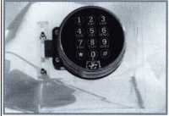

Grand Prize: An expense-paid trip to the ALOA ’98 Security Expo

Each year, the ALOA Publications Commit­tee selects one outstanding tip, the author of which receives a seven-day ALOA con­vention package that includes travel and accomodations.

Authors of any Trade Tip published will still receive $20.

Want to Participate?

Mail your best idea (including photos,

illustrations or parts, if necessary) to

Keynotes

Trade Tips Editor

3003 Live Oak St.

Dallas, TX, 75204-6186.

All entries are sent to the Trade Tips editor with the author’s identity deleted. The tips must be submitted exclusively to Keynotes and become the exclusive property of ALOA. Tips are judged on the basis of accuracy, professionalism, ethical stan­dards, originality and usefulness.

y

January 1998 Keynotes \ 35

Chapter

News

Dana Barnum, CML Committee Chairman

^ ***ALOA chapter members can write to Dana Barnum at: CHAPTER NEWS; 3003 Live Oak Street; Dallas TX 75204; fax (214) 827-1810; aloa@anet-dfw. com***

Mountains and molehills.

Since I changed the format of the Chapters department, I’ve had a variety of comments from the local front—from mountains to molehills. I’d like to talk about the latter first.

Sweating the Small Stuff

I’d like to address these inquiries as a group. This covers everything from “I didn’t get my meeting notice” to “I don’t like the food where we meet.” Don’t misunderstand—I know that a fairly mn, efficient chapter needs to take many, many details into considera­tion. And I realize that problems crop up when chapter leadership isn’t responsive to membership needs, even small needs. But often these types of issues can be resolved by getting involved in chapter leadership per­sonally, making a contribution as opposed to expecting to be catered to and waited on.

The Big Picture

What concerns me most is that I see “big picture” issues falling by the wayside for many chapter members. Issues such as ...

* Why do we even have a chapter of ALOA? Is it to communicate local concerns to the national office about legislation or techni­cal competency? Are we doing that?
* Did we form a chapter of ALOA to pro­vide fellowship to one another locally? In that case, what are we doing bickering? What kind of message does that send to our chapter members?
* Do we stay informed and participate local­ly in the national efforts of ALOA? Do we promote ACE classes, encourage atten­dance at the annual convention, publicize the ALOA Code of Ethics, read our monthly magazine? Do we promote the signifi­cance of ALOA membership to our cus­tomers and the local media? How do we make national association membership work for the good of locksmiths in our chapter?

Let me repeat that last sentence: How do we make national association membership work for the good of the locksmiths in our chapter? Every day you have the chance to either strengthen membership in ALOA or sabotage our mutual interests.

561 Keynotes January 1998

The Dues and Don’ts of Objecting

Before I put aside my thoughts about com­plaints I’ve heard lately, let me throw one more into the mix. There seem to be some members out there who feel justified in grumbling about the recent (and relatively small) dues increase for ALOA. They say “nobody’s in favor of it” and “nobody knew about it.” This decision was reached at the spring 1997 board meeting, more than five months before ALOA dues billings went out for 1998. The dues increase was the subject of then President David Lowell’s page-long message on p. 2 of the May 1997 issue of Keynotes. The increase was duly and plainly reported in the minutes of the Membership Committee report in that same issue. Anyone wishing to comment had the opportunity to do so. But, of more importance, why are ALOA dues higher this year? The answer is simple—ALOA membership wanted it that way. In the spring 1997 membership opinion survey, the majority of respondents said they would be willing to pay higher dues if ALOA offered more of the benefits they needed. The “bene­fits needed,” according to the survey, includ­ed better legislative representation, the abili­ty to vote-by-mail, and more and better edu­cation. Accordingly, ALOA implemented a dues increase, and hired a Legislative Manag­er and an Education Manager. ALOA’s attor­ney is in the process of positioning ALOA to be able to provide vote-by-mail, even if it means presenting re-drafted Bylaws to the membership and/or re-incorporating in another state. This is what participants in the ALOA membership survey asked that ALOA do. A copy of that opinion survey went out to every member of ALOA. Each one of you receive Keynotes as well. I think it should go without saying that if you do not read the information you receive from ALOA and you do not respond when your opinion is asked, the decisions that are made may not reflect your preferences. Another possibility is that you were simply out-voted by your fellow members. In either case, let’s admit that ALOA has behaved responsively and fairly.

Heading For Japan

Once again, I’m going to summarize corre­

spondence—this time on an international scale. ALOA is working with Joe Lee, our ambassador to Korea, to establish a viable chapter in Japan. This involves a great deal of translation work, including chapter leader­ship training materials and The Glossary of Professional Terms Relating to the Lock Industry. Although ALOA is an international associa­tion, our current staff size, membership size and association budget leave us in the posi­tion of relying heavily on volunteer efforts from our international members when it comes to issues of language and personal con­tact. Joe is a rarity, a true professional—gen­uinely excited about locksmithing and eager to contribute to the advancement of high standards in other countries. We’re lucky to have grassroots participants like him and many others who take so much on them­selves to help those in our industry.

Welcome to ALOA, Japan.

Chapter Scholarships

A memo has gone out from the ALOA Scholarship Foundation to chapters announc­ing the availability of funds for scholarships (an application is on the tear off card in this issue of Keynotes). I hope that you will actively encourage members of your chapter to con­sider applying, or recommending applicants, so that individuals who desire to do so will have every chance to enter the locksmith field or to improve their professional skills. By uti­lizing ALOA’s scholarship program, you are sending a positive, two-fold message: educa­tion is important to professional develop­ment, and ALOA is there to help.

J About the Chairman: Dana Bar-

num, CML, #05444, operates South Penn Lock  
& Safe Co. in Media, Penn. He also serves on the  
ALOA Education Committees, as well as having  
been on the board of directors of the Greater  
Philadelphia Locksmiths Association (GPLA).  
Dana has also sponsored many new ALOA mem-  
bers. Dana can also be reached at FAX (610)  
565-9902 or e-mail him at  
danabamum@aol. com

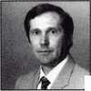

A

Chapter

Roster

Dept

**The best way to learn about ALOA’s programs**

**and to network with locksmiths in your area is by  
participating in local ALOA chapter activities. This is  
your opportunity to exchange management and tech-  
nical information, build your professional image, and  
share tmde tips with your fellow locksmiths.**

**If you want to start a chapter in your area, please call  
ALOA, (214) 827-1701.**

w

Alabama

Alabama Locksmiths Association

4116th St.

Decatur, AL 35601 (800) 292-5008 *Larry Warnick, CML

Arizona

Grand Canyon Chapter

13016 S. 131st St.

Gilbert, AZ 85233 (602)786-8182 * Larry Schlemmer, CRL

California

Los Angeles/

Orange Counties Chap­ter

P.O. Box 697

Alhambra, CA 91820-0697 (310) 869-2555 *John H. Cosby, CPL San Diego Chapter

1049 Island Ave.

San Diego, CA 92101-7228

(619) 234-4829

Burt Fieser—Chairman

Colorado

Colorado Front Range

2603 Pearl St.

Boulder, CO 80302 (303)443-9740 John I. Shandy, CML— Chairman

*John M. Thomas, CRL— Vice Chairman (303) 666-8980

Connecticut

Nutmeg Chapter

Phil’s Lock Shop 360 E. Main

Meriden, CT 06450-6022 (203)237-4602 Phillip Hobbs, CPL—Chair­man

Florida

South Florida Chapter

1710 NE Miami Gardens Dr.

Miami, FL 33179 (305)944-0469

*Jerri Moeller, CRL Secretary Paul Renderer, CML— Chairman

Georgia

Georgia Chapter

P.O. Box 48088 Atlanta, GA 30362-1088 (404) 455-6244 John T. Grist, CML—Chair­man

*M.W. Whitman, Jr.

Hawaii

Hawaii Chapter

4420 Lawehana St.

Unit 4

Honolulu, HI 96818 (808) 623-5914 *Andreas Muenker, CML— Chairman

Indiana

Central Indiana

1237 Wabash Ave.

Terre Haute, IN 47807 (812) 234-6249

* Herbert Dusenberry, CML

Northern Indiana

122 N Orchard St. Kendallville, IN 46755 (219) 347-1754 *Earl Shanfelt

Southern Indiana

P.O. Box 185 Bloomington, IN 47402- 0185

(812)334-3737

* Daniel W. Hill, CML

Kentucky

Kyana Chapter

510 E. Parrish Ave. Owensboro, KY 42303- 3125

(502) 684-5093

*Timothy Morrison, CML—

Secretary

Maryland

Chesapeake Chapter

700 Rappolla St.

Baltimore, MD 21224 (410) 633-0111

* Bob De Weese, CPL— Chairman

Massachusetts

Massachusetts Chapter

200 Weir Street Taunton, MA 02780 (508)823-4649 *Stephen Ehrlich, CML— Treasurer

Minnesota

Minnesota Chapter

3M Center Bldg. 223-BE-04 St. Paul, MN 55144-1000 (612) 733-6674 *Douglas Rude, CRL

Montana

Montana Chapter

Mountain Locksmithing 210 N 7th Bozeman, MT 59715 (406) 586-5187 *Jim Morrissey, CRL— Chairman

Carol Morrissey, CRL— Secretary

Nebraska

Nebraska Chapter

343 W. 2nd St.

Hastings, NE 68901 (402) 463-6661 *Brad Boden

Nevada

Sierra Nevada Chapter

C/O Pamela Vankirk P.O. Box 115 Reno, NV 89504 (702) 328-9285 *Danniel F. Howard,

CML—Chairman

New Jersey

Garden State Chapter

106 Ridgedale Ave. Morristown, NJ 07960 (201) 538-2737 *Steve Frei, Chairman

New Mexico

New Mexico Chapter

917 2nd St. NW Albuquerque, NM 87102 (505)242-1380 *Evelyn Wersonick, CML Marc McGrannahan, Chair­man

Sunbelt Chapter

South Central Region New Mexico State University

Box 30001 Dept. 3545 Las Cruces, NM 88003-0001 (505)846-6292 *Don Brazil—Chairman

North Dakota

North Dakota Chapter

Rte. 1 Box 67

Devil’s Lake, ND 58301-

3907

(701) 662-5625 *James H. Strong, CRL

Ohio

Ohio North Coast Chapter

#2 Horseshoe Drive Monroeville, OH 44847 (419)465-4153

* Ronald Betschman, CML— Chairman

Ohio Valley Chapter

144 Julep

Cincinnati, OH 45218 (513) 825-7528 *James T. Brickler,

Chairman

Pennsylvania

Keystone State Chapter

3 W 4th St.

Bridgeport, PA 19405 (610) 272-9292 *Barry Leas, CRL

South Dakota

South Dakota Chapter

402 S. Minnesota Ave.

Sioux Falls, SD 57102 (605) 331-6026 *Ronald Heidzig—Chair­man

Tennessee

Smokey Mountain Chapter

2557 Middle Creek Rd. Pigeon Forge, TN 37863 (615)453-8344 *Jessie Swan, RL West Tennessee 1261 Wellsville Rd. Memphis, TN 38117 (901)685-1130 *John Singleton

Texas

Sunbelt Chapter

see New Mexico listing

Washington, DC

Washington, DC Area

2987 Thomas Rd.

Bryan Road, MD 20616 (301)283-0145

* William Smith, Jr., CML— Chairman

Wisconsin

Fox Valley Chapter

1425 N. Richmond St. Appleton, WI 54911 (414) 731-5400 e-mail [sageinc@athenet.net](mailto:sageinc@athenet.net) *John F. Engel, CRL Chairman

Matt Swoboda—Vice Chair­man

Indianhead Chapter

201 N. Barstow St.

Eau Claire, WI 54703-3525 (715)832-4207 *John Dorsey, CPL Chairman

Wyoming

Wyoming Chapter

5920 E. Pershing Cheyenne, WY 82001 (307) 638-8752 *Betty Crenshaw, CML

International Chapters **Korea Chapter**

#1250-7 Bi San 7 Dong Seo Gu TaeGu Korea

(053) 353-0058 *Joe J. Lee 5430 Howland St.

Phila., PA 19124 (215) 744-5254

* Denotes contact person for this chapter.

All questions regarding chap­ter activities, meetings and events should he directed to this individual.

January 1998

Keynotes

k



|  |  |
| --- | --- |
| ALOA | i |
| Extra | \ |



Dept

In Memory

Doyle Eugene Poteat

Doyle Eugene Poteat passed away this year. He had been an ALOA active bonded mem­ber since January of 1973 and was propri­etor of Poteat’s Lock and Key in Glen Alpine, N.C.

Elwin Carswell

Elwin Carswell left us this year at the age of 74. During his time as an ALOA member, he serves as Chapter Vice Chairman of the Georgia Chapter as well as the 82 Local Association Officer for the Dixie Lock­smiths.

Chauncy Browning

Chauncy Browning passed away this year as the result of a heart attack. He was an employee of A-l Lock & Associates in Dal­ton, Ga. Browning was 51 years-old.

Dave Baldridge

At the age of 54, Dave Baldridge passed on. Baldridge was an employee of Reiter’s Lock­smith and Safe in El Centro, Calif.

Important Tax Information for Small Businesses

For details, tips, and other helpful informa­tion on tax advice for small businesses, or to offer your input to help provide I.R.S. reforms for small businesses, feel free to con­tact Mark Warren, the Committee On Small Business’s tax counsel at (202) 224-5175.

Correction

In the Backpage section of the Nov./Dec. issue of Keynotes, which detailed some facts on keys from the Roman Empire, the title read “Roamin’ Around 200 Years Ago.” Of course, everyone knows that the Roman Empire was long gone by the time the 1800s rolled around, so our apologies to all as the headline should have read “Roamin’ Around 2,000 Years Ago.”

$40 Get-A-Member

By now most of you have seen the fliers and ads promoting ALOA’s $40 Get-A-Member

recruitment program. The terms are, quite simply, that you receive a $40 check from ALOA for every new member you recruit for ALOA during 1998. The only proviso is that your applicant must qualify for and be accepted for membership, and your recruit’s application fee and membership dues must be paid before we send you your reward. So, let’s get out there and add to our ranks!

**Membership Directory**

The 1998 membership directory will be available on the ALOA website ([www.aloa.org](http://www.aloa.org)) and will be updated on a regular basis during the year. Providing this information to membership (and the public) is both more cost effective and more timely through this channel. If you have a special need for a hard copy of any portion of the membership listings, please contact the ALOA office so that we can work out a way to help. (Keep in mind—the ALOA list prepped for mailing is available for a nomi­nal fee.)

*Keynotes* Plans

Your association magazine is in the process of formulating a new editorial plan designed, among other things, to tighten industry and association news coverage. The new format will premiere with the conven­tion issue—June/July 1998, and will con­tinue for subsequent issues. Changes are based, in part, on comments received from the 1997 membership opinion survey. We hope you find the revised coverage to be helpful and more concise.

**Positive ID Policy**

Use the following positive identification pol­icy when servicing lockouts:

Notify Caller. When a call comes in to request lockout services, ask the caller if he/she has identification and authority to open the lock.

Complete Form. Upon arrival at the job site, the locksmith should complete an Authorization Form that asks for the name, address, phone number, identification num­ber and property description from the cus­

tomer. ALOA provides a model form.

Verify I.D. Verify the customer’s photo-iden­tification card and compare it to the infor­mation provided by the customer. If no pho- to-ID card is available, ask for some other reasonable form of ID.

Verify Authority. The locksmith should inquire as to what authority the customer has to open the lock, and request to see any reasonable and appropriate evidence that could verify the authority. This may be impossible in some cases.

Ask for Signature. Ask the customer to sign the Authorization Form, which should contain a statement that (a) the information given by the customer is correct, (b) the cus­tomer has the authority to open the lock, and (c) the customer shall identify and hold harmless the locksmith against liability.

The ALOA model form contains this state­ment.

Optional Last Resort. If you have any sus­picions that the customer is giving false information or does not have authority to open the lock, say that you will be happy to open the lock provided a law enforcement officer is present. If the customer agrees, call the police; if not, leave.

File the Form. Keep the Authorization Form on file for a reasonable period of time.

***Keynotes Advertisers Index***

|  |  |  |
| --- | --- | --- |
| RS# | Advertiser | Page |
| 19 | Abus Lock Company | 37 |
| 30 | All-Lock Company | 40 |
| 100 | Jet Hardware Mfg., Inc. | BC |
| 1 | Locksmith Publishing Corp. | IFC |
| 23 | MLANJ | 43 |
| 20 | Monday Security Group | 37 |
| 17 | MUL-T-LOCK USA, Inc. | 21 |
| 31 | Nationwide Advertising | 52 |
| 21 | Southern Lock and Supply Col | 39 |
| 18 | Timemaster | 29 |
| 22 | Unlocks Inc. | 39 |



Keynotes

January 1998

Locksmithing is at war with big business.

But you have more firepower than you realize.

Your fellow locksmiths joined forces more  
than 40 years ago, understanding the need  
to fight battles together. Today, benefits of  
membership in the Associated Locksmiths  
of America, Inc. have grown far beyond  
the early vision, but they still rest on one  
enduring truth: Strength in numbers.

Your best chance of surviving the struggle

ahead is being a part of an organization

with others like yourself. Through our

common voice we will refuse to be

legislated out of business.

As a united front, we can command technical advice from world-renowned instructors and authors who know how to make our business boom.

It starts with you.

It ends with all of us together.

Recruit a member today.

For a supply of membership applications, contact:

Associated Locksmiths of America, inc.

3003 Live Oak Street, Dallas, Texas 75204 Voice: 214.827.1701 Fax: 214.827.1810

Email: [aloa@anet-dfw.com](mailto:aloa@anet-dfw.com)

**We’re Right Behind You.**



Keynotes

What do you do when you’re a  
kid who’s a master magician, jug-  
gler, puzzle solver, the only stu-  
dent to beat the “Austrian Knot”  
and a LEGO® engineering genius  
who wants to accomplish some-  
thing never before attempted  
with LEGO1 elements?

I don’t know how to tell you  
this one.

Young Paul has built a work-  
ing lock—not a model—a work-  
ing lock with tumblers and a  
key. Go ahead and laugh, you  
non-believers.

The lock is built in two halves,  
which are held together by a  
series of piston rod elements.The

halves do not naturally “stick” to  
each other because the upper  
surface of the lower half is cov-  
ered with flat plates.The piston

rods have been designed in such  
a way that all muSt be disengaged  
to separate the two halves.The  
rods also are cleverlyTStaggered so  
that one cannot slip in any old  
stick into the keyhole—one must

use a specific key to activate the

piston rod tumblers.

Are you with me?

The key itself was made out of

LEGO® axles, bushings and piston  
rods, and took on the appearance  
of an old skeleton key.

You can’t fool me. Every single  
one of you is headed up to the  
attic right now.

—Anne Davis,ABC



January 1998

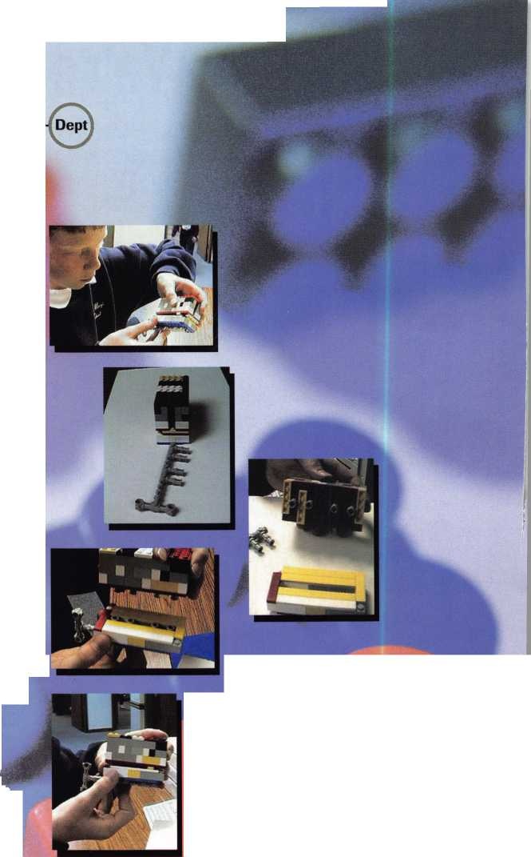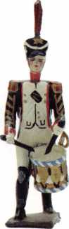

S A F E T E C H '98



SAFETECH IB CONVENTION AND TRADE SHOW • VALLEY FORGE, PENNSYLVANIA • MAT 11-23

Die Hard Manipulation Time Lock Servicing Advanced Servicing and Defeat Methods Red Label GSA Containers

Safe Opening Extravaganza Electric Locks and Safe Retrofitting Safe Moving and Installation

SAFE AND VADET TECHNICIANS ASSOCIATION

3 0 0 3 LIVE OAK STREET

DALLAS, TEXAS 75204

214.027.7233

21 4.0 27.1 01 0 (FAX)

**E MAIL: [C0NVTI0N@ANEHFW.CDM](mailto:C0NVTI0N@ANEHFW.CDM)**



**•**

**MAT**



Y157C-PH

Y155C-PH

Y154C-PH

Y157C

Y155C

Y154C

Y159C-PH

A Quality Licensed Product.

QUALITY FOR YOURSCLF!

JET HARDWARE MANUFACTURING CO

800 HINSDALE STREET, BROOKLYN, NY 11207

Y159C

Chrysler is a registered trademark of Chrysler Corporation, USA and is used under license. ©CHRYSLER CORPORATION 1

